Måløy, Vestland, Norway
A working Norwegian fishing town on the island of Vågsøy where a legendary WWII commando raid meets one of Europe's most striking rock formations — and the cruise pier sits steps from the centre.
⚓ Docked (Garpeskjær Quay) · 🕒 Typical call: 6-8 hrs · 💵 Norwegian Krone (NOK) — cards accepted everywhere · 🗣️ Norwegian · 🎣 Authentic fishing-port atmosphere
✍️ MY DAY IN PORT (FILL IN)
Ship / Date
In port | arrive ______ · all aboard ______
Booked excursion
Notes / meeting point
GETTING ASHORE
- Docking: Docked at Garpeskjær Quay, 5–10 min walk to town centre
- Best For: WWII history, coastal scenery, Kannesteinen rock formation
- Don't Miss: Måløy Raid Centre — Operation Archery brought 'Mad Jack' Churchill here in 1941
- Weather: Unpredictable coastal climate; windproof layers essential year-round
GETTING AROUND
- 🚕 Taxi: 128–325 NOK — Local taxis (Måløy Taxi) available for trips to outlying sights like Kannesteinen or Refviksanden Beach. Norway caps tax
TOP THINGS TO DO
- Måløy Raid Centre — Operation Archery — The centrepiece of any visit: an interactive museum telling the story of the 27 December 1941 commando raid on Vågsøy — the first…
- Kannesteinen & Refviksanden Beach — Kannesteinen is a mushroom-shaped boulder sculpted by millennia of Atlantic waves near Oppedal village, ≈10 km from the pier…
- Vestkapp & Kråkenes Lighthouse RIB Safari — Vestkapp (West Cape), on the Stadlandet peninsula, is the westernmost mountain plateau on mainland Norway, with clifftop…
- Selja Monastery Boat Tour — A guided boat trip to Selja Island (≈30 min from Måløy) where Norway's only female saint, St Sunniva, is said to have perished.
- Street Art Walk & Town Stroll — Måløy's compact centre features ≈20 murals and street-art pieces celebrating coastal fishing culture, all within easy walking…
BEST WALKS
- Town Centre & Waterfront Loop: 1.5 km · 25 min · Flat · Free — From the pier, walk along the waterfront promenade past working fishing trawlers, through the town…
- Kletten Day-Hike: 2-3 hrs return · Moderate · Free — A family-friendly hike up to the Kletten day-trip cabin above town, rewarding with panoramic views…
WEATHER · DAYLIGHT · MONEY
Month | High °F | Low °F | Rainy days
May | 52 | 43 | 16
Jul | 61 | 53 | 18
Sep | 58 | 50 | 20
Daylight: May 4:46AM–10:27PM · Jul 4:24AM–11:05PM · Sep 7:06AM–8:01PM
cruiseports.org/maloy · Confirm terminal & all-aboard time with your ship

Måløy, Vestland, Norway — Port Map
Red = walkable sights · Amber = excursions farther out · P = cruise terminal
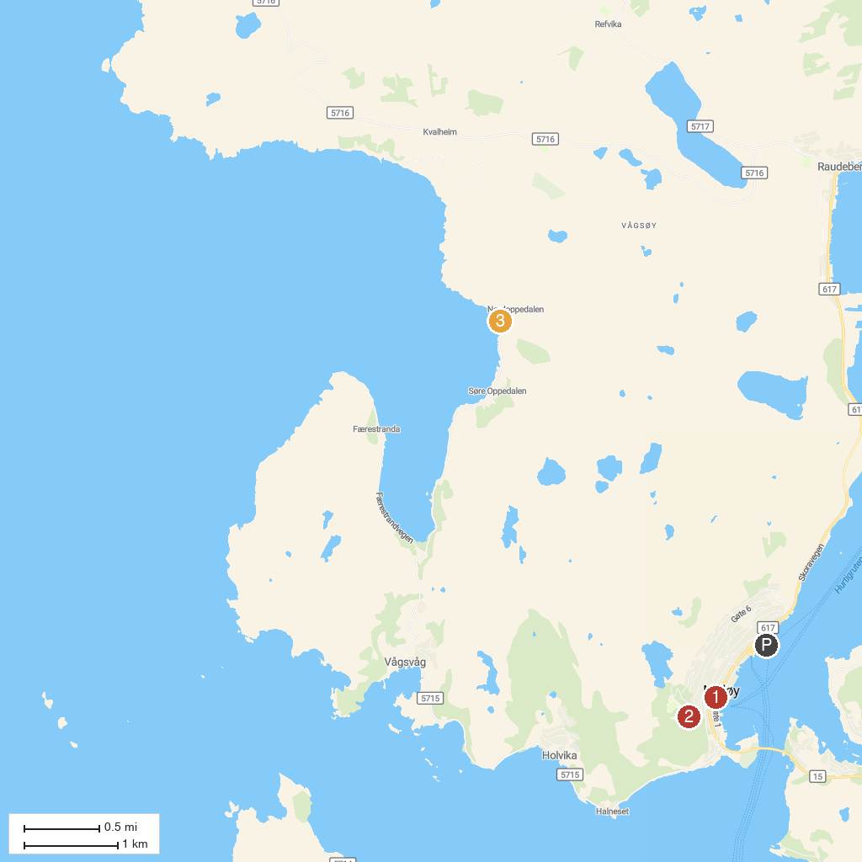
MAP KEY
1. Måløyraid Senteret | 3. Kannesteinen
2. Ellingskarshornet
P. Cruise port / terminal
Map © MapTiler © OpenStreetMap contributors · cruiseports.org

