Malé, Maldives
One of the world's most densely packed island capitals — a vivid coral-stone mosque, a lively fish market, and a turquoise lagoon ringed by reefs just minutes from the city dock. Most cruisers are here for the water, not the skyline.
⚓ Tender port (ships anchor off Malé) · 🕒 Typical call: 6–8 hrs · 💵 Maldivian Rufiyaa (MVR) · USD widely accepted · 🗣️ Dhivehi · English spoken in tourism
✍️ MY DAY IN PORT (FILL IN)
Ship / Date
In port | arrive ______ · all aboard ______
Booked excursion
Notes / meeting point
GETTING ASHORE
- Docking: Tender to Malé ferry terminal
- Walk to center: 5 min from tender dock
- Best For: Reefs · Sandbanks · Culture
- Don't Miss: Hukuru Miskiy (Friday Mosque)
GETTING AROUND
- 🚕 Taxi: MVR 25–30 (~$1.50–2 USD) within Malé; MVR 85–100 (~$5.50–6.50 USD) to Hulhumalé — Government-regulated flat fares apply within city limits. Taxis are readily available near the port; confirm fare before
- 📱 Rideshare: ❌ not available
TOP THINGS TO DO
- Snorkeling reef excursion — Boat trip to a nearby house reef or dedicated snorkel site in the North Malé Atoll.
- Sandbank & lagoon day — Transfer to a shallow sandbank or uninhabited island for swimming and sunbathing in an impossibly blue lagoon.
- Resort island day pass — Access a nearby resort island — pool, beach, and often lunch included.
- Scuba diving in the North Malé Atoll — For certified divers, the atolls around Malé offer drift dives, reef walls, and regular encounters with rays and sharks.
- Malé city walk: mosques, market & museum — Cover the Friday Mosque (Hukuru Miskiy), the Grand Friday Mosque, the fish market, and Sultan Park on foot in a couple of hours.
BEST WALKS
- Old Malé heritage loop: ~2.5 km · 1.5 hrs · easy, flat — From the ferry terminal, walk to the 17th-century Hukuru Miskiy (Friday Mosque) with its carved…
- Rasfannu waterfront stroll: ~1.5 km · 45 min · easy — Head south from the ferry terminal along the reclaimed waterfront to Rasfannu beach — Malé's…
WEATHER · DAYLIGHT · MONEY
Month | High °F | Low °F | Rainy days
May | 84 | 81 | 25
Jul | 83 | 80 | 17
Sep | 83 | 79 | 20
Daylight: May 5:53AM–6:11PM · Jul 6:01AM–6:21PM · Sep 5:57AM–6:05PM
cruiseports.org/male · Confirm terminal & all-aboard time with your ship

Malé, Maldives — Port Map
Red = walkable sights · Amber = excursions farther out · P = cruise terminal
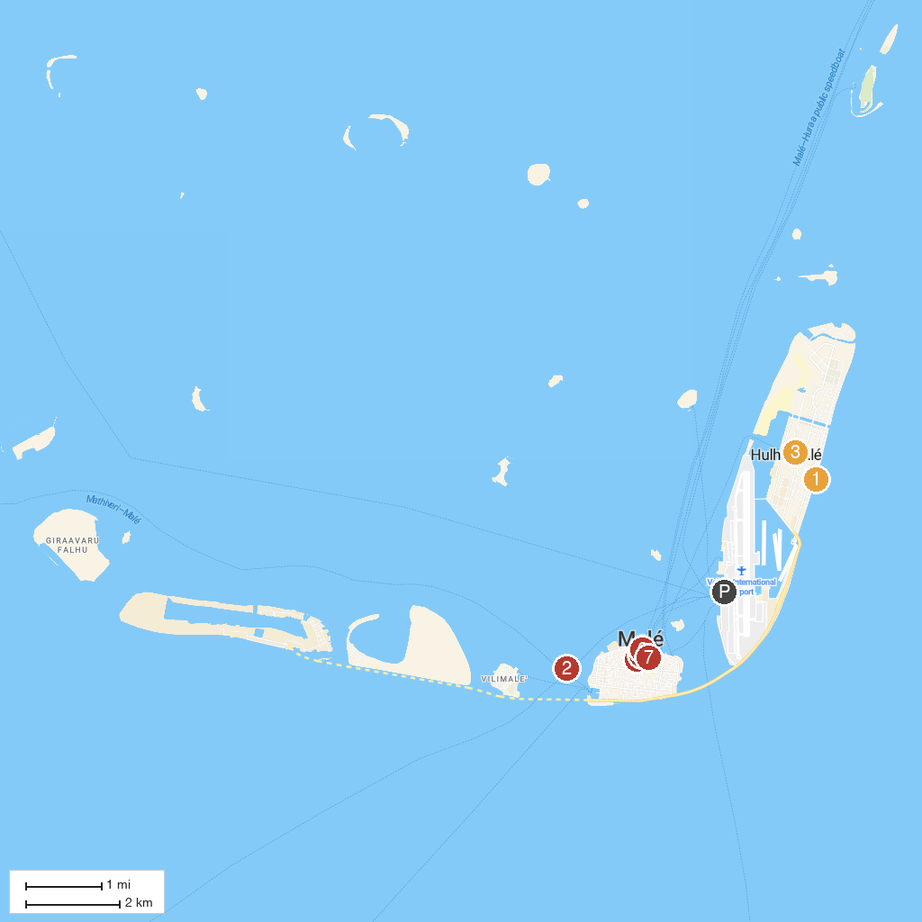
MAP KEY
1. Hulhumale Public Beach | 5. Victory Monument
2. Whale Submarine | 6. Republic Square
3. Central Park (Hulhumalé) | 7. Muliaage (Palace)
4. National Museum
P. Cruise port / terminal
Map © MapTiler © OpenStreetMap contributors · cruiseports.org

