Malacca, Melaka, Malaysia
Where Portuguese, Dutch, and British empires left their marks on a single riverside square, Malacca is a living UNESCO World Heritage city that rewards every cruiser who steps ashore.
⚓ Mixed — tender or pier depending on ship · 🕒 Typical call: 8–10 hrs · 💵 Malaysian Ringgit (MYR) · 🗣️ Malay / English widely spoken · 🏛️ UNESCO World Heritage Site
✍️ MY DAY IN PORT (FILL IN)
Ship / Date
In port | arrive ______ · all aboard ______
Booked excursion
Notes / meeting point
GETTING ASHORE
- Docking: Tender to Parameswara Jetty (most ships) or pier at Tanjung Bruas / MICT
- Walk to center: 5–10 min from tender jetty; 30–45 min drive from Tanjung Bruas
- Best For: History, Peranakan culture, street food, colonial architecture
- Don't Miss: Dutch Square, St. Paul's Hill, Jonker Street, chicken rice balls
GETTING AROUND
- 🚕 Taxi: ~RM 30 — From the Melaka Gateway Cruise Terminal in Klebang to Dutch Square (city center) takes about 20 minutes. Grab is widely
- 📱 Rideshare: ✅ Grab
TOP THINGS TO DO
- Dutch Square & St. Paul's Hill — The iconic red Stadthuys and Christ Church anchor Dutch Square — then climb the hill to Portuguese-era church ruins and sweeping…
- Baba & Nyonya Heritage Museum — A superbly preserved 19th-century Peranakan townhouse showing how Straits Chinese merchants lived — intricate tilework, ancestral…
- Jonker Street Food Walk — Malacca's Chinatown street is lined with Peranakan cafes, antique shops, and street stalls.
- Harmony Street Temple Trio — On a single short street — Cheng Hoon Teng (Malaysia's oldest Chinese temple), Kampung Kling Mosque (Sumatran-style minaret), and…
- Malacca River Cruise — A 45-minute boat ride through the city's riverfront reveals colourful murals, traditional Malay houses, and ornate bridges.
BEST WALKS
- Heritage Core Loop: 2–3 km · 1.5–2 hrs · Easy, flat — From the tender jetty walk north past the Maritime Museum to Dutch Square and Christ Church.
- Riverside Mural Walk: 1 km · 30–45 min · Easy — Stroll both banks of the Malacca River between the two road bridges.
WEATHER · DAYLIGHT · MONEY
Month | High °F | Low °F | Rainy days
May | 86 | 78 | 28
Jul | 85 | 77 | 23
Sep | 84 | 76 | 23
Daylight: May 7:01AM–7:13PM · Jul 7:10AM–7:23PM · Sep 7:02AM–7:09PM
cruiseports.org/malacca · Confirm terminal & all-aboard time with your ship

Malacca, Melaka, Malaysia — Port Map
Red = walkable sights · Amber = excursions farther out · P = cruise terminal
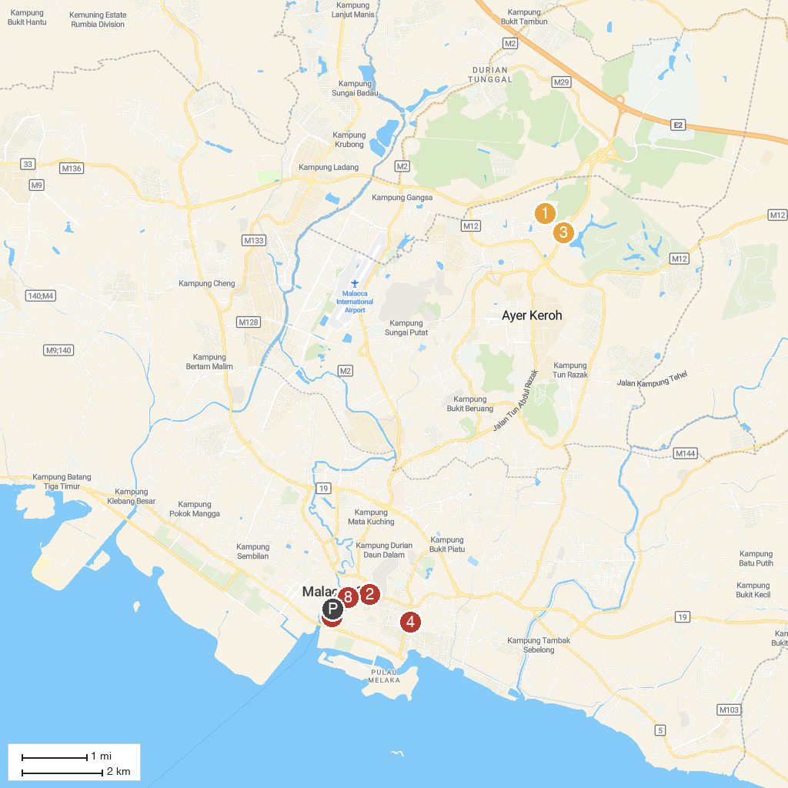
MAP KEY
1. Melaka Wonderland Theme Park & Resort | 5. Menara Taming Sari
2. Sultan's Well, Perigi Hang Li Poh | 6. Melaka River Cruise Jeti Quayside
3. Zoo Melaka | 7. Malaysia Youth Museum
4. St John's Fort | 8. Church of St. Francis Xavier Melaka
P. Cruise port / terminal
Map © MapTiler © OpenStreetMap contributors · cruiseports.org

