Makassar, South Sulawesi, Indonesia
The unofficial capital of Eastern Indonesia, Makassar is a genuine working port city where hand-built wooden schooners still load cargo alongside container ships and the city's legendary food stalls draw visitors from across the archipelago.
⚓ Pier (Soekarno-Hatta Harbour) · 🕒 Typical call: 8–10 hrs · 💵 Indonesian Rupiah (IDR) · 🗣️ Bahasa Indonesia · 🌶️ Famous Indonesian food city
✍️ MY DAY IN PORT (FILL IN)
Ship / Date
In port | arrive ______ · all aboard ______
Booked excursion
Notes / meeting point
GETTING ASHORE
- Docking: Pier — Soekarno-Hatta Harbour (cargo/passenger port, basic terminal)
- Walk to centre: Port is industrial — take a taxi or Grab app (2–3 km to Fort Rotterdam)
- Best For: History, street food, Pinisi wooden ships, authentic Indonesian city life
- Don't Miss: Coto Makassar soup + Paotere Harbour for working Pinisi schooners
GETTING AROUND
- 🚕 Taxi: IDR 30,000–50,000 (~$2–3) — Blue Bird taxis operate with meters from Soekarno-Hatta Harbour. The port is about 2–3 km from the city center — a short
- 📱 Rideshare: ✅ Grab, Gojek
TOP THINGS TO DO
- Fort Rotterdam & La Galigo Museum — One of the best-preserved Dutch colonial forts in Indonesia, built in the 17th century on the site of a Gowanese fortification.
- Paotere Harbour — Working Pinisi Ships — Watch Bugis crews load cargo onto hand-built wooden schooners exactly as they have for centuries.
- Coto Makassar & Street Food Trail — Makassar is one of Indonesia's top culinary cities.
- Samalona Island Day Trip — A tiny coral island just 2 km offshore with white sand and decent snorkelling.
- Balla Lompoa Palace Museum — A faithful reconstruction of the Sultan of Gowa's royal palace, built on traditional stilts and housing royal regalia, crowns…
BEST WALKS
- Losari Waterfront Promenade: 1.5 km | Easy | Flat — Stroll the concrete seafront promenade from the Amirul Mukminin Floating Mosque south to the Pisang…
- Fort Rotterdam to Somba Opu Souvenir Street: 0.8 km | Easy | Flat — Start at Fort Rotterdam for a 30-minute explore of the fort and museum, then walk south along Jalan…
WEATHER · DAYLIGHT · MONEY
Month | High °F | Low °F | Rainy days
May | 85 | 77 | 22
Jul | 85 | 74 | 12
Sep | 88 | 75 | 6
Daylight: May 6:02AM–5:54PM · Jul 6:12AM–6:03PM · Sep 5:55AM–5:59PM
cruiseports.org/makassar · Confirm terminal & all-aboard time with your ship

Makassar, South Sulawesi, Indonesia — Port Map
Red = walkable sights · Amber = excursions farther out · P = cruise terminal
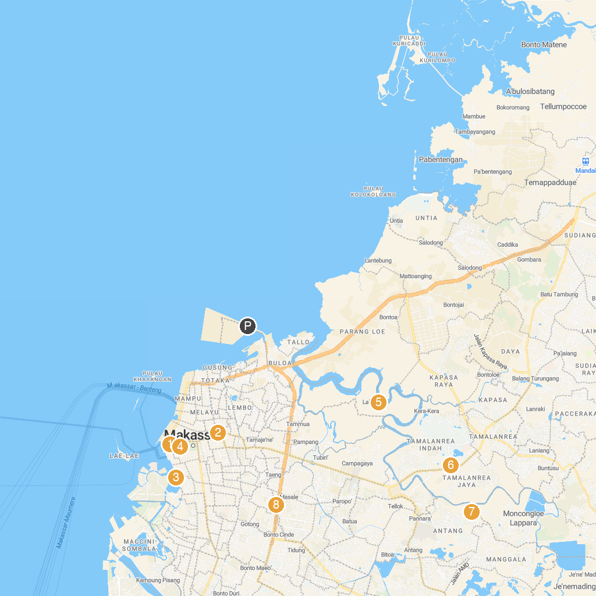
MAP KEY
1. Fort Rotterdam | 5. Travel Island Lakkang
2. Masjid Raya Makassar | 6. Taman Teras Unhas
3. Losari Beach Platform | 7. Bugis Waterpark Adventure
4. Museum of Makassar | 8. Pakui Sayang Park
P. Cruise port / terminal
Map © MapTiler © OpenStreetMap contributors · cruiseports.org

