Makarska, Dalmatia, Croatia
Sheer limestone peaks of Biokovo rise almost 2,000 m directly behind red-roofed Makarska — a seaside town where a Franciscan monastery harbours one of the world's finest shell collections and a Skywalk dangles over the Adriatic.
⚓ Tender or docked (size-dependent) · 🕒 Typical call: 6–8 hrs · 💶 Currency: Euro (€) · 🗣️ Language: Croatian
✍️ MY DAY IN PORT (FILL IN)
Ship / Date
In port | arrive ______ · all aboard ______
Booked excursion
Notes / meeting point
GETTING ASHORE
- Docking: Large ships tender; small/expedition ships dock at the Osejava pier
- Walk to center: Immediate — the Riva promenade is right at the landing point
- Best For: Beaches, mountain scenery, Dalmatian cuisine, easy strolling
- Don't Miss: Biokovo Skywalk (glass platform 1,228 m up) & the Franciscan Shell Museum
GETTING AROUND
- 🚕 Taxi: €5–€15 — Local taxis are available at the port. The base fare is around €5 with ~€4/km; most in-town rides cost under €15. Useful
- 📱 Rideshare: ✅ Uber, Bolt
TOP THINGS TO DO
- Biokovo Skywalk & Nature Park — A horseshoe-shaped glass viewing platform suspended at 1,228 m offers dizzying views of the islands of Hvar, Brač and Korčula.
- Franciscan Monastery & Shell Museum — A 16th-century Franciscan monastery in the heart of the old town houses one of the most scientifically significant shell…
- Makarska Town Beach (Gradska Plaža) — A 2 km stretch of fine pebbles backed by pine trees, 10–15 min on foot from the pier.
- Nugal Beach Hike — A 40-minute trail through Osejava Forest leads to a dramatic, cliff-framed pebble cove.
- Island Boat Trip to Hvar or Brač — Several operators run day trips to Hvar town or the beaches of Brač.
BEST WALKS
- Old Town & Riva Stroll: 1.5 km · 30–45 min · Flat · Free — From the tender landing on the Riva, walk west along the promenade past the statue of poet Andrija…
- St. Peter Peninsula Loop: 2 km · 45 min · Easy · Free — Head west from the harbour along the Riva and enter the forested Sveti Petar peninsula.
WEATHER · DAYLIGHT · MONEY
Month | High °F | Low °F | Rainy days
May | 72 | 58 | 13
Jul | 88 | 71 | 4
Sep | 78 | 64 | 9
Daylight: May 5:28AM–8:09PM · Jul 5:25AM–8:29PM · Sep 6:31AM–7:01PM
cruiseports.org/makarska · Confirm terminal & all-aboard time with your ship

Makarska, Dalmatia, Croatia — Port Map
Red = walkable sights · Amber = excursions farther out · P = cruise terminal
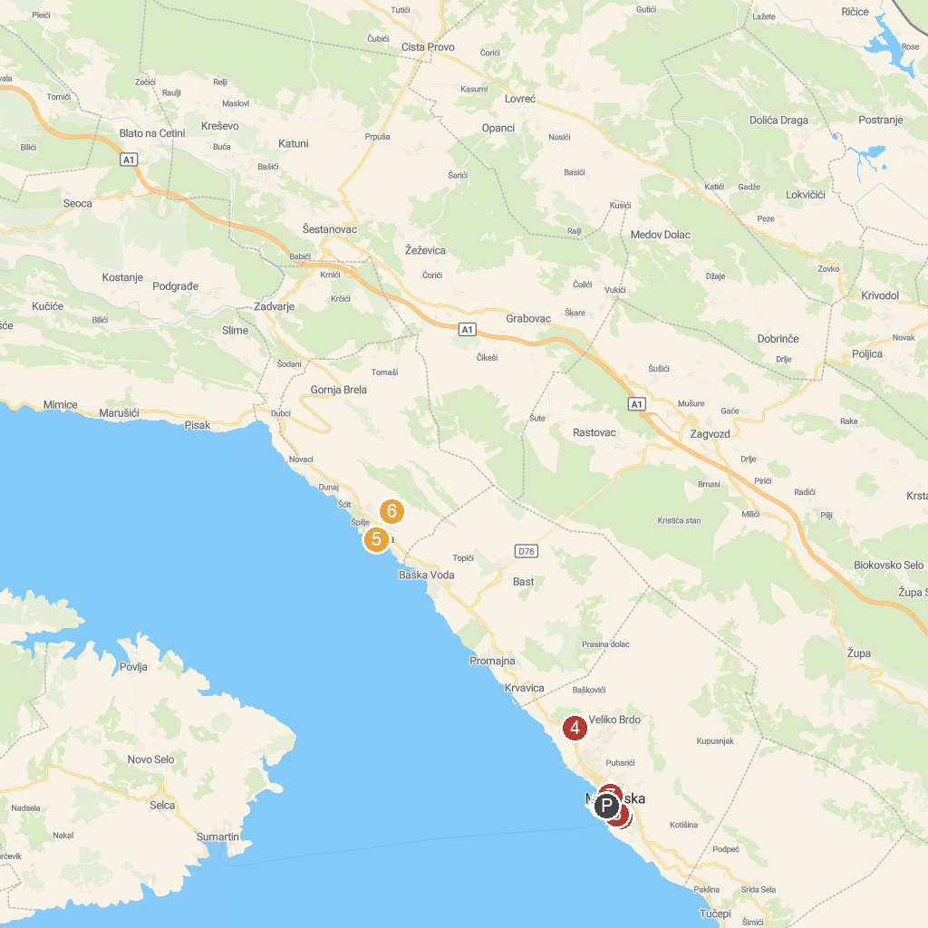
MAP KEY
1. City Museum | 5. Church of Our Lady of Mount Carmel
2. Malacological Museum | 6. Poučna staza "Francuska cesta"
3. Admiral Automat Club | 7. Zale's tower
4. Shrine of Our Lady of Lourdes | 8. Skywalk Biokovo quad, buggy and scooter tours
P. Cruise port / terminal
Map © MapTiler © OpenStreetMap contributors · cruiseports.org

