Maizuru, Kyoto Prefecture, Japan
A naval city with red-brick Meiji-era warehouses and the best crab on the Sea of Japan — or catch a train to Amanohashidate or Kyoto itself.
⚓ Pier (no tender) · 🕒 Typical call: 8–10 hrs · 💴 Currency: Japanese Yen (JPY) · 🗣️ Language: Japanese · 🚌 Free city shuttle from pier
✍️ MY DAY IN PORT (FILL IN)
Ship / Date
In port | arrive ______ · all aboard ______
Booked excursion
Notes / meeting point
GETTING ASHORE
- Docking: Pier — Kyoto Maizuru Port International Wharf (Pier No. 2)
- Walk to center: ~2.2 km (25–30 min) to Nishi-Maizuru; shuttle buses usually provided free
- Best For: Naval history, Amanohashidate day trip, fresh seafood, Kyoto excursions
- Don't Miss: Maizuru Red Brick Park, Tore-Tore Seafood Center, Maizuru Repatriation Museum
GETTING AROUND
- 🚕 Taxi: ¥500 flag fall + ¥100/255m — Taxis available at the port gates, but taking the free shuttle to Nishi-Maizuru Station first saves ~¥2,500. Night surch
- 📱 Rideshare: ✅ Uber
TOP THINGS TO DO
- Maizuru Red Brick Park — Twelve Meiji-era naval warehouses (8 are Important Cultural Properties) repurposed as museums, craft beer bars, and souvenir shops.
- Amanohashidate — Bridge to Heaven — One of Japan's Three Scenic Views: a 3.6 km pine-covered sandbar.
- Maizuru Repatriation Memorial Museum — UNESCO Memory of the World site documenting the return of 660,000 Japanese POWs and civilians from Siberian labor camps through…
- Maizuru Port Tore-Tore Center — The port's legendary seafood market — choose your crab, sea urchin, oysters, or squid live from the stalls and have them grilled…
- Kyoto City Day Trip — Maizuru is the 'Kyoto port' — the ancient capital is ~90 min by express train or 1.5–2 hrs by coach.
BEST WALKS
- East Maizuru Naval History Walk: 2–3 km · Easy · 1.5–2 hrs — From the Red Brick Park shuttle stop, explore the 12 Meiji warehouses, then walk along the harbour…
- West Maizuru Old Town Wander: 2 km · Easy · 1 hr — From Nishi-Maizuru Station, stroll through the Showa-era shotengai shopping arcades, past the…
WEATHER · DAYLIGHT · MONEY
Month | High °F | Low °F | Rainy days
May | 74 | 56 | 12
Jul | 86 | 74 | 18
Sep | 80 | 69 | 16
Daylight: May 4:54AM–6:55PM · Jul 4:54AM–7:14PM · Sep 5:41AM–6:05PM
cruiseports.org/maizuru · Confirm terminal & all-aboard time with your ship

Maizuru, Kyoto Prefecture, Japan — Port Map
Red = walkable sights · Amber = excursions farther out · P = cruise terminal
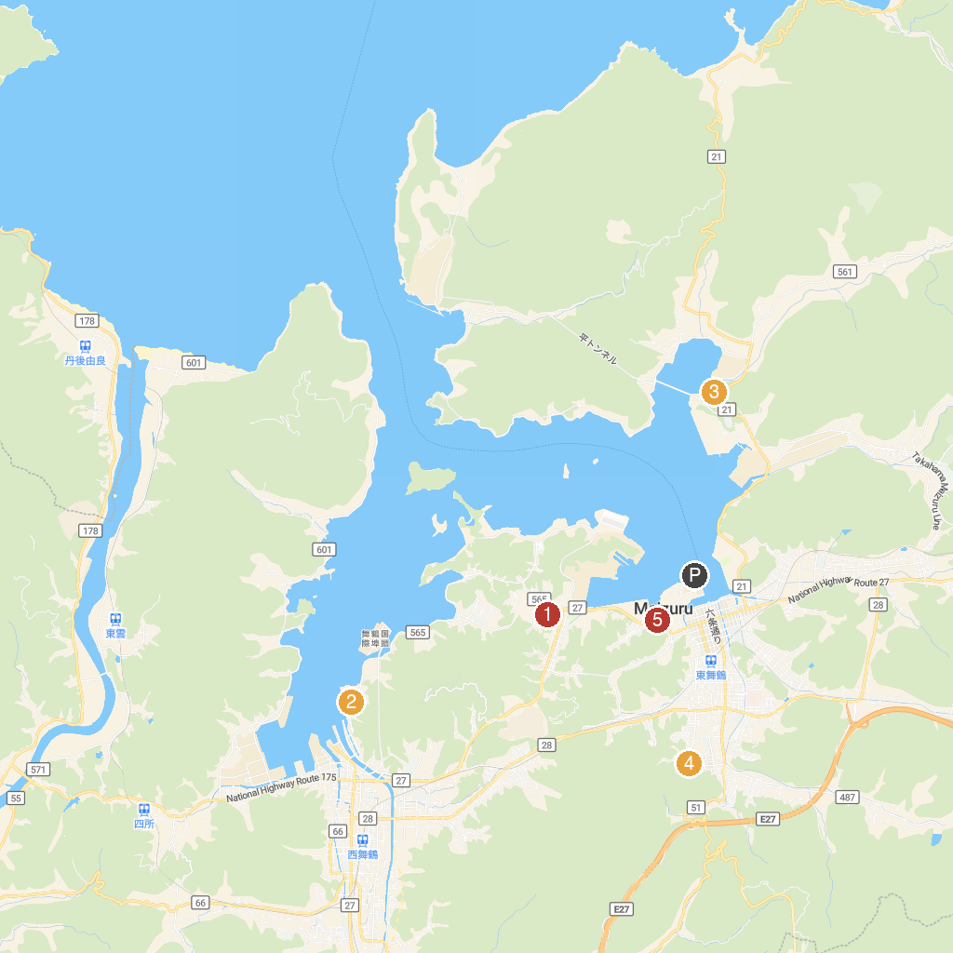
MAP KEY
1. Kyouraku Park | 4. Higashi-Maizuru Park
2. Nioizaki Park | 5. Craft House
3. Maizuruhikiage Memorial Park
P. Cruise port / terminal
Map © MapTiler © OpenStreetMap contributors · cruiseports.org

