Mainz, Rhineland-Palatinate, Germany
The city where Gutenberg changed the world sits right on the Rhine, its six-spired cathedral watching over cobbled squares and wine bars that have been pouring Riesling for centuries.
⚓ Docked (river pier) · 🕒 Typical call: 6–8 hrs · 💵 Euro (€) · 🗣️ German · 🍷 Wine region
✍️ MY DAY IN PORT (FILL IN)
Ship / Date
In port | arrive ______ · all aboard ______
Booked excursion
Notes / meeting point
GETTING ASHORE
- Docking: River pier at Victor-Hugo-Ufer — no tender needed
- Walk to center: 10–15 min on foot to Marktplatz & Cathedral
- Best For: History, printing press heritage, Rhine wine culture
- Don't Miss: Gutenberg Museum (now at interim site) & Chagall windows at St. Stephen's
GETTING AROUND
- 🚕 Taxi: €12–€16 — Taxis from the port to the city center (Hauptbahnhof) cover about 2–3 km at a base fare of €4.50 plus €2.40/km. Journey
- 📱 Rideshare: ✅ Uber, Bolt
TOP THINGS TO DO
- Gutenberg Museum (Interim Exhibition) — The world's finest collection of early printing history, including two original 42-line Gutenberg Bibles.
- Mainz Cathedral (Dom St. Martin) — One of Germany's finest Romanesque cathedrals, built from 975 AD and rebuilt after fires into a unique mix of Romanesque, Gothic…
- St. Stephen's Church & Chagall Windows — This Gothic church is famed for nine stunning stained-glass windows designed by Marc Chagall in his twilight years (1978–1985).
- Rhine Wine Tasting — Mainz sits at the heart of the Rheinhessen wine region, Germany's largest.
- Roman Mainz — Museum of Ancient Seafaring — Mainz was the Roman fortress city of Mogontiacum.
BEST WALKS
- Riverfront to Cathedral & Gutenberg Museum: 1.2 km | 15 min | Flat | Core sights — The essential Mainz stroll: from the Rhine embankment up through the old town to the Dom, then a…
- Cathedral to Chagall Windows: 1.5 km round trip | 20 min | Flat | Art & architecture — From the Dom, walk southwest through the Altstadt lanes past Kirschgarten square to St.
WEATHER · DAYLIGHT · MONEY
Month | High °F | Low °F | Rainy days
May | 67 | 50 | 10
Jul | 79 | 61 | 10
Sep | 71 | 54 | 8
Daylight: May 5:41AM–9:06PM · Jul 5:35AM–9:30PM · Sep 7:03AM–7:39PM
cruiseports.org/mainz · Confirm terminal & all-aboard time with your ship

Mainz, Rhineland-Palatinate, Germany — Port Map
Red = walkable sights · Amber = excursions farther out · P = cruise terminal
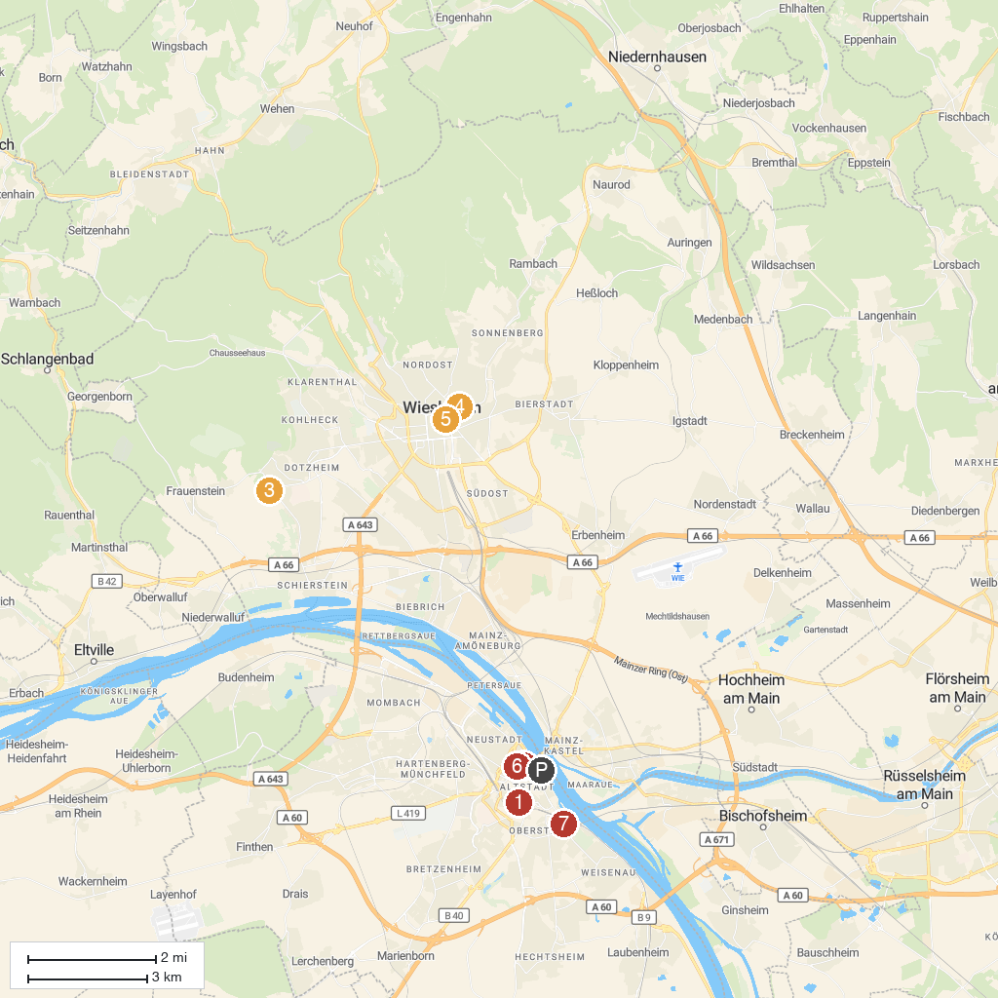
MAP KEY
1. St. Stephan's Church | 5. Spielbank Wiesbaden
2. Nerobergbahn Wiesbaden | 6. Evangelical Market church Wiesbaden
3. Gutenberg Museum | 7. Landesmuseum Mainz
4. Schloss Freudenberg | 8. Stadt Park
P. Cruise port / terminal
Map © MapTiler © OpenStreetMap contributors · cruiseports.org

