Mahé, Seychelles
The largest island in the Seychelles combines a compact colonial capital with dramatic granite boulders, turquoise bays, and lush cloud-forest mountains — all reachable in a single shore day.
⚓ Docked (pier) · 🕒 Typical call: 7-10 hrs · 💵 SCR / USD & EUR widely accepted · 🗣️ Creole, English, French · 🏖️ World-class beaches
✍️ MY DAY IN PORT (FILL IN)
Ship / Date
In port | arrive ______ · all aboard ______
Booked excursion
Notes / meeting point
GETTING ASHORE
- Docking: Pier at Port Victoria — no tender required
- Walk to center: ~20 min (1.5 km flat, but hot — shuttle available)
- Best For: Beaches, snorkeling, Creole food, giant tortoises
- Don't Miss: Sir Selwyn Selwyn-Clarke Market in Victoria (closed Sundays)
GETTING AROUND
- 🚕 Taxi: €15–€25 to city center — A taxi rank operates at Port Victoria (Mon–Fri 8:00–16:00). Agree on the fare before you depart; meters are not always u
- 📱 Rideshare: ❌ not available
TOP THINGS TO DO
- Beau Vallon Beach Day — The island's most popular beach — a 3 km crescent of white sand on the northwest coast with calm water, sun loungers, and…
- Botanical Gardens & Giant Tortoises — Stroll through the National Botanical Gardens on the edge of Victoria to see Coco de Mer palms, fruit bats roosting in the trees…
- Saint Anne Marine Park Snorkel Cruise — Glass-bottom boat trip around Saint Anne Marine National Park — coral gardens, colorful reef fish, and the chance to swim with…
- Copolia Trail Hike — A moderately challenging jungle trail from the Sans Souci road into Morne Seychellois National Park, ending at a granite plateau…
- Victoria City Walk — Explore the world's smallest capital: the silver clocktower ("Little Ben"), the colorful Hindu Arul Mihu Navasakthi Vinayagar…
BEST WALKS
- Victoria City Loop: 2–3 km · 45–60 min · Flat · Free — Start at the clock tower, visit the Selwyn-Clarke Market for local spices and fresh fish, peek into…
- Pier to Town Center: 1.5 km · 20 min · Flat — A straightforward walk from the Port Victoria pier along the waterfront road into the heart of the…
WEATHER · DAYLIGHT · MONEY
Month | High °F | Low °F | Rainy days
May | 79 | 69 | 11
Jul | 77 | 65 | 10
Sep | 80 | 69 | 10
Daylight: May 6:03AM–5:11PM · Jul 6:17AM–5:17PM · Sep 5:37AM–5:35PM
cruiseports.org/mahe-island-seychelles · Confirm terminal & all-aboard time with your ship

Mahé, Seychelles — Port Map
Red = walkable sights · Amber = excursions farther out · P = cruise terminal
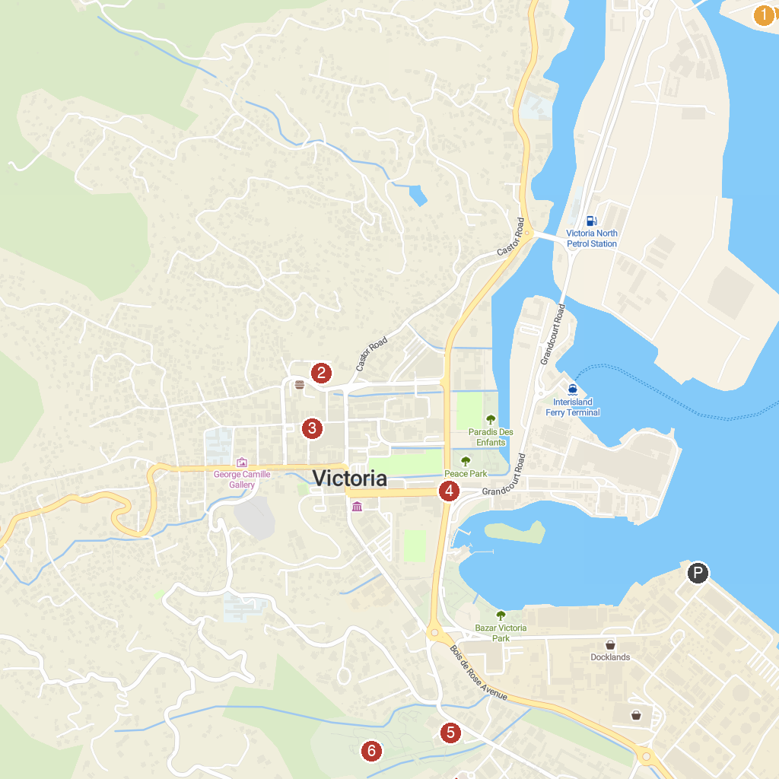
MAP KEY
1. Saint-Anne Marine National Park | 4. Bicentenary Monument Seychelles
2. Immaculate Conception | 5. National Botanical Garden
3. Sir Selwyn Selwyn-Clarke Market | 6. Giant Tortoise Enclosure
P. Cruise port / terminal
Map © MapTiler © OpenStreetMap contributors · cruiseports.org

