Magong, Penghu, Taiwan
Sitting astride the Taiwan Strait, Magong is one of Asia's most rewarding walk-off ports — the oldest Mazu temple in Taiwan is five minutes from the pier, and wild basalt coastlines await just beyond the city.
⚓ Pier (docked — expanded 2024) · 🕒 Typical call: 8-10 hrs · 💵 New Taiwan Dollar (TWD); carry cash · 🗣️ Mandarin / Taiwanese · 🌊 Beaches, temples & basalt geology
✍️ MY DAY IN PORT (FILL IN)
Ship / Date
In port | arrive ______ · all aboard ______
Booked excursion
Notes / meeting point
GETTING ASHORE
- Docking: Pier No. 1, Magong Harbor (upgraded 2024; handles ships up to 150,000 GT)
- Walk to center: 5–10 min on foot to Zhongyang Old Street and Tianhou Temple
- Best For: History lovers, beach seekers, foodies, and geology enthusiasts
- Don't Miss: Cactus ice cream on Old Street and the Penghu Fireworks Festival (Apr–Jun)
GETTING AROUND
- 🚕 Taxi: NTD 120–300 — Taxis are available at the port; fares are negotiated (no meters). The port is centrally located in Magong, so most down
TOP THINGS TO DO
- Zhongyang Old Street & Tianhou Temple — Walk the oldest street in Penghu to reach Taiwan's oldest Mazu temple (founded c.
- Basalt Columns & Daguoye Geology — Penghu's volcanic basalt forms dramatic hexagonal columns and sea caves unlike anywhere else in Asia.
- Shanshui or Shili Beach — Penghu's beaches rival anything in Southeast Asia.
- Erkan Historical Village — One of Taiwan's best-preserved traditional villages, built from coral stone (laogu shi) and volcanic basalt.
- Island-Hopping & Snorkeling — Boat tours fan out to Jibei (north), Wang'an, and the outer islands of South Penghu Marine National Park, where lavender coral…
BEST WALKS
- Old Town Loop: 1.5 km · ~45 min · Easy — From the pier, follow the harbor promenade to Penghu Tianhou Temple at the entrance of Zhongyang…
- Guanyinting & Rainbow Bridge: 3 km from pier · 20 min walk or short taxi · Easy — Head southwest along the coast road to Guanyinting Park and the Rainbow Bridge, a pedestrian…
WEATHER · DAYLIGHT · MONEY
Month | High °F | Low °F | Rainy days
May | 79 | 77 | 13
Jul | 84 | 81 | 11
Sep | 82 | 80 | 10
Daylight: May 5:20AM–6:36PM · Jul 5:24AM–6:50PM · Sep 5:48AM–6:05PM
cruiseports.org/magong · Confirm terminal & all-aboard time with your ship

Magong, Penghu, Taiwan — Port Map
Red = walkable sights · Amber = excursions farther out · P = cruise terminal
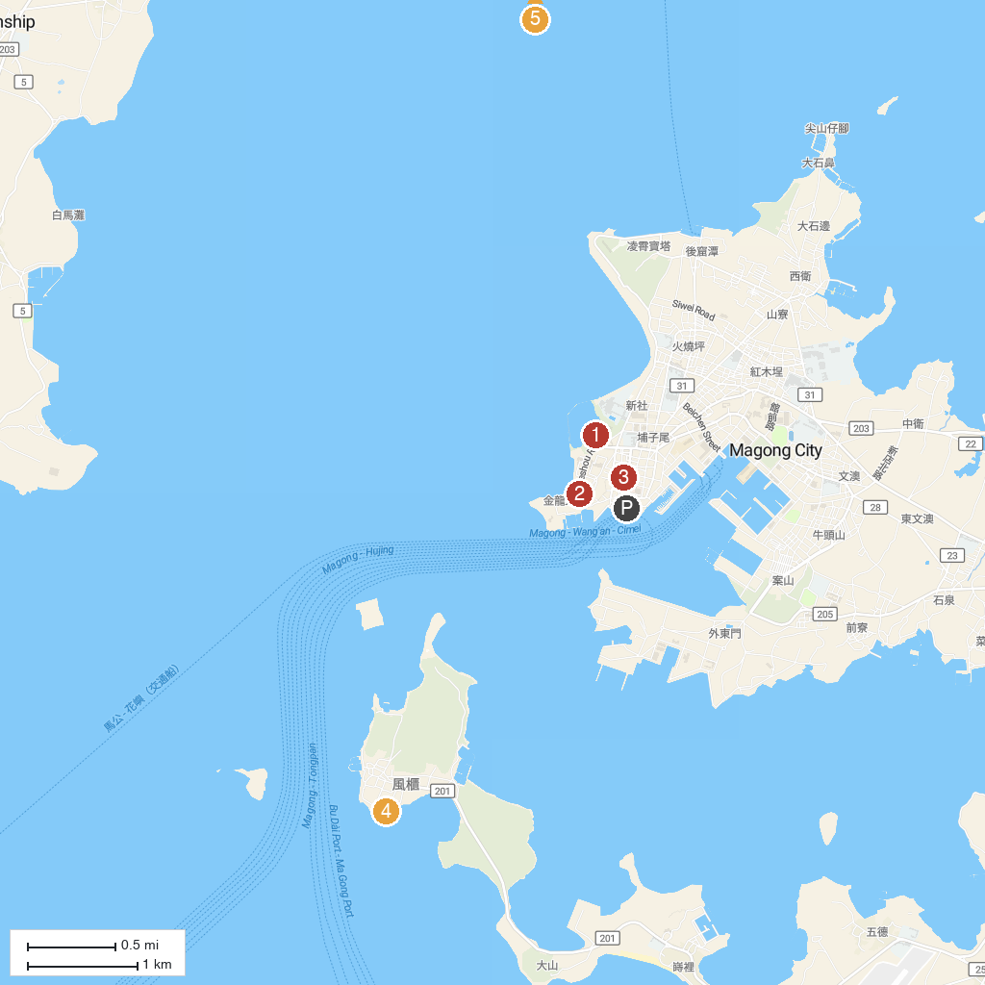
MAP KEY
1. Guanyinting Recreation Area | 4. Fongguei Cave
2. Duxingshi Village | 5. Whale Cave
3. 四眼井 | 6. Tongliang Great Banyan
P. Cruise port / terminal
Map © MapTiler © OpenStreetMap contributors · cruiseports.org

