Magdeburg, Saxony-Anhalt, Germany
Capital of Saxony-Anhalt and burial city of Emperor Otto the Great, Magdeburg blends Gothic grandeur with a hot-pink Hundertwasser masterpiece and a river that floats ships over itself.
⚓ Pier (floating pontoon) · 🕒 Typical call: 6-8 hrs · 💶 Euro (€) · 🗣️ German
✍️ MY DAY IN PORT (FILL IN)
Ship / Date
In port | arrive ______ · all aboard ______
Booked excursion
Notes / meeting point
GETTING ASHORE
- Docking: Pier — floating pontoon at Petriförder on the Elbe Promenade
- Walk to center: ~10-15 min on foot to Alter Markt; Cathedral ~20 min
- Best For: History lovers, architecture fans, easy city walking
- Don't Miss: Magdeburg Cathedral (Otto the Great's tomb) & the Green Citadel
GETTING AROUND
- 🚕 Taxi: €14–16 — Taxis are readily available at the cruise pier. The city center is roughly 4 km away; expect a 10–15 minute ride at offi
- 📱 Rideshare: ✅ Uber, FREE NOW
- 🚌 Hop-on hop-off: ✅
TOP THINGS TO DO
- Magdeburg Cathedral & Otto the Great's Tomb — Germany's oldest Gothic cathedral took 300 years to build and holds the tomb of Emperor Otto the Great, the first Holy Roman…
- Green Citadel (Hundertwasser Building) — Shockingly pink, covered in golden onion domes and trees growing from windows, the Green Citadel is Friedensreich Hundertwasser's…
- Wasserstraßenkreuz — The Water Bridge — The world's longest navigable aqueduct (918 m) carries ships over the Elbe River just north of the city.
- Kulturhistorisches Museum — Home to the original 13th-century Magdeburg Rider statue and exhibits tracing the city's role as a medieval powerhouse.
- Elbauenpark & Millennium Tower — A large riverside park across the Elbe featuring one of the world's tallest wooden towers (60 m).
BEST WALKS
- Elbe Promenade to Cathedral Loop: 3.5 km · ~50 min · Flat — Walk north along the Elbe Promenade to Petrikirche, continue up Breiter Weg to Alter Markt, visit…
- Strandbar & River Walk: 1.5 km · ~20 min · Flat — From the pier, stroll south along the Elbe to the seasonal Strandbar beach bar — real sand, deck…
WEATHER · DAYLIGHT · MONEY
Month | High °F | Low °F | Rainy days
May | 66 | 48 | 9
Jul | 77 | 59 | 10
Sep | 69 | 53 | 8
Daylight: May 5:19AM–9:01PM · Jul 5:11AM–9:26PM · Sep 6:48AM–7:27PM
cruiseports.org/magdeburg · Confirm terminal & all-aboard time with your ship

Magdeburg, Saxony-Anhalt, Germany — Port Map
Red = walkable sights · Amber = excursions farther out · P = cruise terminal
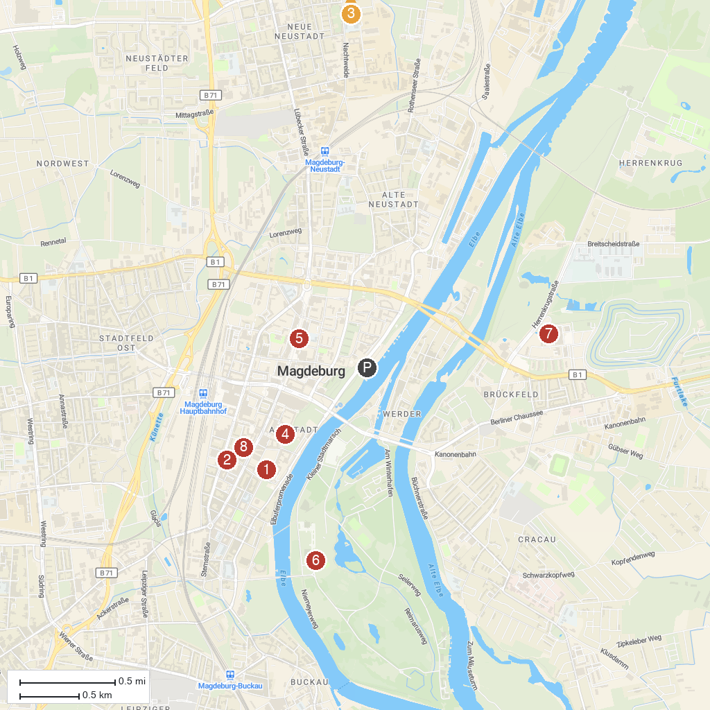
MAP KEY
1. Magdeburg Cathedral Saint Mauritius and Catherine | 5. Katharinenturm
2. Museum of Cultural History Magdeburg | 6. Albinmüller-Turm
3. Zoo Magdeburg | 7. Elbauenpark
4. Kunstmuseum Magdeburg - Kloster Unser Lieben Frauen | 8. Saint Sebastian Cathedral
P. Cruise port / terminal
Map © MapTiler © OpenStreetMap contributors · cruiseports.org

