Madison, Indiana, USA
Indiana's greatest river town froze beautifully in time when the railroads passed it by. Today its 133-block National Historic Landmark District — America's largest contiguous one — greets cruise passengers with brick streets, Greek Revival mansions, and a Main Street that's been a Great American Main Street since 2024.
⚓ Docked (riverfront pier) · 🕒 Typical call: 8–12 hrs · 💵 USD · 🗣️ English · 🏛️ Historic landmark district
✍️ MY DAY IN PORT (FILL IN)
Ship / Date
In port | arrive ______ · all aboard ______
Booked excursion
Notes / meeting point
GETTING ASHORE
- Docking: Direct tie-up at Madison City Dock, 100 W. Vaughn Dr — no tender
- Walk to Main Street: 2–3 blocks (5 min) from the riverfront dock
- Best For: Architecture fans, history lovers, antique hunters, foodies
- Don't Miss: Lanier Mansion gardens & Hinkle's Sandwich Shop since 1933
GETTING AROUND
- 🚕 Taxi: Metered — inexpensive in town — Speedy Cab and B's Taxi both operate in Madison. Short in-town trips are inexpensive; useful for reaching Clifty Falls S
- 📱 Rideshare: ✅ Uber
TOP THINGS TO DO
- Lanier Mansion State Historic Site — The 1844 Greek Revival crown jewel of Madison's historic district.
- Historic District Self-Guided Walk — Stroll 133 blocks of the largest contiguous National Historic Landmark District in the US.
- Clifty Falls State Park — Just 2.5 miles from downtown, deep limestone gorges and four major waterfalls make this one of Indiana's most dramatic state parks.
- Rockin Thunder Jet Boat Tour — High-speed jet boat rides on the Ohio and Kentucky Rivers departing from Madison's riverfront.
- Main Street Shops & Broadway Fountain — Over 100 independent shops, antique malls, galleries, and cafés line Madison's mile-long Main Street.
BEST WALKS
- Riverfront to Main Street & Broadway Fountain: 0.6 miles • ~15 min • Easy — Walk north from the City Dock through Riverfront Park, turn up any cross street to Main Street, and…
- Lanier Mansion & West Historic District: 0.6 miles round trip • ~20 min • Easy — From the dock head west along the riverfront path to Lanier Mansion at the west end of Elm Street.
WEATHER · DAYLIGHT · MONEY
Month | High °F | Low °F | Rainy days
May | 68 | 50 | 12
Jul | 81 | 65 | 9
Sep | 73 | 58 | 10
Daylight: May 5:34AM–8:14PM · Jul 5:32AM–8:34PM · Sep 6:37AM–7:06PM
cruiseports.org/madison-in · Confirm terminal & all-aboard time with your ship

Madison, Indiana, USA — Port Map
Red = walkable sights · Amber = excursions farther out · P = cruise terminal
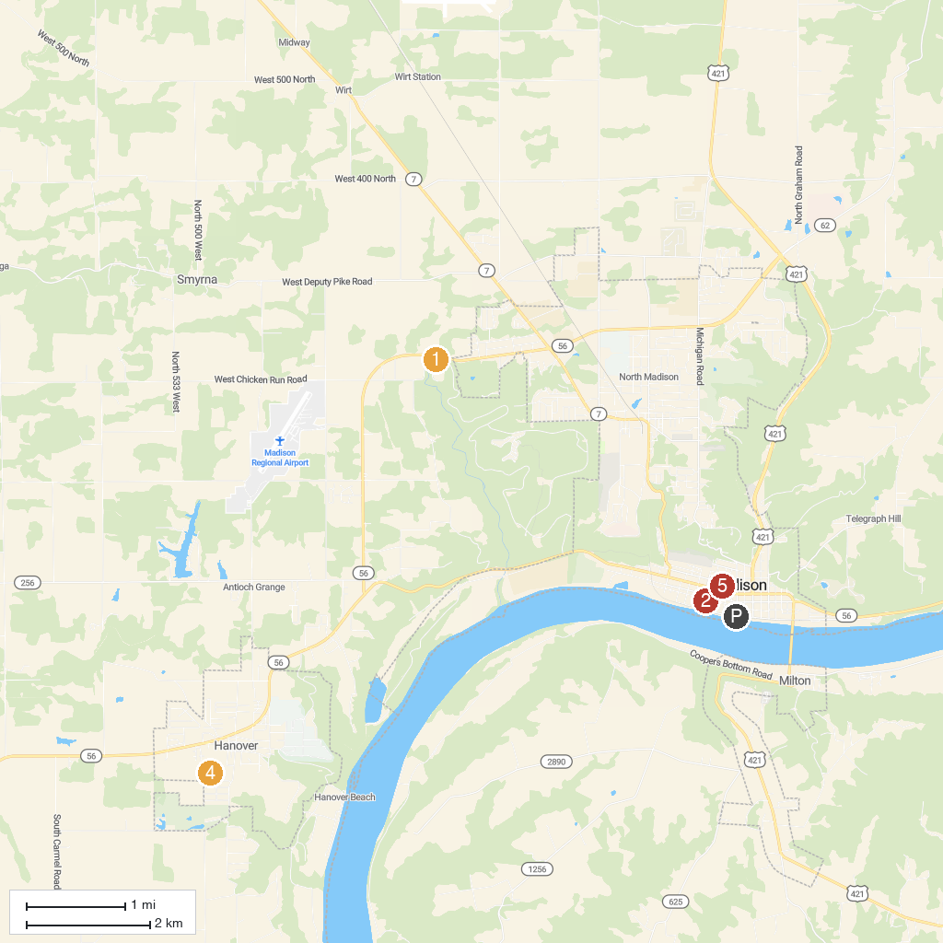
MAP KEY
1. Clifty Falls State Park | 4. Hanover Park
2. Lanier Mansion State Historic Site | 5. Broadway Fountain
3. Rockin Thunder River Tours
P. Cruise port / terminal
Map © MapTiler © OpenStreetMap contributors · cruiseports.org

