Mâcon, France
A historic Saône River town on the Lyon–Chalon corridor, Mâcon is the gateway to southern Burgundy's Mâconnais Chardonnay vineyards, the great abbey of Cluny, and the Roche de Solutré — and home town of the Romantic poet Alphonse de Lamartine.
⚓ Central quay (Quai Lamartine — docked, no tender) · 🕒 Typical call: half to full day · 💶 Euro (EUR) · 🗣️ French
✍️ MY DAY IN PORT (FILL IN)
Ship / Date
In port | arrive ______ · all aboard ______
Booked excursion
Notes / meeting point
GETTING ASHORE
- Arrival: River ships dock on the Saône at Quai Lamartine, in the town centre
- Walk to centre: Step off the ship straight onto the riverside promenade — the old town and cathedral are a 5 min walk
- Best For: Burgundy Chardonnay, medieval abbeys, riverside strolls, French gastronomy
- Don't Miss: Mâconnais wine tasting, Cluny Abbey, and the Roche de Solutré
GETTING AROUND
- 🚕 Taxi: €6–€10 — Taxis are available at the port area. The ride to the train station or city center is under 2 km and takes just a few mi
- 📱 Rideshare: ✅ Uber
TOP THINGS TO DO
- Mâconnais & Pouilly-Fuissé Wine Tasting — Mâcon is the gateway to southern Burgundy's white-wine country.
- Cluny Abbey — About 25 km west, the Abbey of Cluny was for centuries the largest church in Christendom and the centre of one of medieval…
- Roche de Solutré — A dramatic limestone escarpment rising above the vineyards west of Mâcon, the Roche de Solutré gives the Solutrean prehistoric…
- Musée des Ursulines & Old Town — Housed in a 17th-century former Ursuline convent, this museum traces Mâcon's archaeology, regional history, and fine art…
- Tournus & Saint-Philibert Abbey — About 15 km north along the Saône, the small town of Tournus is famed for the Abbey of Saint-Philibert, one of the finest and…
BEST WALKS
- Riverside & Old Town Loop: ~2 km · 45 min · Flat — From the moorings on Quai Lamartine, stroll the riverside promenade past the Pont Saint-Laurent…
- Lamartine Heritage Walk: ~1.5 km · 30 min · Flat — Follow the trail of Mâcon's most famous son, Romantic poet Alphonse de Lamartine: from the…
WEATHER · DAYLIGHT · MONEY
Month | High °F | Low °F | Rainy days
May | 70 | 49 | 11
Jul | 80 | 57 | 8
Sep | 72 | 51 | 8
Daylight: May 5:16AM–9:09PM · Jul 5:07AM–9:25PM · Sep 6:21AM–7:50PM
cruiseports.org/macon · Confirm terminal & all-aboard time with your ship

Mâcon, France — Port Map
Red = walkable sights · Amber = excursions farther out · P = cruise terminal
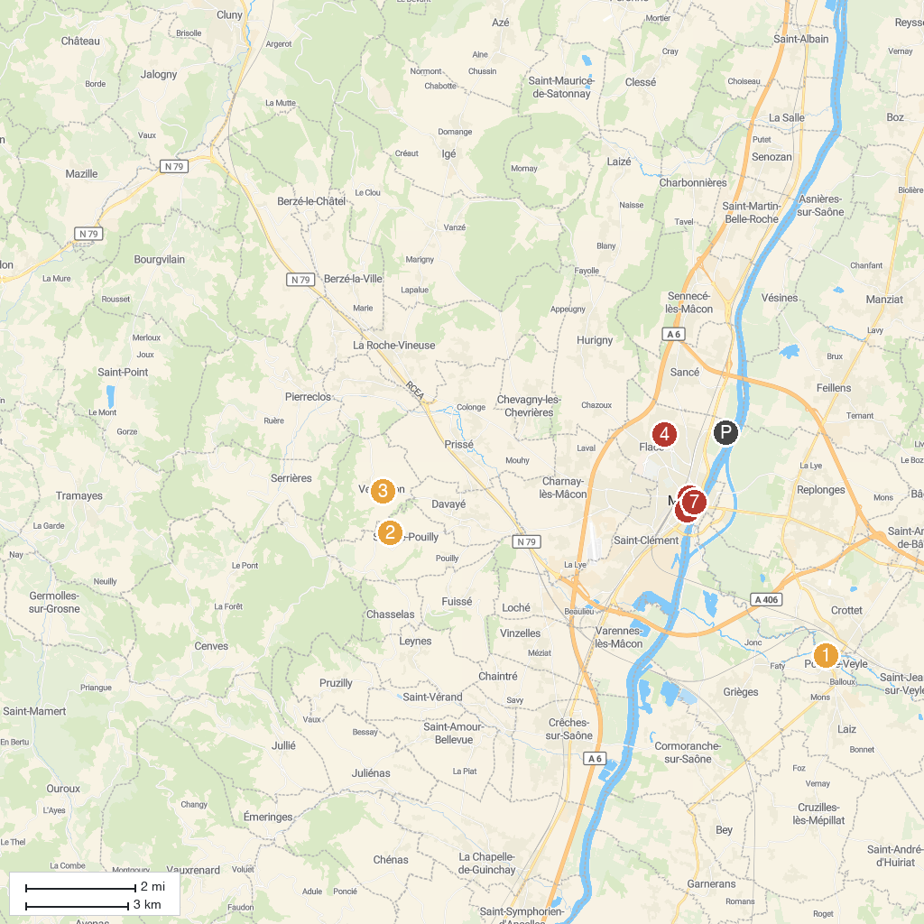
MAP KEY
1. Château de Pont-de-Veyle | 5. Musée des Ursulines
2. Musée de préhistoire de Solutré | 6. Église Saint-Pierre de Mâcon
3. Vergisson | 7. Le Poteau Mou
4. Mémorial Jean-Claude BERNARDET
P. Cruise port / terminal
Map © MapTiler © OpenStreetMap contributors · cruiseports.org

