Maceio, Brazil
The city is compact, with most attractions along the waterfront or nearby lagoons. Taxis and ride-sharing apps are the most reliable way to reach outlying beaches.
Pajuçara Beach: Famous for its natural pools accessible by traditional jangada raft. · Pontal da Barra: Traditional neighborhood renowned for Filé lace-making and the river-sea confluence. · Praia do Francês: Stunning beach with calm natural pools and surf-friendly waves. · Jaraguá Historic District: Colorful colonial architecture, restaurants, and nightlife.
✍️ MY DAY IN PORT (FILL IN)
Ship / Date
In port | arrive ______ · all aboard ______
Booked excursion
Notes / meeting point
GETTING ASHORE
- Natural Pools: Take a jangada raft from Pajuçara Beach to the clear natural pools for snorkeling.
- Filé Lace: Visit Pontal da Barra to watch artisans create traditional Filé lace and buy authentic pieces.
- Beach Kiosks: Enjoy fresh coconut water or local seafood at the many quiosques along the waterfront.
- Historic Center: Stroll Jaraguá's colorful streets lined with 19th-century mansions and lively bars.
GETTING AROUND
- 🚕 Taxi: R$15–30 (~$3–6 USD) — Metered taxis are available at the port. Base fare R$4.79 + R$2.63/km daytime. The short distance to city center keeps c
- 📱 Rideshare: ✅ Uber, 99
TOP THINGS TO DO
- Pajuçara Beach — Enjoy the turquoise waters and natural pools reached by jangada.
- Pontal da Barra — Explore traditional Filé lace-making and the riverside craft market.
- Praia do Francês — Visit one of Alagoas' most beautiful beaches with natural pools.
- Jaraguá Historic District — Wander colorful colonial streets filled with restaurants and bars.
BEST WALKS
- Pajuçara Beach: The turquoise waters and natural pools are a must-visit. — The most iconic beach of the city.
- Pontal da Barra: Traditional Filé lace-making is a unique cultural experience. — The center of local craftsmanship.
- Praia do Francês: Crystal-clear water and scenic beauty. — A nearby beach paradise.
WEATHER · DAYLIGHT · MONEY
Month | High °F | Low °F | Rainy days
May | 82 | 76 | 26
Jul | 79 | 73 | 28
Sep | 80 | 74 | 22
Daylight: May 5:29AM–5:09PM · Jul 5:40AM–5:17PM · Sep 5:16AM–5:19PM
cruiseports.org/maceio · Confirm terminal & all-aboard time with your ship

Maceio, Brazil — Port Map
Red = walkable sights · Amber = excursions farther out · P = cruise terminal
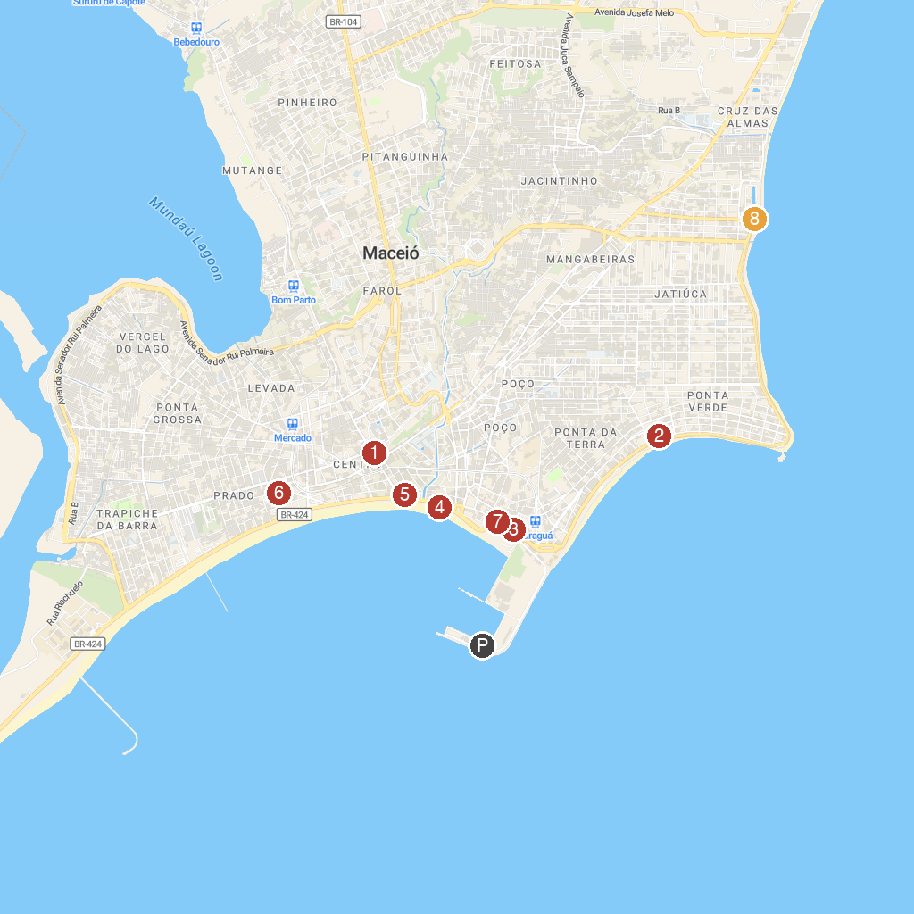
MAP KEY
1. Catedral Metropolitana de Maceió - Paróquia Nossa Senhora dos Prazeres | 5. Museu Théo Brandão
2. Crafts Pavilion | 6. Natural History Museum
3. Museum of Image and Sound of Alagoas (MISA) | 7. Associação Comercial de Maceió
4. Memorial à República | 8. Lagoa da Anta
P. Cruise port / terminal
Map © MapTiler © OpenStreetMap contributors · cruiseports.org

