Macau, Macau SAR, China
The world's gambling capital wears a Portuguese face — cobblestone squares, baroque church ruins, and pastel colonial buildings sit minutes from the most opulent casino resorts on earth.
⚓ Pier (Taipa Ferry Terminal) · 🕒 Typical call: 8–10 hrs · 💵 Macau Pataca (HKD accepted) · 🗣️ Cantonese / Portuguese / Mandarin · 🎰 UNESCO Historic Centre
✍️ MY DAY IN PORT (FILL IN)
Ship / Date
In port | arrive ______ · all aboard ______
Booked excursion
Notes / meeting point
GETTING ASHORE
- Docking: Pier — Taipa Ferry Terminal (Pac On), Taipa Island
- Walk to center: Not walkable; LRT or taxi to Historic Centre (~20 min)
- Best For: History, fusion food, casino spectacle, day-tripper culture
- Don't Miss: Ruins of St. Paul's and a warm egg tart from Lord Stow's Bakery
GETTING AROUND
- 🚕 Taxi: MOP 60–100 (~$7–12 USD) — Yellow-and-black metered taxis available at all ferry terminals. Flag-fall MOP 21; surcharge for luggage and Taipa Termi
- 📱 Rideshare: ✅ Uber
- 🚌 Hop-on hop-off: ✅ Goldspark Macau Tours
TOP THINGS TO DO
- UNESCO Historic Centre Walk — Senado Square, the Holy House of Mercy, St.
- Casino Resort Spectacle — Walk the lobbies of The Venetian (indoor canal, sky-painted ceiling), The Parisian (half-scale Eiffel Tower), and The Londoner…
- Macanese Food & Egg Tart Crawl — Sample pork chop buns at Rua do Cunha, African Chicken at A Lorcha near A-Ma Temple, and warm custard egg tarts at Lord Stow's…
- Taipa Village — A preserved historic quarter on Taipa Island with colonial Portuguese villas (Taipa Houses Museum), Chinese temples, and…
- Macau Tower Skywalk or Bungee — The world's highest commercial bungee jump from a building (233 m), run by AJ Hackett.
BEST WALKS
- Historic Centre Loop: 2.5 km · 60–90 min · Easy (uphill to St. Paul's) — Start at Senado Square, follow the shopping lane up to the Ruins of St.
- Taipa Village Stroll: 1.5 km · 30–45 min · Easy — From Taipa LRT station, walk through Rua do Cunha (Food Street) past egg tart shops and roast meat…
WEATHER · DAYLIGHT · MONEY
Month | High °F | Low °F | Rainy days
May | 83 | 76 | 22
Jul | 87 | 80 | 23
Sep | 86 | 78 | 21
Daylight: May 5:46AM–6:58PM · Jul 5:51AM–7:12PM · Sep 6:12AM–6:29PM
cruiseports.org/macau · Confirm terminal & all-aboard time with your ship

Macau, Macau SAR, China — Port Map
Red = walkable sights · Amber = excursions farther out · P = cruise terminal
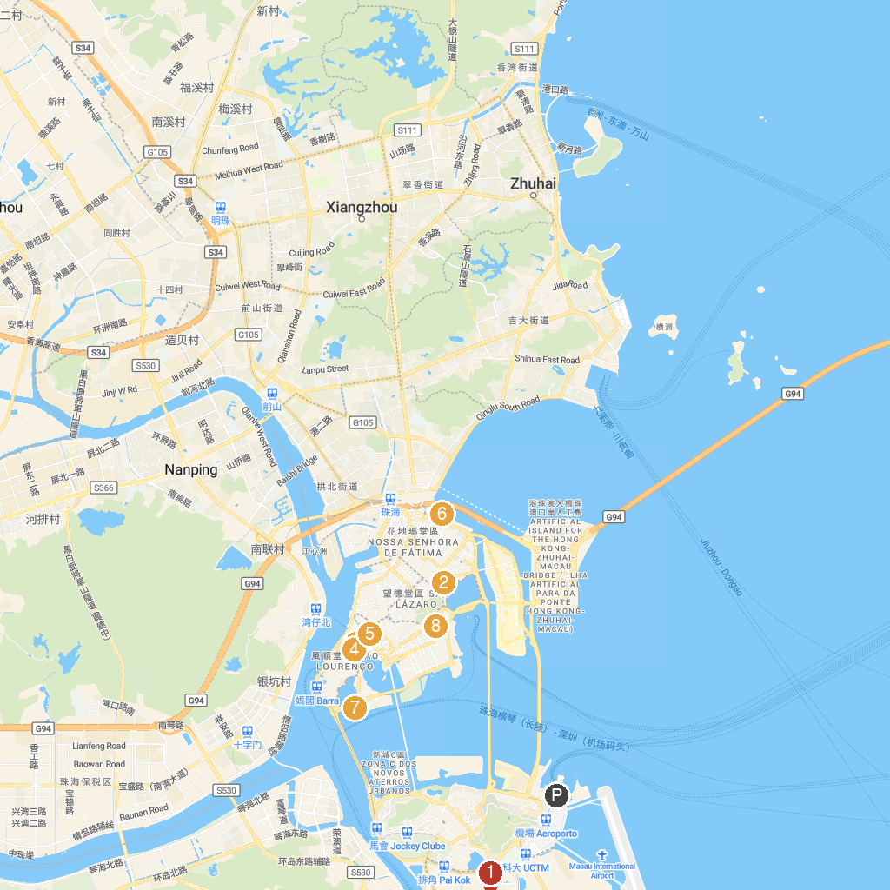
MAP KEY
1. The Cotai Strip | 5. Senado Square
2. Macau Islamic Mosque & Cemetery | 6. 拱北口岸
3. St. Joseph's Seminary and Church | 7. Macau Tower Convention and Entertainment Center
4. St. Lawrence’s Church | 8. Macao Grand Prix Museum
P. Cruise port / terminal
Map © MapTiler © OpenStreetMap contributors · cruiseports.org

