Maastricht, Limburg, Netherlands
The Netherlands' most un-Dutch city — birthplace of the EU, laced with medieval walls and underground limestone caves, and famous for its love of good food, wine, and slow living on the Meuse.
⚓ River dock (no tender) · 🕒 Typical call: 8–10 hrs · 💶 Euro (€) · 🗣️ Dutch / English widely spoken
✍️ MY DAY IN PORT (FILL IN)
Ship / Date
In port | arrive ______ · all aboard ______
Booked excursion
Notes / meeting point
GETTING ASHORE
- Docking: River quays along the Maas (Maaspromenade / Kesselkade) — walk straight into town
- Walk to center: 5–10 min to Vrijthof or Markt (flat, ~500 m; cobblestones inside)
- Best For: History, food & wine, medieval architecture, underground cave tours
- Don't Miss: Dominicanen Bookstore, St. Pietersberg Caves, Vrijthof Square, Limburgse Vlaai
GETTING AROUND
- 🚕 Taxi: €10/person one-way — Maastricht Marina offers a seasonal water taxi direct to the city center. Runs daily at 11:00 AM and 4:30 PM in summer.
- 📱 Rideshare: ✅ Uber
TOP THINGS TO DO
- St. Pietersberg Caves — Over 20,000 tunnels carved into limestone — used as WWII shelters and to hide Rembrandt's Night Watch.
- Dominicanen Bookstore — A 700-year-old Gothic Dominican church converted into one of the world's most beautiful bookstores.
- Vrijthof Square & Basilica Tour — The city's grand public square, flanked by the Basilica of St.
- Burgundian Food Walk — Maastricht is the culinary capital of the Netherlands — try Limburgse vlaai (fruit pie) at the Bisschopsmolen watermill…
- Helpoort & Jeker Quarter — The oldest surviving city gate in the Netherlands (1229), linked to medieval stone walls and the charming Jeker Quarter where…
BEST WALKS
- Quay to Vrijthof Loop: ~2 km | 45 min | Easy (flat to cobbles) — Walk off the ship along the Maaspromenade, cross the Sint Servaasbrug (oldest bridge in the…
- Wyck District Coffee & Boutiques: ~1.5 km | 30–45 min | Easy — Cross to the east bank of the Maas into the trendy Wyck neighborhood for artisan coffee…
WEATHER · DAYLIGHT · MONEY
Month | High °F | Low °F | Rainy days
May | 65 | 48 | 11
Jul | 74 | 58 | 13
Sep | 68 | 53 | 11
Daylight: May 5:48AM–9:19PM · Jul 5:41AM–9:44PM · Sep 7:13AM–7:50PM
cruiseports.org/maastricht · Confirm terminal & all-aboard time with your ship

Maastricht, Limburg, Netherlands — Port Map
Red = walkable sights · Amber = excursions farther out · P = cruise terminal
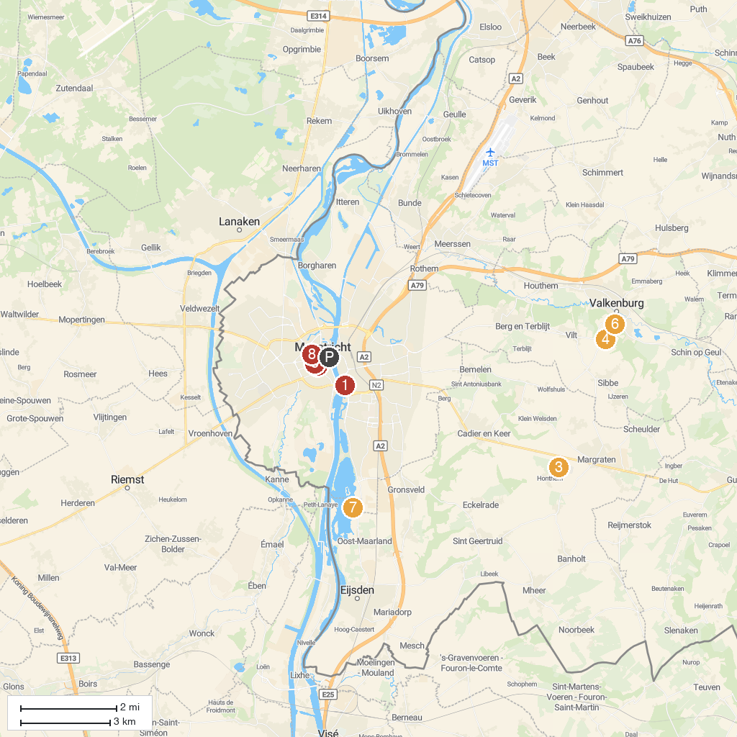
MAP KEY
1. Bonnefanten museum | 5. Treasury St. Servaas
2. Museum aan het Vrijthof | 6. Fluweelengrot (Velvet cave)
3. Netherlands American Cemetery | 7. Fun Valley Maastricht
4. Steenkolenmijn Valkenburg | 8. Marres
P. Cruise port / terminal
Map © MapTiler © OpenStreetMap contributors · cruiseports.org

