Lyttelton, Canterbury, New Zealand
A flooded volcanic crater turned maritime town, Lyttelton punches well above its size — Antarctic expedition history, a thriving arts scene, and the gateway to Christchurch and Banks Peninsula.
⚓ Pier (dedicated cruise berth) · 🕒 Typical call: 8-10 hrs · 💵 NZD · 🗣️ English · 🌿 Strict biosecurity rules
✍️ MY DAY IN PORT (FILL IN)
Ship / Date
In port | arrive ______ · all aboard ______
Booked excursion
Notes / meeting point
GETTING ASHORE
- Docking: Dedicated cruise pier in Inner Harbour; free shuttle to Lyttelton town
- Walk to town: 5-min free shuttle to Norwich Quay, Lyttelton; Christchurch ~30 min by shuttle/bus
- Best For: City exploration, Antarctic history, Banks Peninsula day trips
- Don't Miss: Christchurch Botanic Gardens, Riverside Market, Lyttelton's Bridle Path viewpoint
GETTING AROUND
- 🚕 Taxi: NZ$45–69 — Blue Star Taxis offer a set fare of NZ$45 from Lyttelton to the Christchurch CBD. The trip takes about 20–25 minutes thr
- 📱 Rideshare: ✅ Uber
- 🚌 Hop-on hop-off: ✅
TOP THINGS TO DO
- Christchurch City Tour — Explore the rebuilt city centre — the striking Cardboard (Transitional) Cathedral, the Riverside Market food hall, and the…
- Christchurch Botanic Gardens & Punting — A 30-hectare Victorian garden in the heart of the city.
- Antarctic History & International Antarctic Centre — Lyttelton was the departure point for Scott and Shackleton's Antarctic expeditions.
- Bridle Path Hike to Port Hills — The historic Bridle Path climbs from Lyttelton to the Port Hills ridgeline — the same track early settlers used to reach the…
- Akaroa French Village Day Trip — A 90-minute drive around Banks Peninsula reaches Akaroa — a picturesque village founded by French and British settlers in 1840.
BEST WALKS
- Lyttelton London Street Stroll: 1 km • 20 min • Easy — From the shuttle drop-off at Norwich Quay, walk up Oxford Street to London Street — the heart of…
- Christchurch City Centre Loop: 3 km • 1 hr • Easy — From The Bridge of Remembrance, walk along the Avon River through the Botanic Gardens, past the…
- Bridle Path Viewpoint: 3 km return • 45-60 min • Moderate — From the base of the Bridle Path in Lyttelton, climb the historic track to the Port Hills saddle…
WEATHER · DAYLIGHT · MONEY
Month | High °F | Low °F | Rainy days
May | 58 | 45 | 9
Jul | 52 | 39 | 10
Sep | 57 | 42 | 9
Daylight: May 7:36AM–5:14PM · Jul 7:58AM–5:12PM · Sep 6:31AM–6:17PM
cruiseports.org/lyttelton-christchurch · Confirm terminal & all-aboard time with your ship

Lyttelton, Canterbury, New Zealand — Port Map
Red = walkable sights · Amber = excursions farther out · P = cruise terminal
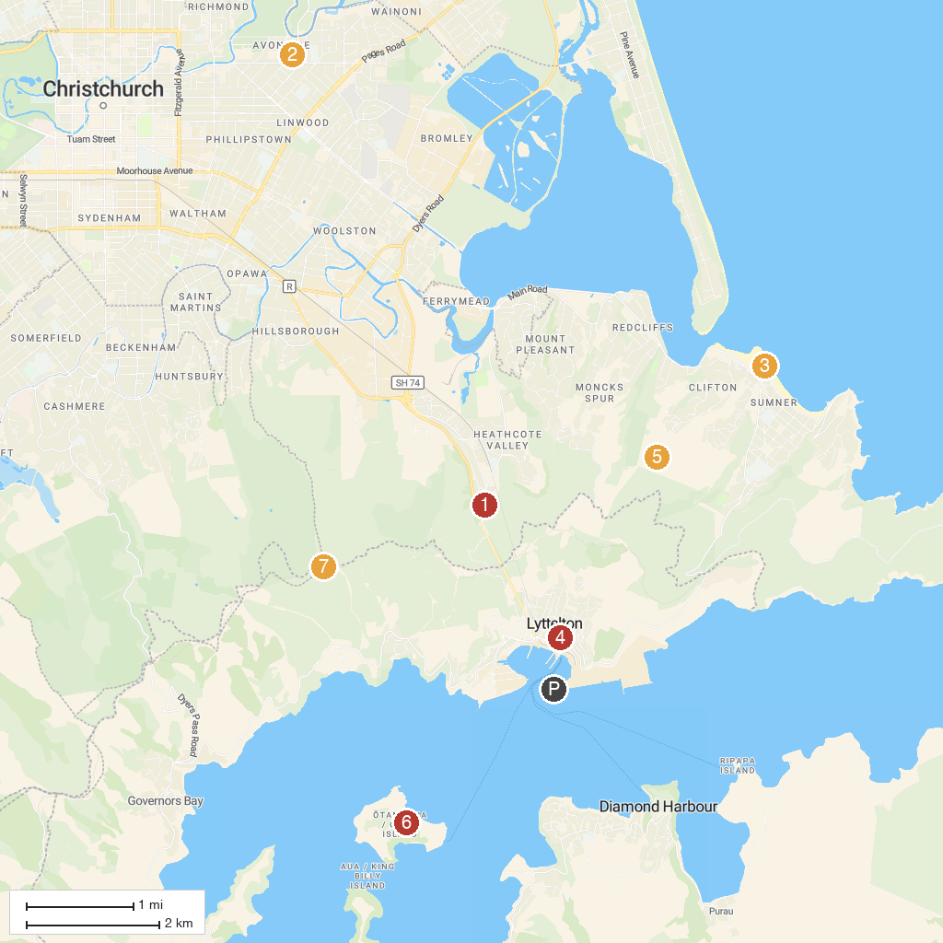
MAP KEY
1. Kate Sheppard House | 5. Lyttelton Farmers Market
2. Christchurch Gondola | 6. Eastenders Track
3. Woodham Park | 7. Quail Island Recreation Reserve
4. Cave Rock / Tuawera | 8. Witch Hill / Te Upoko o Kurī
P. Cruise port / terminal
Map © MapTiler © OpenStreetMap contributors · cruiseports.org

