Lyon, Auvergne-Rhône-Alpes, France
France's undisputed culinary capital sits where the Rhône and Saône rivers meet, its UNESCO-listed Renaissance old town and hilltop basilica rising within easy walking distance of the quay.
⚓ Docked (river quay) · 🕒 Typical call: full day or embark/disembark · 💶 Euro (€) · 🗣️ French
✍️ MY DAY IN PORT (FILL IN)
Ship / Date
In port | arrive ______ · all aboard ______
Booked excursion
Notes / meeting point
GETTING ASHORE
- Docking: River berth at Quai Claude Bernard (Rhône) or Saône quays; all within 10–20 min walk of Vieux-Lyon
- Walk to center: 10–20 min on foot from Quai Claude Bernard to Place Bellecour or Vieux-Lyon
- Best For: Food lovers, history buffs, architecture explorers
- Don't Miss: A traditional bouchon lunch and the funicular up to Fourvière Basilica
GETTING AROUND
- 🚕 Taxi: €10–€20 — Taxis are readily available along the quai. Given the dock's central location, most city-center rides are short and affo
- 📱 Rideshare: ✅ Uber, Bolt
- 🚌 Hop-on hop-off: ✅ Lyon City Tour
TOP THINGS TO DO
- Vieux-Lyon & the Traboules — Europe's largest Renaissance district is a labyrinth of cobbled lanes, Gothic-Roman cathedral, and hidden passageways called…
- Fourvière Hill & Basilica — Ride the historic funicular from Vieux-Lyon to the top of Fourvière Hill, where Lyon's landmark Neo-Byzantine basilica presides…
- Bouchon Lunch & Market Tour — Lyon is the gastronomic capital of France.
- Croix-Rousse Silk District — The Croix-Rousse hillside neighbourhood was once home to Lyon's legendary silk weavers (Canuts).
- Musée des Confluences — Sitting where the Rhône and Saône rivers merge, this striking stainless-steel museum explores science, societies, and natural…
BEST WALKS
- Quai to Vieux-Lyon & Fourvière: 3–4 hrs | Mostly flat + funicular | Free (funicular ~€3.50) — Walk north along Quai Claude Bernard to Pont Bonaparte, cross to the Saône's west bank, enter…
- Presqu'île & Place Bellecour Stroll: 1–2 hrs | Flat | Free — From the Rhône quay, cross into the Presqu'île (the peninsula between the two rivers) and walk up…
WEATHER · DAYLIGHT · MONEY
Month | High °F | Low °F | Rainy days
May | 69 | 51 | 12
Jul | 83 | 63 | 9
Sep | 75 | 57 | 7
Daylight: May 6:09AM–9:05PM · Jul 6:05AM–9:26PM · Sep 7:19AM–7:51PM
cruiseports.org/lyon · Confirm terminal & all-aboard time with your ship

Lyon, Auvergne-Rhône-Alpes, France — Port Map
Red = walkable sights · Amber = excursions farther out · P = cruise terminal
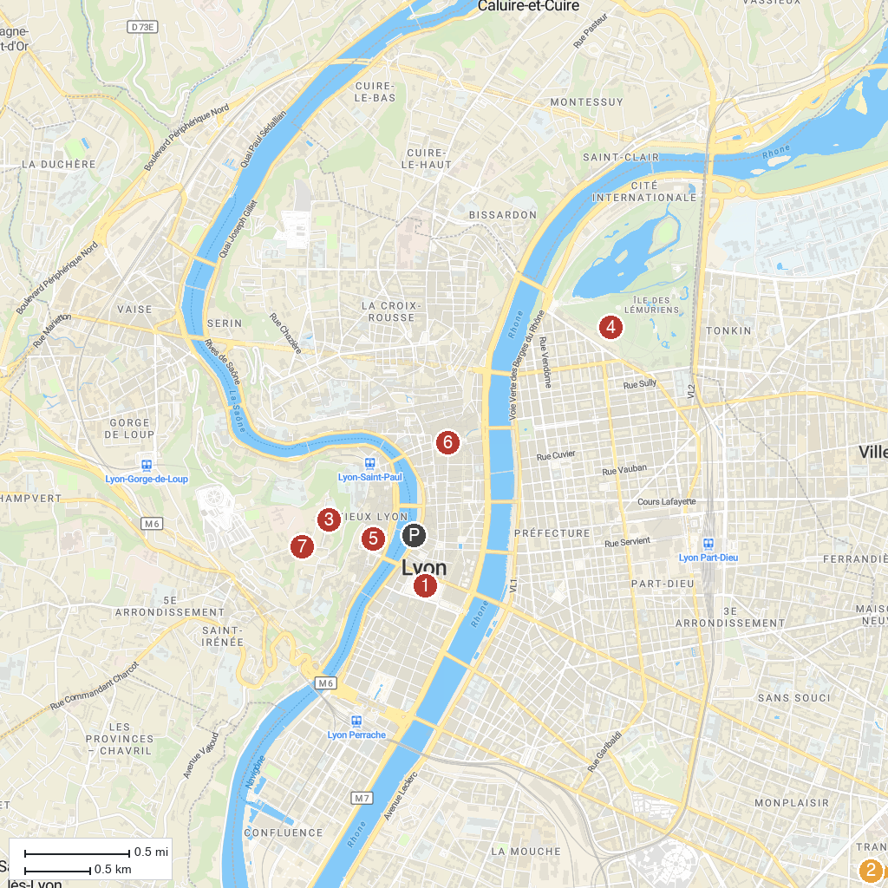
MAP KEY
1. Place Bellecour | 5. Cathédrale Saint-Jean-Baptiste
2. Great Mosque of Lyon | 6. Hôtel de Ville de Lyon
3. Basilica of Notre Dame of Fourvière | 7. Gallo-Roman Museum of Lyon-Fourvière
4. Parc de la Tête d'Or
P. Cruise port / terminal
Map © MapTiler © OpenStreetMap contributors · cruiseports.org

