Lyngseidet, Troms, Norway
Where the Lyngen Alps plunge straight into an Arctic fjord. Lyngseidet is a small, authentic Norwegian village backed by snow-capped peaks — an expedition favourite for hikers, kayakers, and anyone chasing the midnight sun.
⚓ Tender or small quay · 🕒 Typical call: 6-8 hrs · 💵 NOK (cards everywhere — Norway is nearly cashless) · 🗣️ Norwegian · 🌞 Midnight Sun (May–Jul) / Northern Lights (Sep–Apr)
✍️ MY DAY IN PORT (FILL IN)
Ship / Date
In port | arrive ______ · all aboard ______
Booked excursion
Notes / meeting point
GETTING ASHORE
- Docking: Small quay or tender; most expedition ships use the ferry pier
- Walk to centre: Village centre is right at the pier — 2 min walk
- Best For: Hiking, fjord scenery, whisky distillery, Arctic photography
- Don't Miss: Lyngentrappa — 1,200 steps to a 468 m viewpoint over the fjord
GETTING AROUND
- 🚕 Taxi: NOK 100–200 (~$9–18 USD) for short trips — Local taxis are available for trips around Lyngen municipality. Norwegian taxis charge a base fare of ~NOK 100 plus ~NOK
TOP THINGS TO DO
- Lyngentrappa — The Lyngen Stairs — Hike 1,200 steps (completed 2022) from the fjord shore up to 'Verdens Ende' (World's End) at 468 m.
- Lyngenfjord Kayak — Guided sea-kayak tours paddle beneath the peaks of the Lyngen Alps with reflections of glaciers and snow-capped summits in the…
- Aurora Spirit Distillery Visit — Located 12 km north of Lyngseidet, this is the world's northernmost whisky distillery.
- Fjord Fishing & Wildlife Cruise — Head out on Lyngenfjord to fish for cod, haddock, and coalfish while scanning for sea eagles, porpoises, and — in season…
- Lyngen Church & Village Walk — Lyngen Church (1782, on a site used since c.1740) is one of northern Norway's oldest churches.
BEST WALKS
- Village Centre Stroll: 30 min · Flat · Free — From the pier, walk to Gollis (the 9 m Santa Claus statue), Prestelvparken, Lyngen Church, and the…
- Lyngentrappa Staircase: 2-4 hrs return · Strenuous · Free — Start at the Lyngentrappa trailhead near the waterfront and climb 1,200 steps to the 468 m…
WEATHER · DAYLIGHT · MONEY
Month | High °F | Low °F | Rainy days
May | 46 | 36 | 15
Jul | 64 | 53 | 13
Sep | 52 | 44 | 18
Daylight: Sep 5:53AM–7:12PM
cruiseports.org/lyngseidet · Confirm terminal & all-aboard time with your ship

Lyngseidet, Troms, Norway — Port Map
Red = walkable sights · Amber = excursions farther out · P = cruise terminal
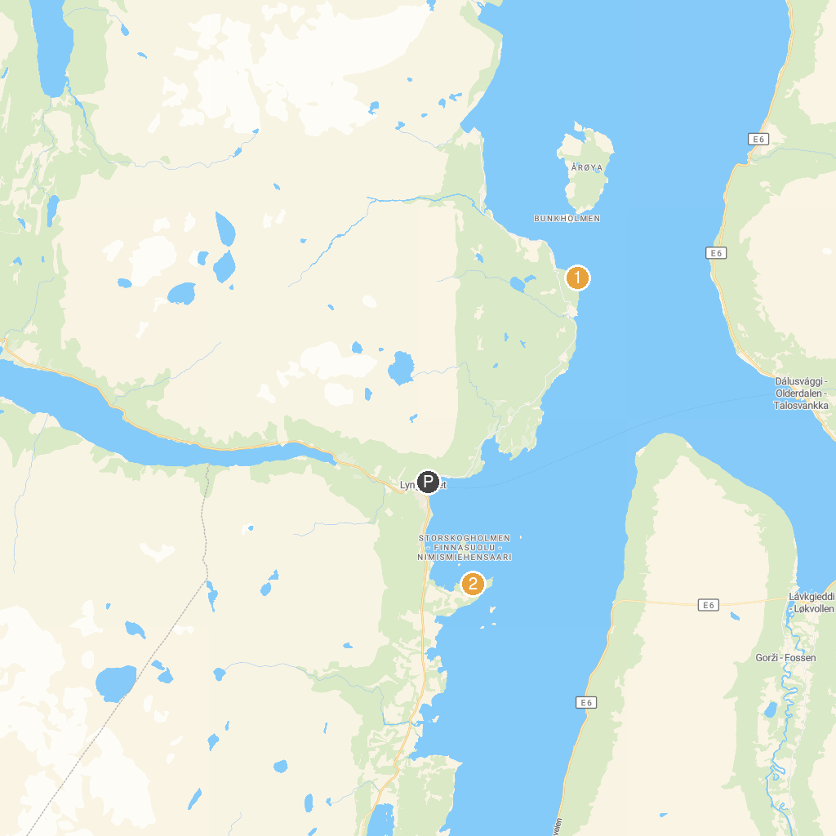
MAP KEY
1. Aurora Spirit as | 3. Hotell Savoy
2. Team Lyngen Tours
P. Cruise port / terminal
Map © MapTiler © OpenStreetMap contributors · cruiseports.org

