Luxor, Luxor Governorate, Egypt
Built on the ruins of ancient Thebes, Luxor is Egypt's crown jewel — the Valley of the Kings, Karnak Temple, and the Avenue of Sphinxes await across the same landscape where pharaohs once ruled the world.
⚓ Docked (Nile East Bank Corniche — or via Safaga if ocean cruise) · 🕒 Typical call: 1-3 days (Nile cruise) / full shore day (from Safaga) · 💵 Egyptian Pound (cards accepted at major sites) · 🗣️ Arabic (English widely spoken at tourist sites)
✍️ MY DAY IN PORT (FILL IN)
Ship / Date
In port | arrive ______ · all aboard ______
Booked excursion
Notes / meeting point
GETTING ASHORE
- Docking: Nile cruises dock at the East Bank Corniche in central Luxor; ocean cruises dock at Safaga Port (~3-4 hrs by road)
- Walk to center: Nile arrivals: Luxor Temple 5-20 min walk; Karnak too far (taxi/caleche). Safaga arrivals: bus transfers only
- Best For: Valley of the Kings, Karnak Temple Complex, hot air balloon over the West Bank at sunrise
- Don't Miss: The Mortuary Temple of Hatshepsut and the Avenue of Sphinxes lit up at night
GETTING AROUND
- 🚕 Taxi: EGP 30–100 (~$1–3 USD) — Taxis are plentiful at the cruise mooring on the East Bank, just minutes from Luxor Temple and the town center. Agree on
TOP THINGS TO DO
- Valley of the Kings — The burial ground of New Kingdom pharaohs for over 500 years, including Tutankhamun, Ramses the Great, and Seti I.
- Karnak Temple Complex — The largest religious complex ever built, covering over 200 acres and developed by successive pharaohs for 2,000 years.
- Mortuary Temple of Hatshepsut — Built into sheer desert cliffs at Deir el-Bahari, Hatshepsut's three-tiered temple is one of Egypt's most architecturally…
- Sunrise Hot Air Balloon over the West Bank — Luxor is one of the world's premier ballooning destinations.
- Luxor Temple & Avenue of Sphinxes — The East Bank temple dedicated to the god Amun sits in the center of the city and connects to Karnak via the restored 2.7 km…
BEST WALKS
- East Bank Corniche to Luxor Temple: 0.5-2 km · 15-30 min · Flat paved promenade — From the Nile dock, walk south along the Corniche waterfront boulevard to Luxor Temple entrance.
- West Bank Self-Guided Loop (by car/bike): 10-15 km circuit · Half-day · Flat desert road — Cross to the West Bank via ferry or taxi, then circuit the key monuments: Colossi of Memnon (free…
WEATHER · DAYLIGHT · MONEY
Month | High °F | Low °F | Rainy days
May | 102 | 73 | 0
Jul | 106 | 80 | 0
Sep | 103 | 76 | 0
Daylight: May 6:04AM–7:27PM · Jul 6:07AM–7:42PM · Sep 6:35AM–6:53PM
cruiseports.org/luxor · Confirm terminal & all-aboard time with your ship

Luxor, Luxor Governorate, Egypt — Port Map
Red = walkable sights · Amber = excursions farther out · P = cruise terminal
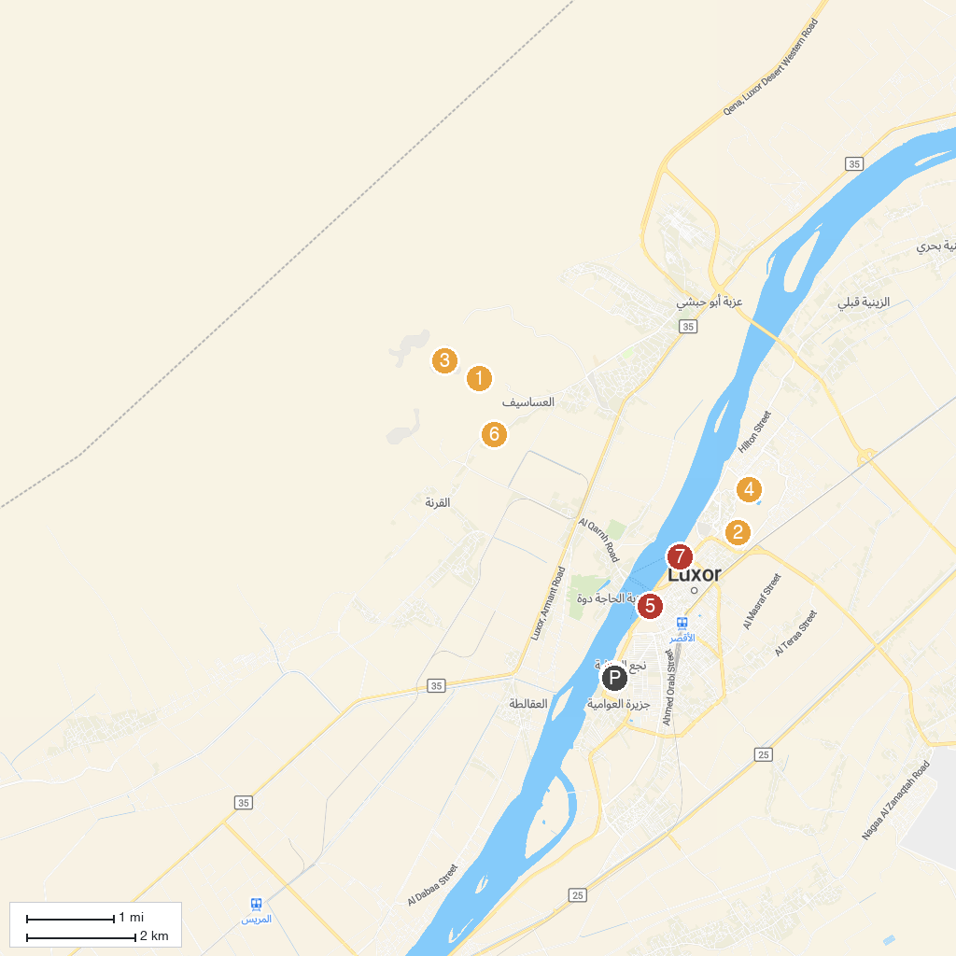
MAP KEY
1. Deir el-Bahari | 5. Luxor Temple
2. Mut Temple | 6. Ramesseum
3. Valley of the Kings | 7. Luxor Museum
4. Karnak | 8. Magic Horizon Balloons, Luxor
P. Cruise port / terminal
Map © MapTiler © OpenStreetMap contributors · cruiseports.org

