Lundy Island, Devon, England
A granite outcrop in the Bristol Channel where puffins nest on windswept cliffs, Atlantic grey seals haul out on rocky shores, and a pub that never locks its doors waits at the top of a steep hill. Lundy is remote, raw, and completely car-free.
⚓ Tender only (no pier for cruise ships) · 🕒 Typical call: 4–6 hrs · 💷 Currency: British Pound (GBP) · 🗣️ Language: English · 🌊 Weather-dependent landing
✍️ MY DAY IN PORT (FILL IN)
Ship / Date
In port | arrive ______ · all aboard ______
Booked excursion
Notes / meeting point
GETTING ASHORE
- Docking: Tender to Beach Jetty — anchor in Lundy Roads
- Walk to village: ~0.6 mi uphill from jetty (15–25 min, steep)
- Best For: Wildlife, walking, digital detox, history
- Don't Miss: Marisco Tavern & mailing a postcard with a Lundy stamp
GETTING AROUND
- 📱 Rideshare: ❌ not available
TOP THINGS TO DO
- Puffin Watching at Jenny's Cove — Walk the west coast path to Jenny's Cove to spot Atlantic puffins nesting in cliff burrows.
- Seal Spotting at Landing Bay — Atlantic grey seals are resident year-round and frequently haul out on the rocks near the jetty.
- Marisco Castle & Old Light — The 13th-century Marisco Castle was built by Henry III to repel pirates.
- West Coast Cliff Walk — Follow the western cliff path for dramatic Atlantic views and to look for Lundy Cabbage — a yellow-flowered plant that exists…
- Lundy Stamp Post Office — Buy a postcard at the General Store, attach a Lundy island stamp alongside a Royal Mail stamp, and post it from the island's red…
BEST WALKS
- Jetty to Village & Marisco Tavern: 0.6 mi · 15–25 min · Steep climb — The essential walk for every visitor.
- Village to Old Light Lighthouse: 0.5 mi · 10–15 min · Easy — From the village, walk north along the ridge to the 1819 Old Light lighthouse at the island's…
- West Coast Cliff Walk to Jenny's Cove: ~2 mi one-way · 45–60 min · Moderate — Head west from the village across the plateau then follow the cliff path north to Jenny's Cove…
WEATHER · DAYLIGHT · MONEY
Month | High °F | Low °F | Rainy days
May | 53 | 50 | 10
Jul | 61 | 58 | 11
Sep | 61 | 58 | 14
Daylight: May 5:28AM–9:02PM · Jul 5:21AM–9:27PM · Sep 6:54AM–7:32PM
cruiseports.org/lundy-island-england · Confirm terminal & all-aboard time with your ship

Lundy Island, Devon, England — Port Map
Red = walkable sights · Amber = excursions farther out · P = cruise terminal
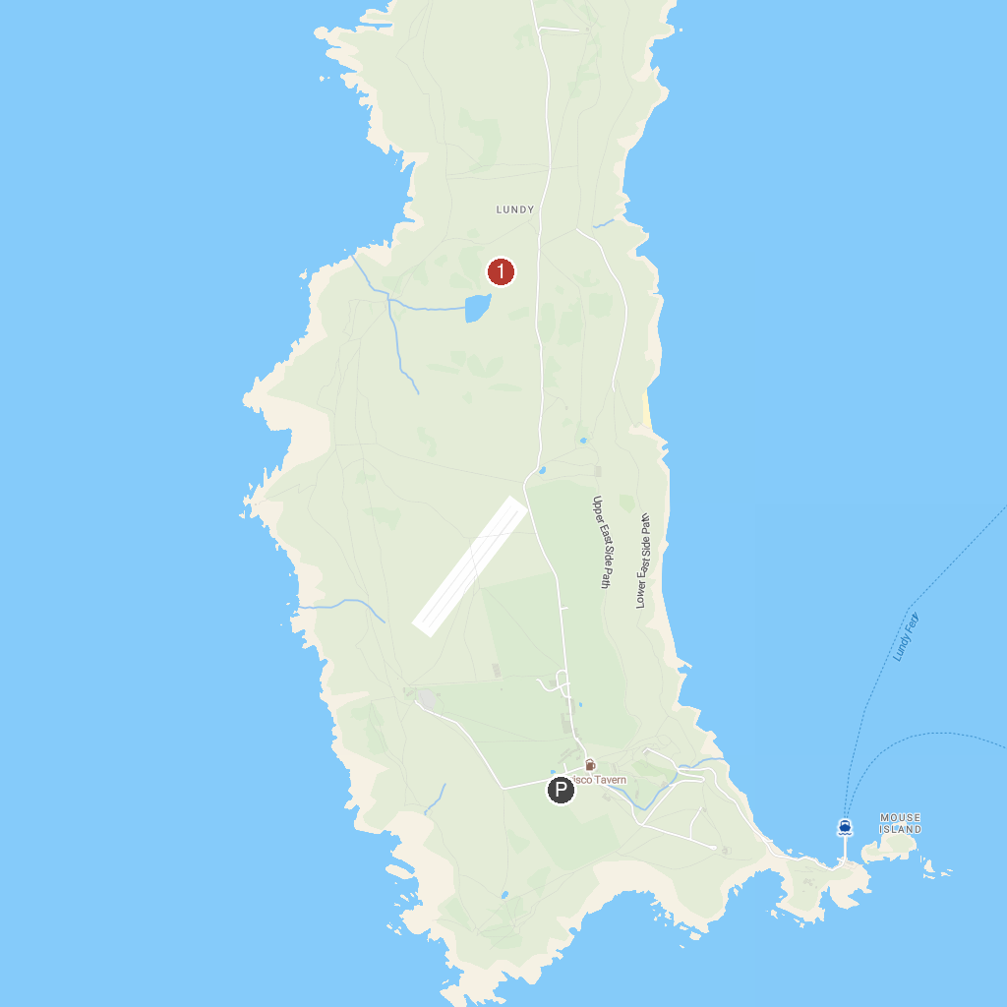
MAP KEY
1. Lundy Heritage Coast | 2. National Trust - Lundy
P. Cruise port / terminal
Map © MapTiler © OpenStreetMap contributors · cruiseports.org

