Luleå, Norrbotten, Sweden
Sweden's northern capital sits just below the Arctic Circle, where a UNESCO-listed church town, world-class caviar, and near-endless summer daylight greet cruise passengers stepping ashore.
⚓ Pier (Södra Hamn or Svartön Quay) · 🕒 Typical call: 8-10 hrs · 💵 SEK (cards accepted everywhere — Sweden is nearly cashless) · 🗣️ Swedish / English widely spoken · 🌞 Midnight sun in June–July
✍️ MY DAY IN PORT (FILL IN)
Ship / Date
In port | arrive ______ · all aboard ______
Booked excursion
Notes / meeting point
GETTING ASHORE
- Docking: Pier — Södra Hamn (central, small/mid ships) or Svartön Quay (larger ships, bus/taxi to center). Note: Svartön unavailable May–Nov 2024–2028.
- Walk to Center: 0–5 min from Södra Hamn; 10–15 min by taxi/bus from Svartön Quay
- Best For: UNESCO heritage, Sami culture, Arctic cuisine, summer nature
- Don't Miss: Gammelstad Church Town (UNESCO) — take Bus #9 from city center
GETTING AROUND
- 🚕 Taxi: 100–200 SEK (~€9–18) — Local taxis (MinTaxi Norrbotten, Sverige Taxi Luleå) are readily available. Base fare ~75 SEK plus ~15 SEK/km; a short c
TOP THINGS TO DO
- Gammelstad Church Town (UNESCO) — Sweden's best-preserved church town: over 400 red wooden cottages clustered around a 15th-century stone church (Nederluleå…
- Norrbottens Museum — Free regional museum covering northern Swedish history from Viking-era settlers to the indigenous Sami people.
- Luleå Archipelago by Boat — The Gulf of Bothnia's 1,300-island archipelago offers tranquil fishing villages and wildlife.
- Gammelstadsviken Nature Reserve — A prime birdwatching site adjacent to Gammelstad Church Town, recognized as one of Sweden's best migration hotspots.
- Arctic Flavors: Kalix Caviar & Reindeer — Luleå lies within the home region of Kalix Löjrom — Sweden's first EU protected-origin (PDO) caviar, harvested from vendace in…
BEST WALKS
- City Center Loop: 2 km · ~45 min · flat paved — Start at Södra Hamn, walk north along the waterfront to Luleå Cathedral (red-brick Neo-Gothic…
- Gültzauudden Beach Walk: 3 km one-way · ~40 min · flat paths — Head south from the harbor along the waterfront trail through the pine forest park to Gültzauudden…
WEATHER · DAYLIGHT · MONEY
Month | High °F | Low °F | Rainy days
May | 50 | 38 | 10
Jul | 67 | 56 | 11
Sep | 55 | 47 | 10
Daylight: Sep 5:52AM–6:58PM
cruiseports.org/lulea · Confirm terminal & all-aboard time with your ship

Luleå, Norrbotten, Sweden — Port Map
Red = walkable sights · Amber = excursions farther out · P = cruise terminal
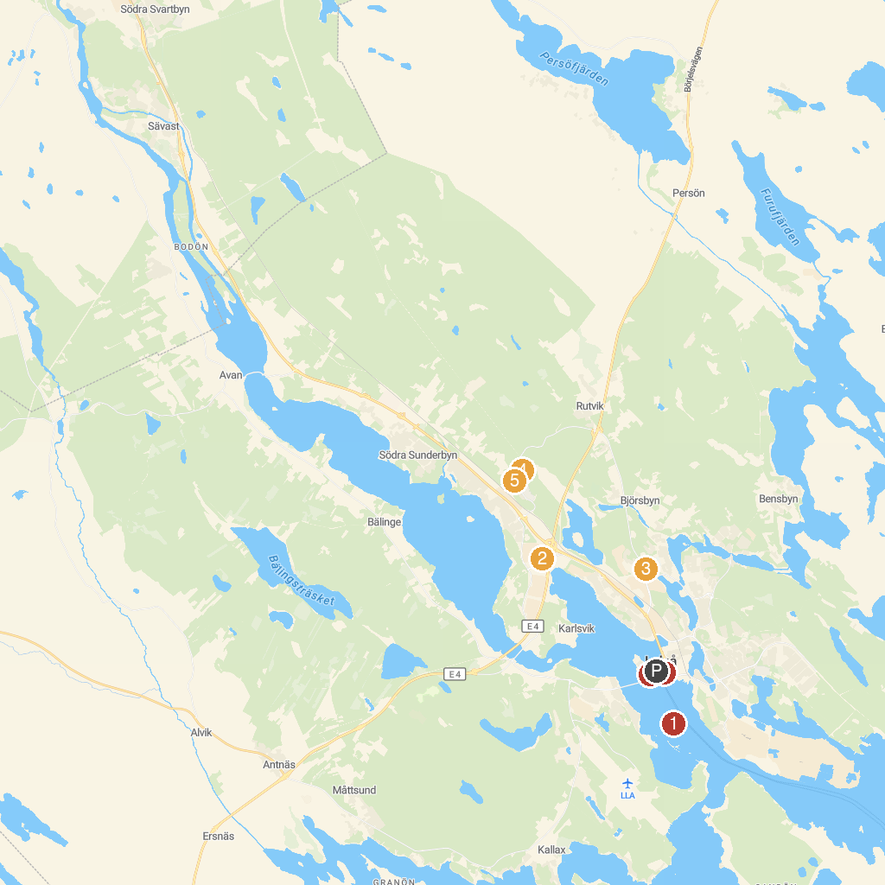
MAP KEY
1. Gråsjälören | 5. Friluftsmuseet Hägnan
2. 360 Trampoline Center | 6. Gammelstad Church Town
3. Bälingeberget | 7. Norrbottens museum
4. Teknikens Hus | 8. Luleå Cathedral
P. Cruise port / terminal
Map © MapTiler © OpenStreetMap contributors · cruiseports.org

