Ludwigsburg, Baden-Württemberg, Germany
Ludwigsburg is Germany's Baroque showpiece — a planned royal city of 452-room palaces, gilded gardens, and Swabian comfort food. Neckar River cruises dock here for a city that WWII left virtually untouched.
⚓ Docked (Hoheneck pier) · 🕒 Typical call: 6-8 hrs · 💶 Euro (€) · 🗣️ German · 🎃 World's largest Pumpkin Festival (Aug–Nov)
✍️ MY DAY IN PORT (FILL IN)
Ship / Date
In port | arrive ______ · all aboard ______
Booked excursion
Notes / meeting point
GETTING ASHORE
- Docking: River pier at Ludwigsburg-Hoheneck, ~3 km from city center
- Walk to center: 35-40 min walk or 10-min bus/€12 taxi
- Best For: Baroque architecture, palace gardens, Swabian cuisine
- Don't Miss: Residenzschloss palace tour and Blühendes Barock gardens
GETTING AROUND
- 🚕 Taxi: €10–€15 — Taxis are available at the pier and nearby stands. Expect €10–€15 to Ludwigsburg Palace or city center; agree on fare or
- 📱 Rideshare: ✅ Uber
TOP THINGS TO DO
- Residenzschloss Palace Guided Tour — One of Europe's largest Baroque palaces with 452 rooms across 18 buildings.
- Blühendes Barock Gardens & Fairy-Tale Garden — The sweeping Baroque gardens surrounding the palace feature geometric flowerbeds, an aviary, and the beloved Märchengarten — an…
- Pumpkin Festival (Kürbisausstellung) — The world's largest pumpkin festival transforms the palace gardens with 450,000+ pumpkins crafted into giant sculptures, plus a…
- Schloss Favorite & Favoritepark — A charming Baroque hunting lodge (built 1717–1723) set inside a 72-hectare wildlife park where fallow deer roam freely.
- Swabian Food & Wine Tasting — Ludwigsburg sits in the heart of Swabia, home to Maultaschen (Swabian ravioli), Kässpätzle (cheese noodles), and the Neckar…
BEST WALKS
- Palace to Marktplatz Loop: 1.5 km · 25 min · flat — From the Residenzschloss, walk south through the formal garden forecourt to the Marktplatz…
- Palace to Schloss Favorite via Favoritepark: 1.2 km · 15 min · easy — Follow the shaded park path north from the main palace through Favoritepark — watch for…
WEATHER · DAYLIGHT · MONEY
Month | High °F | Low °F | Rainy days
May | 66 | 48 | 13
Jul | 78 | 60 | 11
Sep | 70 | 53 | 9
Daylight: May 5:41AM–8:58PM · Jul 5:36AM–9:21PM · Sep 7:00AM–7:35PM
cruiseports.org/ludwigsburg · Confirm terminal & all-aboard time with your ship

Ludwigsburg, Baden-Württemberg, Germany — Port Map
Red = walkable sights · Amber = excursions farther out · P = cruise terminal
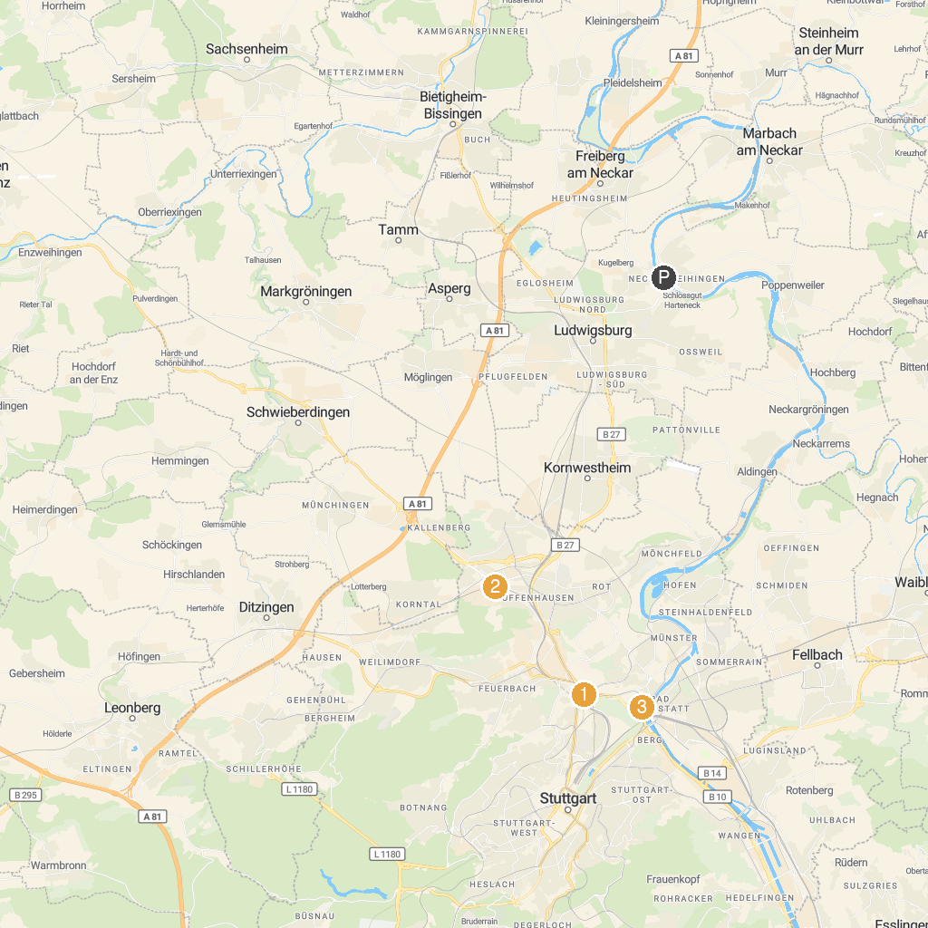
MAP KEY
1. Neues Schloss Stuttgart | 5. Wilhelma - Zoological-botanical garden
2. Leibfriedscher Garten | 6. Linden Museum Stuttgart
3. Mercedes-Benz Museum | 7. Staatsgalerie Stuttgart
4. Porsche Museum | 8. The Staatstheater Stuttgart
P. Cruise port / terminal
Map © MapTiler © OpenStreetMap contributors · cruiseports.org

