Lüderitz, Namibia
A surreal pocket of German colonial history marooned on the Namib Desert coast — where Art Nouveau churches face jackass penguins and a sand-buried ghost town waits 10 km away.
⚓ Docked (small harbor) · 🕒 Typical call: 7-9 hrs · 💵 Namibian Dollar (NAD) / South African Rand · 🗣️ Afrikaans, German, English · 🏜️ Desert coast
✍️ MY DAY IN PORT (FILL IN)
Ship / Date
In port | arrive ______ · all aboard ______
Booked excursion
Notes / meeting point
GETTING ASHORE
- Docking: Pier in Lüderitz Harbour — ships usually berth alongside (occasionally anchor and tender); small port, no gangway bus needed
- Walk to center: 5-10 min on foot from the pier to Bismarck Street and the town center
- Best For: History buffs, photographers, wildlife lovers, and anyone who finds a diamond ghost town irresistible
- Don't Miss: Kolmanskop ghost town — sand-filled rooms, Art Deco ruin, and an eerie silence 10 km inland
GETTING AROUND
- 🚕 Taxi: NAD 50–150 (negotiated) — Local taxis gather near the port gate on cruise days. Fares are negotiated flat rates — always agree on a price before g
TOP THINGS TO DO
- Kolmanskop Ghost Town — A diamond-rush boomtown abandoned in the 1950s, now half-swallowed by sand dunes.
- Halifax Island Penguin Cruise — A short boat trip into the sheltered lagoon reveals Halifax Island — home to a substantial African (jackass) penguin colony.
- Colonial Architecture Walking Tour — Lüderitz preserves Germany's only intact colonial-era townscape outside Europe.
- Diaz Point & Bogenfels Excursion — Diaz Cross marks where Portuguese explorer Bartolomeu Dias landed in 1488.
- Namib Desert Dune Drive — Head inland to the edge of the Sperrgebiet (Forbidden Diamond Area) for dramatic dune landscapes.
BEST WALKS
- Colonial Town Stroll: 1-2 km · 45-60 min · Easy — From the harbor gate, walk up Bismarck Street past the Woermannhaus (a handsome 1909 colonial…
- Shark Island Causeway Walk: 2 km round-trip · 30-40 min · Easy — A causeway connects the town to Shark Island, a rocky peninsula with sweeping views of the bay…
WEATHER · DAYLIGHT · MONEY
Month | High °F | Low °F | Rainy days
May | 71 | 55 | 0
Jul | 69 | 52 | 1
Sep | 68 | 52 | 0
Daylight: May 7:31AM–6:19PM · Jul 7:47AM–6:23PM · Sep 6:56AM–6:52PM
cruiseports.org/luderitz · Confirm terminal & all-aboard time with your ship

Lüderitz, Namibia — Port Map
Red = walkable sights · Amber = excursions farther out · P = cruise terminal
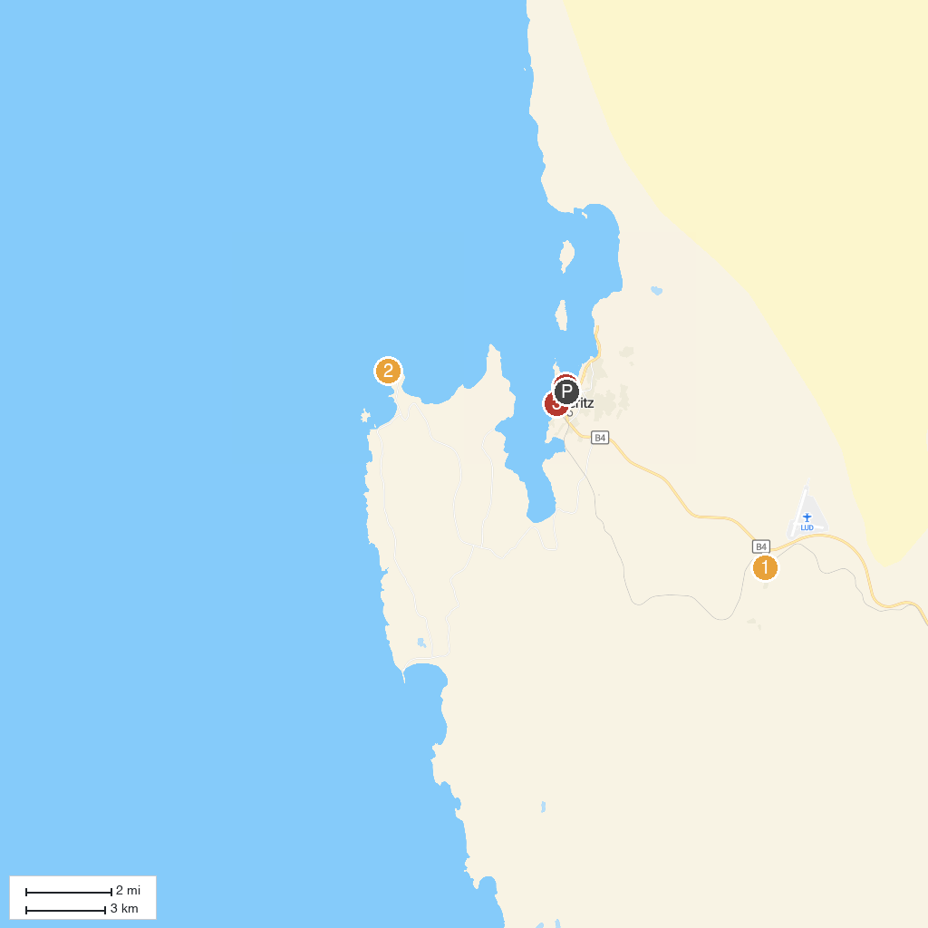
MAP KEY
1. Kolmanskop | 3. Lüderitz Museum
2. Site of Original Dias Cross | 4. Robert Harbour
P. Cruise port / terminal
Map © MapTiler © OpenStreetMap contributors · cruiseports.org

