Luang Prabang, Luang Prabang Province, Laos
A UNESCO-listed riverside town where gilded temples, saffron-robed monks, and the slow Mekong conspire to slow everything down. One of Southeast Asia's most serene river ports.
⚓ River docking (mooring on Mekong banks) · 🕒 Typical call: full day or overnight · 💵 Lao Kip (USD & Thai Baht accepted) · 🗣️ Lao (English spoken in tourist areas) · 🏛️ UNESCO World Heritage Site
✍️ MY DAY IN PORT (FILL IN)
Ship / Date
In port | arrive ______ · all aboard ______
Booked excursion
Notes / meeting point
GETTING ASHORE
- Docking: River banks — floating pontoon or steps; luxury ships moor in town center
- Walk to center: 0–5 min from town-center mooring; 3–5 km from outer piers (tuk-tuk)
- Best For: Temple-hopping, morning alms ceremony, Kuang Si Falls, Mekong boat trips
- Don't Miss: Tak Bat alms-giving at sunrise and Wat Xieng Thong at the peninsula tip
GETTING AROUND
- 📱 Rideshare: ❌ not available
TOP THINGS TO DO
- Tak Bat — Morning Alms Ceremony — Watch hundreds of saffron-robed monks file silently through the streets at sunrise collecting offerings of sticky rice.
- Wat Xieng Thong & Royal Palace Museum — Luang Prabang's most beautiful temple sits at the tip of the peninsula — sweeping roofs nearly touch the ground, with a famous…
- Kuang Si Waterfalls — Stunning three-tiered turquoise limestone waterfalls about 30 km (45 min) southwest of town, with natural swimming pools and the…
- Pak Ou Caves by Longtail Boat — Two riverside limestone caves packed with thousands of Buddha statues, 2 hours upstream from town by longtail boat.
- Mount Phousi Sunrise or Sunset — Climb 328 steps to the summit of Mount Phousi for panoramic 360° views of the town, the Mekong, and the Nam Khan River merging in…
BEST WALKS
- Peninsula Temple & Palace Loop: ~2.5 km · 45–60 min · Flat — The essential Luang Prabang walk.
- Bamboo Bridge & Nam Khan Riverbank: ~1.5 km · 30 min · Easy — During dry season (Nov–Apr), cross the famous seasonal bamboo footbridge over the Nam Khan River…
WEATHER · DAYLIGHT · MONEY
Month | High °F | Low °F | Rainy days
May | 93 | 75 | 18
Jul | 88 | 75 | 26
Sep | 86 | 74 | 24
Daylight: May 5:35AM–6:39PM · Jul 5:40AM–6:53PM · Sep 5:58AM–6:14PM
cruiseports.org/luang-prabang · Confirm terminal & all-aboard time with your ship

Luang Prabang, Luang Prabang Province, Laos — Port Map
Red = walkable sights · Amber = excursions farther out · P = cruise terminal
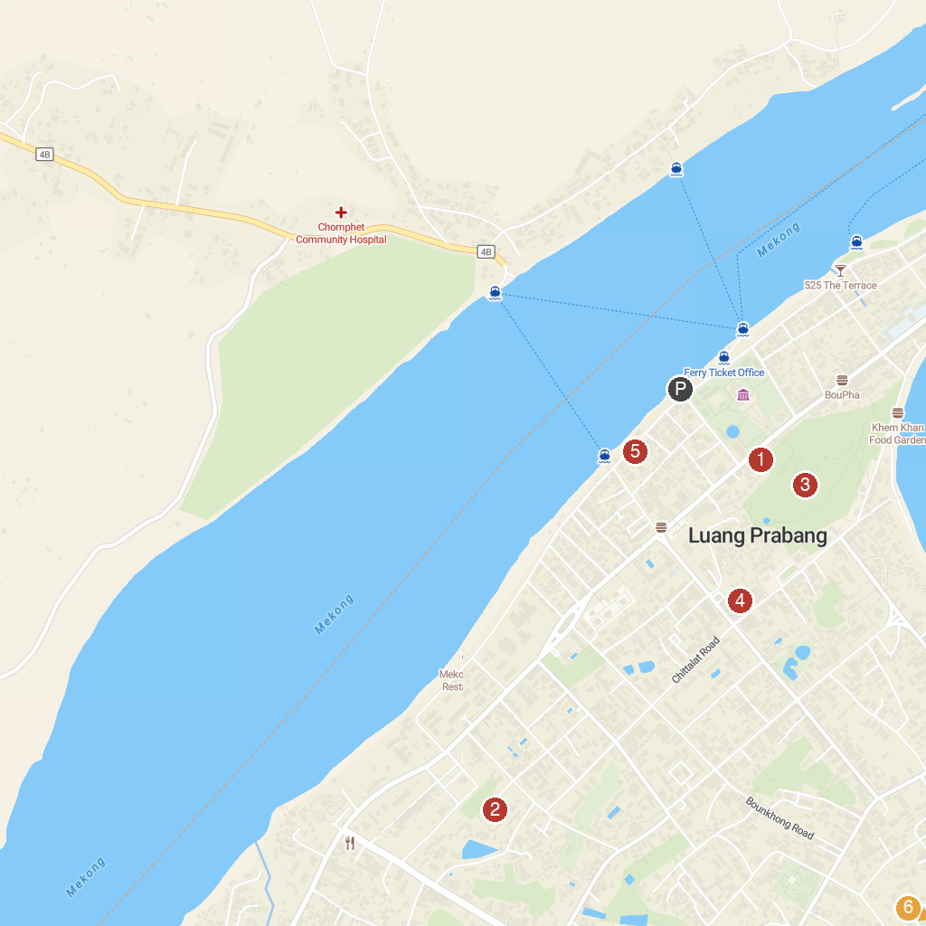
MAP KEY
1. Wat Pa Huak | 4. Dara Market
2. Wat That Luang | 5. Elephant Conservation Center office, Luang Prabang
3. Wat Chom Si | 6. Tat Sae Waterfalls
P. Cruise port / terminal
Map © MapTiler © OpenStreetMap contributors · cruiseports.org

