Luanda, Angola, Africa
Angola's sprawling capital crashes colonial architecture into oil-boom skyscrapers on a crescent Atlantic bay — one of West Africa's most raw and rewarding port calls.
⚓ Pier (commercial port) · 🕒 Typical call: 8-10 hrs · 💵 USD / Angolan Kwanza (AOA) · 🗣️ Portuguese · 🌍 West Africa
✍️ MY DAY IN PORT (FILL IN)
Ship / Date
In port | arrive ______ · all aboard ______
Booked excursion
Notes / meeting point
GETTING ASHORE
- Docking: Commercial pier, Porto de Luanda — shuttle required to city
- Walk to centre: Not walkable from port; shuttle or taxi to Marginal (~10 min)
- Best For: Colonial history, bay views, vibrant African street life
- Don't Miss: Fortaleza de São Miguel & Ilha de Luanda beach strip
GETTING AROUND
- 🚕 Taxi: $4–10 USD — Street taxis are plentiful but unmetered — agree on fare before you get in. Pay in Angolan Kwanza (cash preferred); USD
- 📱 Rideshare: ✅ Bolt, Yango, Heetch
TOP THINGS TO DO
- Fortaleza de São Miguel & Historic Baixa — Climb to the 1576 Portuguese fort crowning the hill above the bay for sweeping panoramic views over Luanda and the Ilha.
- Palácio de Ferro & Old Town Walk — See the striking iron pavilion attributed to Eiffel's workshop, then explore the Nossa Senhora dos Remédios church (1650s) and…
- Ilha de Luanda Beach Club — The Ilha is a 5-mile sand spit just minutes from the port.
- Agostinho Neto Mausoleum (The Sputnik) — Angola's most dramatic landmark — a futuristic space-age obelisk housing the tomb and museum of the country's first president.
- Miradouro da Lua (Moon Lookout) — An hour south of the city, eroded sandstone cliffs have sculpted an eerily lunar landscape of jagged pillars and ridges — a…
BEST WALKS
- The Marginal Waterfront Stroll: 1.5 km • Flat • 20-30 min — From the shuttle drop near Avenida 4 de Fevereiro, walk the bay-side palm-lined promenade past…
- Baixa (Old Town) Heritage Loop: 2 km • Flat • 45 min • Best with a guide — A compact loop past the Palácio de Ferro, Igreja de Nossa Senhora dos Remédios, and the colourful…
WEATHER · DAYLIGHT · MONEY
Month | High °F | Low °F | Rainy days
May | 86 | 74 | 3
Jul | 78 | 65 | 0
Sep | 80 | 69 | 1
Daylight: May 6:12AM–5:54PM · Jul 6:23AM–6:02PM · Sep 6:00AM–6:03PM
cruiseports.org/luanda · Confirm terminal & all-aboard time with your ship

Luanda, Angola, Africa — Port Map
Red = walkable sights · Amber = excursions farther out · P = cruise terminal
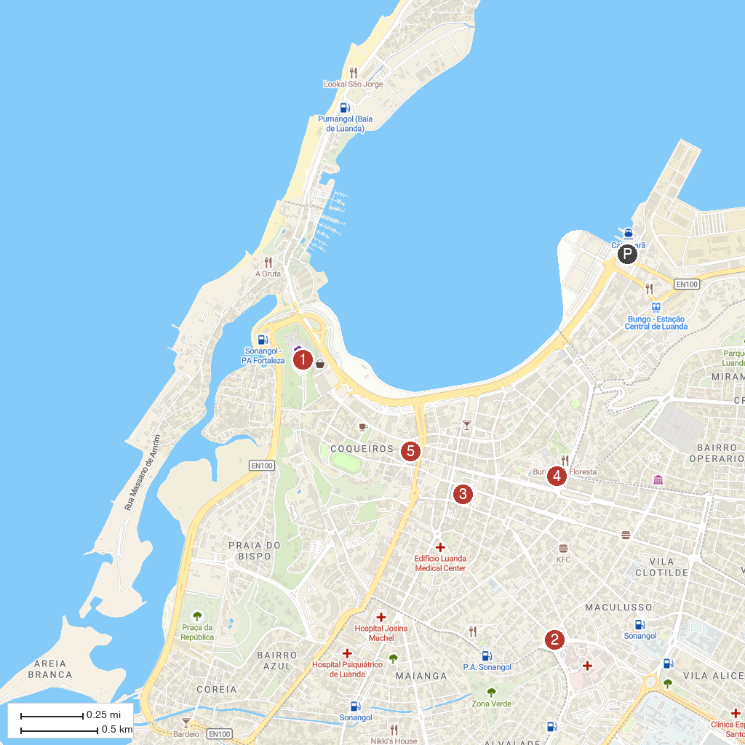
MAP KEY
1. Fortress of São Miguel. | 4. Museum of Natural History
2. Holy Family Church | 5. Church of Our Lady of Remedies
3. Church of Carmo
P. Cruise port / terminal
Map © MapTiler © OpenStreetMap contributors · cruiseports.org

