Lovango Cay, US Virgin Islands
A 118-acre private island anchored in Pillsbury Sound between St. Thomas and St. John, Lovango Cay trades cruise-ship crowds for a solar-powered beach club, a 70-foot infinity pool, and some of the USVI's best snorkeling right off the dock.
⚓ Tender only (no pier) · 🕒 Typical call: 5–8 hrs · 💵 USD (cashless island) · 🗣️ English · 🌿 Eco-resort private island
✍️ MY DAY IN PORT (FILL IN)
Ship / Date
In port | arrive ______ · all aboard ______
Booked excursion
Notes / meeting point
GETTING ASHORE
- Docking: Tender from anchored ship to Lovango Resort Dock
- Walk to center: Everything within 5 min of the dock
- Best For: Beach club days, snorkeling, escape from big-ship crowds
- Don't Miss: Infinity pool overlook, Congo Cay snorkel, North Beach hike
GETTING AROUND
- 📱 Rideshare: ❌ not available
TOP THINGS TO DO
- Infinity Pool & Beach Club Day — The centrepiece of Lovango is a 70-foot infinity pool perched above South Beach, with loungers, cabanas, and full bar service.
- Congo Cay Snorkel Safari — A short boat transfer reaches Congo Cay, a protected bird sanctuary to the north of Lovango with a pristine barrier reef.
- Island Viewpoint Hike — A self-guided trail climbs to the island's highest point for 360° views of St.
- North Beach (Crescent Beach) — A short hike across the island leads to the wilder North Beach (Crescent Beach).
- Waterfront Dining at The Sand Bar — Skip the fine-dining reservation and pull up a stool at The Sand Bar for wood-fired pizza, tacos, and frozen rum drinks with your…
BEST WALKS
- Dock to Viewpoint Loop: 1.5 km • ~45 min • Easy–moderate — From the Lovango Resort Dock, follow signs past the Welcome Center and Beach Club to the marked…
- Beach Club Stroll: < 0.5 km • 10 min • Easy — A flat walk from the dock through the resort shops and Lovango Village to South Beach and the…
WEATHER · DAYLIGHT · MONEY
Month | High °F | Low °F | Rainy days
May | 80 | 78 | 10
Jul | 82 | 79 | 14
Sep | 83 | 80 | 16
Daylight: May 5:45AM–6:45PM · Jul 5:51AM–6:58PM · Sep 6:07AM–6:21PM
cruiseports.org/lovango-cay-usvi · Confirm terminal & all-aboard time with your ship

Lovango Cay, US Virgin Islands — Port Map
Red = walkable sights · Amber = excursions farther out · P = cruise terminal
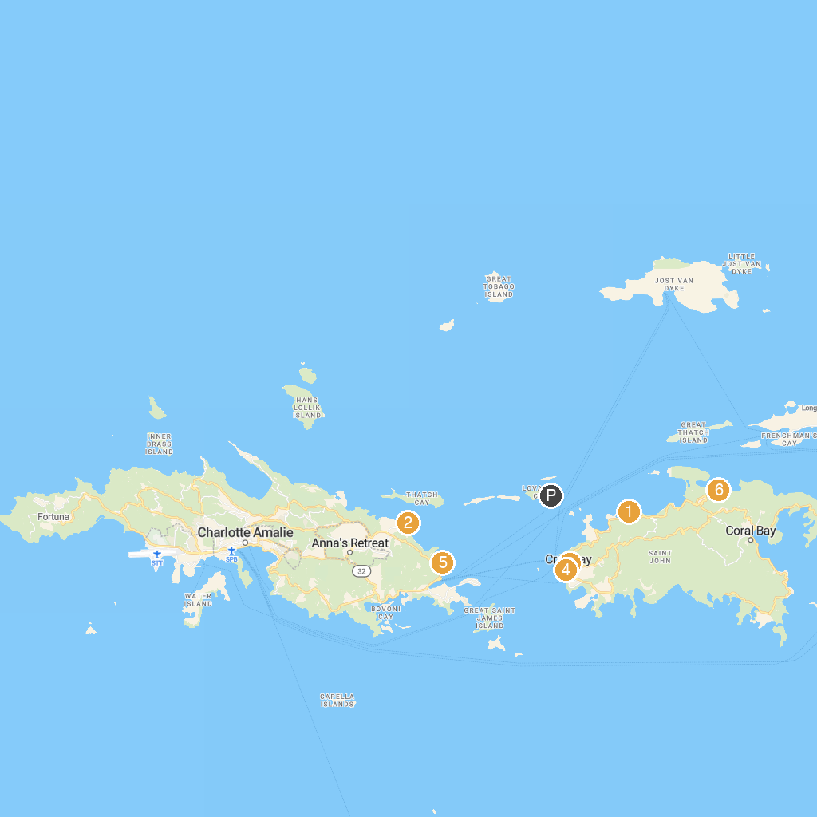
MAP KEY
1. Drake's Seat | 5. Cruz Bay Visitor Center
2. Skyride to Paradise Point | 6. Our Lady Of Mt. Carmel
3. Coral Reef Underwater Park Trail | 7. Parasail Virgin Islands
4. Coral World Ocean Park | 8. Annaberg Sugar Plantation
P. Cruise port / terminal
Map © MapTiler © OpenStreetMap contributors · cruiseports.org

