Louisville, Kentucky, USA
The bourbon capital of the world docks river cruisers right in the heart of downtown — walk off the gangway and straight into Whiskey Row, a 120-foot baseball bat, and the city where Muhammad Ali was born.
⚓ Docked (pier) · 🕒 Typical call: 8-10 hrs · 💵 USD · 🗣️ English · 🥃 Bourbon Trail start
✍️ MY DAY IN PORT (FILL IN)
Ship / Date
In port | arrive ______ · all aboard ______
Booked excursion
Notes / meeting point
GETTING ASHORE
- Docking: Direct pier at Louisville Wharf, Waterfront Park
- Walk to center: 5–10 min to Whiskey Row; 15 min to Museum Row
- Best For: Bourbon tastings, history, foodie dining, urban walks
- Don't Miss: Big Four Bridge walk to Indiana + Louisville Slugger tour
GETTING AROUND
- 🚕 Taxi: $4.70 base + $2.25/mi — Local taxis charge a $4.70 base fare for the first mile plus $2.25 per additional mile. Short downtown hops are inexpens
- 📱 Rideshare: ✅ Uber, Lyft
TOP THINGS TO DO
- Urban Bourbon Trail — Walk Whiskey Row and tour 2–3 of Louisville's downtown distilleries.
- Louisville Slugger Museum & Factory — The 120-foot steel bat leaning against the building makes it unmissable.
- Muhammad Ali Center — A world-class museum dedicated to Louisville's most famous son — his boxing career, humanitarian work, and six core principles.
- Big Four Bridge Walk — A converted 19th-century railroad bridge now carries pedestrians across the Ohio River to Jeffersonville, Indiana.
- Churchill Downs & Kentucky Derby Museum — The legendary home of the Kentucky Derby.
BEST WALKS
- Whiskey Row & Museum Row Loop: 1.5 miles | ~45 min | Easy — Walk south from the wharf up to Main Street, stroll past the cast-iron facades of Whiskey Row (one…
- Big Four Bridge to Indiana: 1.2 miles round-trip | ~30 min | Easy — Head east along the Waterfront Park path to the Big Four Bridge pedestrian ramp.
WEATHER · DAYLIGHT · MONEY
Month | High °F | Low °F | Rainy days
May | 76 | 57 | 12
Jul | 87 | 70 | 13
Sep | 81 | 63 | 7
Daylight: May 6:32AM–8:47PM · Jul 6:32AM–9:05PM · Sep 7:25AM–7:50PM
cruiseports.org/louisville-ky · Confirm terminal & all-aboard time with your ship

Louisville, Kentucky, USA — Port Map
Red = walkable sights · Amber = excursions farther out · P = cruise terminal
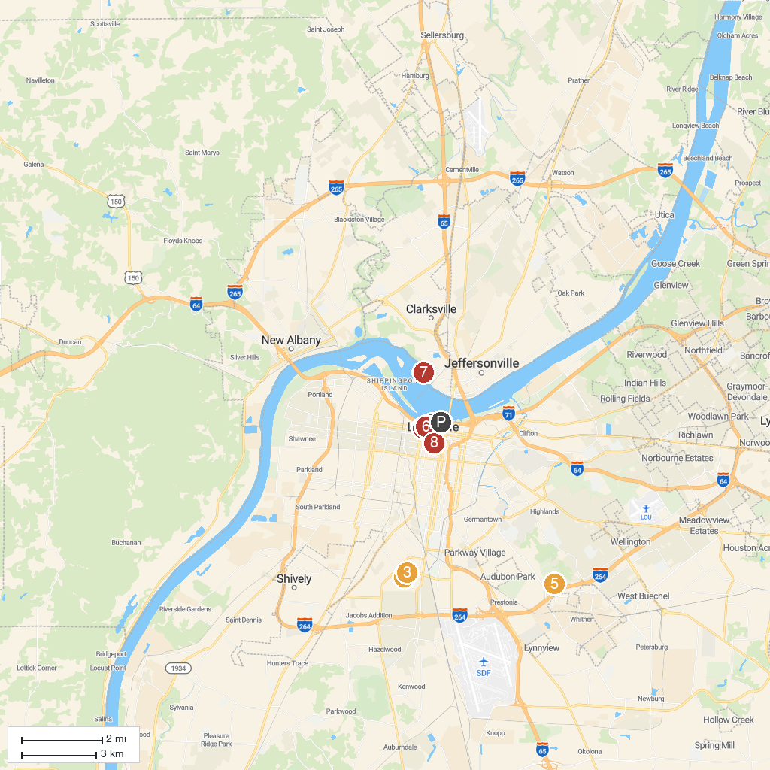
MAP KEY
1. Churchill Downs | 5. Louisville Mega Cavern
2. Louisville Slugger Museum & Factory | 6. Kentucky Science Center
3. Kentucky Derby Museum | 7. Falls of the Ohio State Park
4. Muhammad Ali Center | 8. Cathedral of the Assumption
P. Cruise port / terminal
Map © MapTiler © OpenStreetMap contributors · cruiseports.org

