Louisbourg, Nova Scotia, Canada
A living 18th-century French fortress town perched on Cape Breton's wild Atlantic coast — where costumed soldiers drill, bakers fire stone ovens, and cannon smoke drifts across the harbor.
⚓ Tender (anchor) · 🕒 Typical call: 6-8 hrs · 💵 Canadian Dollar (CAD) · 🗣️ English / French at Fortress · 🏰 History focus
✍️ MY DAY IN PORT (FILL IN)
Ship / Date
In port | arrive ______ · all aboard ______
Booked excursion
Notes / meeting point
GETTING ASHORE
- Docking: Tender — most ships anchor in Louisbourg Harbour and tender ashore near the town centre, in view of the Fortress (small expedition ships may berth at the wharf)
- Walk to Fortress: ~3 km (40 min walk) or short taxi/shuttle ride
- Best For: History buffs, families, photography, coastal hiking
- Don't Miss: Fortress of Louisbourg National Historic Site — North America's largest reconstruction
GETTING AROUND
- 🚕 Taxi: CAD $10–20 one-way — Limited local taxis serve Louisbourg. Short rides within town or to the Fortress visitor centre run roughly $10–20 CAD;
TOP THINGS TO DO
- Fortress of Louisbourg National Historic Site — North America's largest historical reconstruction, recreating the fortified town of 1744.
- Louisbourg Lighthouse Trail — A scenic coastal hike to the site of Canada's first lighthouse (1734), offering dramatic ocean views, sea stacks, and windswept…
- Louisbourg Town Waterfront Stroll — Wander the working fishing village itself — browse the Sydney and Louisbourg Railway Museum, peek into local craft shops, and…
- Kennington Cove & Coastal Beaches — A short drive from the Fortress, Kennington Cove offers a sheltered gravel-and-sand beach with historical significance — British…
- Mi'kmaw Heritage at the Fortress — Inside the Fortress, the Mi'kmaw Interpretive Centre explores the culture and history of the L'nu people and their role in…
BEST WALKS
- Pier to Fortress Walk: 3 km each way | ~40 min | Easy road walk — Follow Main Street south along the harbor from the government wharf, passing the town center, and…
- Louisbourg Lighthouse Trail: 4 km round-trip | ~1.5 hrs | Moderate coastal path — From the Fortress parking area, cross to the lighthouse peninsula trail for sweeping Atlantic…
WEATHER · DAYLIGHT · MONEY
Month | High °F | Low °F | Rainy days
May | 54 | 40 | 12
Jul | 70 | 55 | 10
Sep | 65 | 50 | 11
Daylight: May 4:55AM–8:20PM · Jul 4:45AM–8:45PM · Sep 5:50AM–7:20PM
cruiseports.org/louisbourg-ns · Confirm terminal & all-aboard time with your ship

Louisbourg, Nova Scotia, Canada — Port Map
Red = walkable sights · Amber = excursions farther out · P = cruise terminal
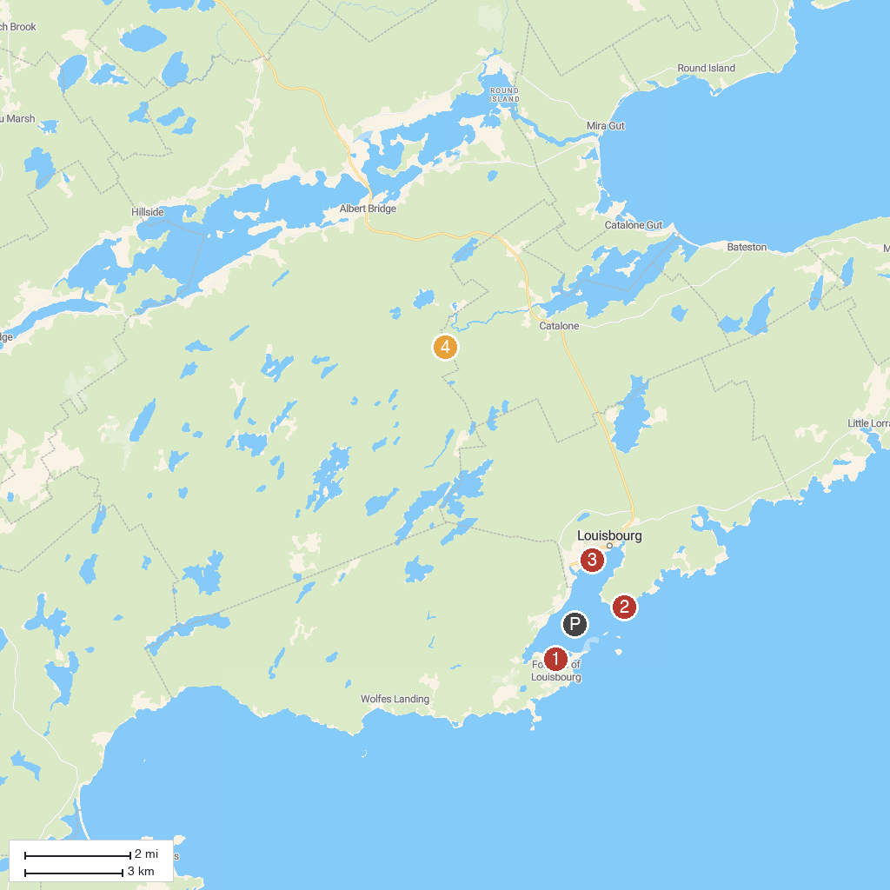
MAP KEY
1. Fortress of Louisbourg National Historic Site | 4. Devil's Hills Falls
2. Louisbourg Lighthouse | 5. Mira River Provincial Park
3. Louisbourg Playhouse
P. Cruise port / terminal
Map © MapTiler © OpenStreetMap contributors · cruiseports.org

