Mali Lošinj, Kvarner, Croatia
Croatia's 'Island of Vitality' delivers what the name promises — pine-scented air, turquoise coves, and a 2,000-year-old bronze athlete waiting in his own museum. Smaller ships dock on the Riva; larger ones tender into the same charming harbor.
⚓ Tender (large ships) / Dock (small ships) · 🕒 Typical call: 6–8 hrs · 💶 Euro (€) · 🗣️ Croatian (English widely spoken)
✍️ MY DAY IN PORT (FILL IN)
Ship / Date
In port | arrive ______ · all aboard ______
Booked excursion
Notes / meeting point
GETTING ASHORE
- Docking: Small/boutique ships dock at the Mali Lošinj Riva quay; larger cruise ships anchor and tender (5–10 min ride) to the harbor pontoon.
- Walk to center: 0 min — tender drops you at the waterfront Riva promenade.
- Best For: Culture, beaches, dolphins, cycling, wellness
- Don't Miss: Museum of Apoxyomenos (bronze statue found on the sea floor) and the coastal path to Veli Lošinj
GETTING AROUND
- 🚕 Taxi: €6 base + €3/km — Local taxis (e.g. Taxi Braco) are available at the port area. Short in-town trips are inexpensive; a ride to the Čikat b
- 📱 Rideshare: ✅ Uber
TOP THINGS TO DO
- Museum of Apoxyomenos — The island's standout attraction: a multi-sensory museum built around a single bronze statue of an athlete, discovered on the…
- Lošinj Aromatic Garden — A short walk from the harbor, this garden showcases 250+ aromatic and medicinal plants (150+ of them indigenous to the…
- Dolphin Watching — Blue World Institute — Lošinj waters host a well-studied resident community of bottlenose dolphins.
- Čikat Bay Beaches & Pine Forest — A 20-minute walk through the shaded 19th-century Čikat Forest Park leads to Čikat Bay, the island's most popular beach area.
- Coastal Cycling to Veli Lošinj — Rent a bike at the harbor and ride the 5 km flat coastal path through pine forest to Veli Lošinj — a postcard fishing village of…
BEST WALKS
- Riva to Apoxyomenos Museum & Old Town: 0.5 km · 15–20 min · Easy · Free (museum paid) — From the tender pontoon, stroll the Riva promenade north to the Museum of Apoxyomenos.
- Čikat Forest Park to the Beach: 2 km one-way · 20–25 min · Easy · Free — Head south-west from the harbor along the Riva, then follow signs into the Čikat Forest Park.
- Coastal Path to Veli Lošinj: 5 km one-way · 60 min · Easy · Free — A flat, paved coastal footpath (Šetnica) hugs the shoreline south from Mali Lošinj to the quaint…
WEATHER · DAYLIGHT · MONEY
Month | High °F | Low °F | Rainy days
May | 65 | 61 | 10
Jul | 78 | 74 | 5
Sep | 72 | 69 | 9
Daylight: May 5:34AM–8:22PM · Jul 5:31AM–8:44PM · Sep 6:41AM–7:12PM
cruiseports.org/losinj-island-croatia · Confirm terminal & all-aboard time with your ship

Mali Lošinj, Kvarner, Croatia — Port Map
Red = walkable sights · Amber = excursions farther out · P = cruise terminal
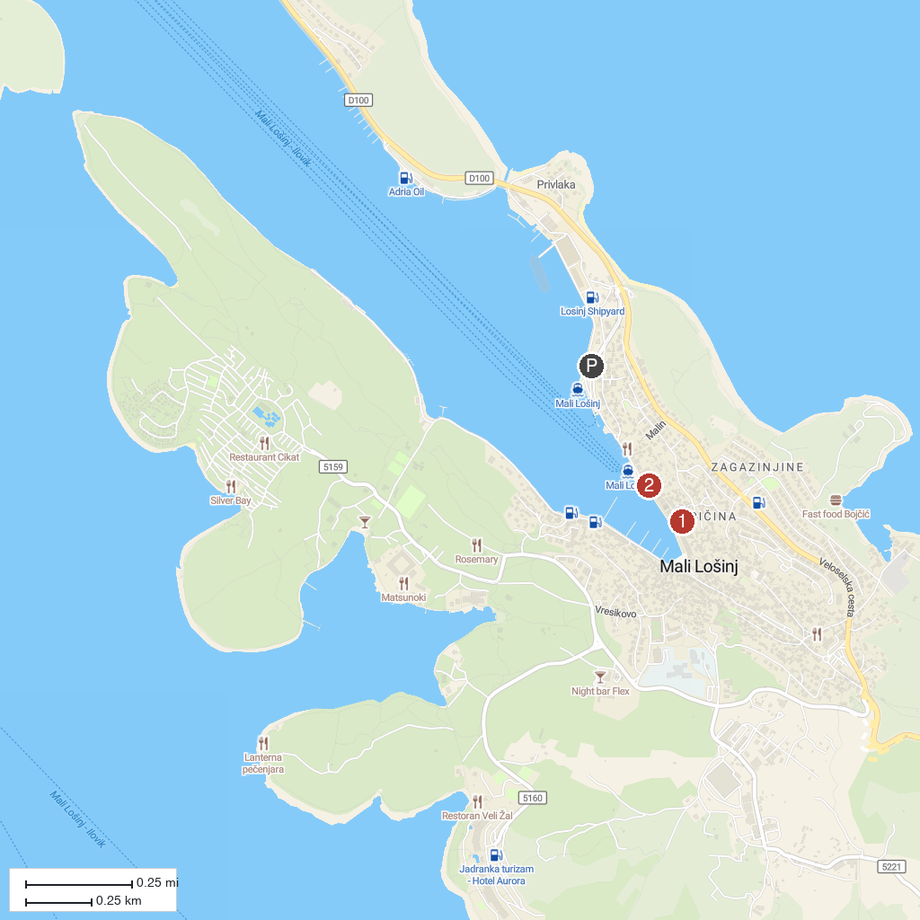
MAP KEY
1. Lošinj Museum | 2. Museum of Apoxyomenos
P. Cruise port / terminal
Map © MapTiler © OpenStreetMap contributors · cruiseports.org

