Los Angeles, California, USA
The West Coast's biggest cruise homeport drops you at San Pedro, a working waterfront with a battleship museum next door and all of LA's iconic sights within reach on a full-day run.
⚓ Pier (docked, no tender) · 🕒 Typical call: 8-10 hrs (or homeport) · 💵 US Dollar · 🗣️ English · 🌤️ Sunny & mild year-round
✍️ MY DAY IN PORT (FILL IN)
Ship / Date
In port | arrive ______ · all aboard ______
Booked excursion
Notes / meeting point
GETTING ASHORE
- Docking: World Cruise Center, San Pedro (Berths 92-93); all ships dock pier-side
- Walk to center: San Pedro downtown ~15 min walk; Hollywood 25 miles (need transport)
- Best For: City icons, beaches, battleship history, whale watching
- Don't Miss: Battleship USS Iowa Museum — literally steps from the pier
GETTING AROUND
- 🚕 Taxi: $50–$70 — Metered taxis available outside the terminal. About 25 miles to Downtown LA; expect 45–75 min depending on traffic.
- 📱 Rideshare: ✅ Uber, Lyft
- 🚌 Hop-on hop-off: ✅
TOP THINGS TO DO
- Battleship USS Iowa Museum — The 'Battleship of Presidents' is moored a short walk from the cruise terminal.
- Hollywood Walk of Fame & TCL Chinese Theatre — The classic LA pilgrimage — celebrity handprints at TCL Chinese Theatre, the Walk of Fame, and the Hollywood Sign viewpoints at…
- Santa Monica Beach & Pier — Ride the famous Ferris wheel on the Santa Monica Pier, stroll the beach, and explore the Third Street Promenade.
- Whale & Dolphin Watching Cruise — Blue whales, humpbacks, fin whales, and dolphins frequent the waters off San Pedro.
- Beverly Hills & Rodeo Drive — Window-shop the world's most famous luxury street, cruise past celebrity mansions, and grab a photo at the Beverly Hills sign…
BEST WALKS
- San Pedro Waterfront Walk: 2 miles | Easy | 45-60 min — From the cruise terminal, walk along the waterfront past the USS Iowa, through the West Harbor…
- Point Fermin & Angels Gate Park: 1.5 miles | Easy | 45 min — Take the trolley or a short rideshare to Point Fermin Park for cliffside ocean views, the 1874…
WEATHER · DAYLIGHT · MONEY
Month | High °F | Low °F | Rainy days
May | 74 | 58 | 2
Jul | 82 | 65 | 1
Sep | 84 | 64 | 1
Daylight: May 5:23AM–6:14PM · Jul 5:29AM–6:26PM · Sep 5:40AM–5:53PM
cruiseports.org/los-angeles · Confirm terminal & all-aboard time with your ship

Los Angeles, California, USA — Port Map
Red = walkable sights · Amber = excursions farther out · P = cruise terminal
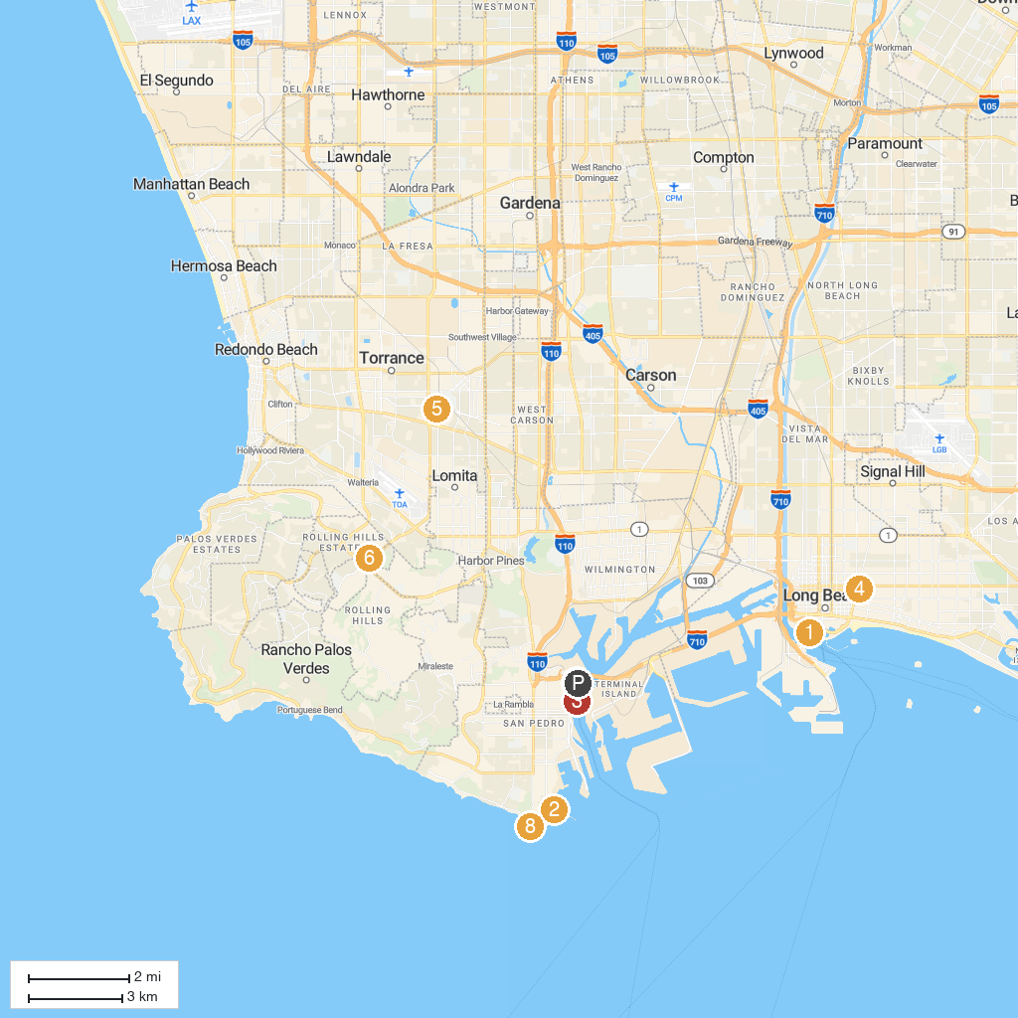
MAP KEY
1. Aquarium of the Pacific | 5. Charles H. Wilson Park
2. Cabrillo Marine Aquarium | 6. South Coast Botanic Garden
3. Battleship USS IOWA | 7. Los Angeles World Cruise Center
4. Museum of Latin American Art (MOLAA) | 8. Point Fermin Park
P. Cruise port / terminal
Map © MapTiler © OpenStreetMap contributors · cruiseports.org

