Loreto, Baja California Sur, Mexico
The oldest permanent Spanish settlement in the Californias, Loreto trades cruise-port bustle for cobblestone streets, a soaring 1697 mission, and a UNESCO marine park teeming with blue whales and sea lions.
⚓ Tender (no pier) · 🕒 Typical call: 6-8 hrs · 💵 USD accepted / MXN preferred · 🗣️ Spanish (English in tourist areas) · 🌊 UNESCO Marine Park
✍️ MY DAY IN PORT (FILL IN)
Ship / Date
In port | arrive ______ · all aboard ______
Booked excursion
Notes / meeting point
GETTING ASHORE
- Docking: Tender — ships anchor in Bahía de Loreto; tenders to municipal pier
- Walk to center: 5 min from tender pier to main plaza and Mission
- Best For: History, snorkeling, whale watching (Jan–Mar), low-key exploration
- Don't Miss: Isla Coronado snorkel tour & Mission Nuestra Señora de Loreto
GETTING AROUND
- 🚕 Taxi: 105–120 MXN (~$6–7 USD) within town — Local taxis are plentiful around the marina, plaza, and hotel zone. Agree on the fare before you depart; drivers sometim
- 📱 Rideshare: ❌ not available
TOP THINGS TO DO
- Isla Coronado Snorkel & Sea Lions — A 30-minute panga ride to this volcanic island delivers a crescent of white sand, crystal-clear turquoise water, and a sea lion…
- Mission San Francisco Javier — A 45-minute drive up into the Sierra de la Giganta leads to one of Baja's best-preserved missions (1699–1758), complete with…
- Blue Whale Watching (Jan–Mar) — The Sea of Cortez near Loreto is one of the world's top spots for blue whales — the largest animals on Earth — during winter…
- Loreto Town & Mission Walk — Walk from the tender pier to the Mission Nuestra Señora de Loreto (1697) — the 'Mother of all Missions' in the Californias — then…
- Sea Kayaking in Loreto Bay — Paddle through the calm, glassy waters of the marine park around Loreto.
BEST WALKS
- Malecón to Mission Loop: ~1.5 km · 30–45 min · Flat · Free — From the tender pier walk south along the Malecón boardwalk past the whale statue and Loreto sign…
- Mission Museum & Artisan Street: ~800 m · 20–30 min · Flat · Museum ~$4 — Head directly from the tender pier to the Mission, step into the Museo de las Misiones next door…
WEATHER · DAYLIGHT · MONEY
Month | High °F | Low °F | Rainy days
May | 83 | 57 | 5
Jul | 78 | 56 | 13
Sep | 76 | 56 | 12
Daylight: May 6:08AM–7:20PM · Jul 6:13AM–7:34PM · Sep 6:35AM–6:50PM
cruiseports.org/loreto · Confirm terminal & all-aboard time with your ship

Loreto, Baja California Sur, Mexico — Port Map
Red = walkable sights · Amber = excursions farther out · P = cruise terminal
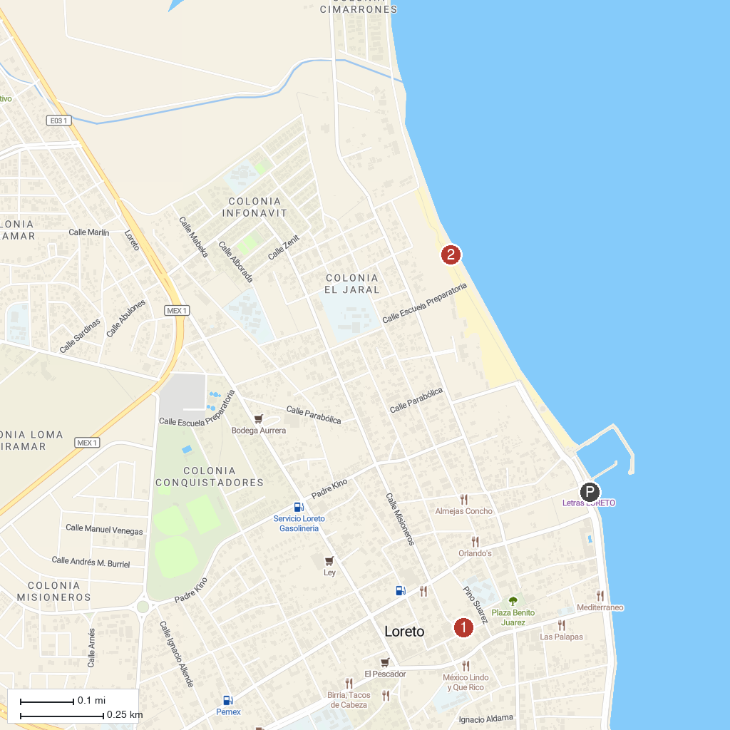
MAP KEY
1. Jesuit Missions of Loreto Museum | 2. La Negrita Beach
P. Cruise port / terminal
Map © MapTiler © OpenStreetMap contributors · cruiseports.org

