Longyearbyen, Svalbard, Norway
Halfway between mainland Norway and the North Pole, Longyearbyen is a former coal-mining settlement turned Arctic adventure hub — where polar bears roam the mountains and the sun never sets in summer.
⚓ Docked (most ships) / Tender (when busy) · 🕒 Typical call: 7-10 hrs · 💵 Norwegian Krone (NOK) — fully cashless · 🗣️ Norwegian · 🐻‍❄️ Polar bear country
✍️ MY DAY IN PORT (FILL IN)
Ship / Date
In port | arrive ______ · all aboard ______
Booked excursion
Notes / meeting point
GETTING ASHORE
- Docking: Bykaia cruise pier; tender when port is full
- Walk to center: 1.5 km (15–20 min) from Bykaia pier
- Best For: Arctic wildlife, expedition history, unique shopping
- Don't Miss: Svalbard Museum and the polar bear warning signs
GETTING AROUND
- 🚕 Taxi: 150–200 NOK (short ride) — Local taxis (Longyearbyen Taxi, Svalbard Buss og Taxi) operate 24/7. Taxis are scarce and pre-booking is strongly recomm
- 📱 Rideshare: ❌ not available
TOP THINGS TO DO
- Coal Mine No. 3 Tour — Don overalls and a hard hat to crawl into Gruve 3, a preserved Norwegian coal mine (operated 1971–1996 by Store Norske).
- Arctic Fjord RIB Boat Tour — Blast across Adventfjorden in an inflatable speedboat to spot walruses, puffins, beluga whales, and glaciers calving into the sea.
- Summer Dog Sledding (Wheeled Cart) — No snow in summer? No problem.
- Global Seed Vault Visit — Trek out to the famous concrete portal built into the permafrost to safeguard the world's crop seeds.
- Polar Bear & Arctic Wildlife Safari — Guided snowmobile or boat expedition into the wilderness in search of polar bears, reindeer, Arctic foxes, and seabirds.
BEST WALKS
- Pier to Town & Museum Loop: 3.5 km round-trip | 1–2 hrs | Flat & paved — Walk from Bykaia pier along the harbor road into the town center.
- Church & Harbor Stroll: 2 km | 45 min | Flat — From the town center, walk up the short hill to Svalbard Church — take your shoes off inside and…
WEATHER · DAYLIGHT · MONEY
Month | High °F | Low °F | Rainy days
May | 30 | 24 | 9
Jul | 49 | 44 | 10
Sep | 39 | 32 | 13
Daylight: Sep 5:39AM–8:01PM
cruiseports.org/longyearbyen · Confirm terminal & all-aboard time with your ship

Longyearbyen, Svalbard, Norway — Port Map
Red = walkable sights · Amber = excursions farther out · P = cruise terminal
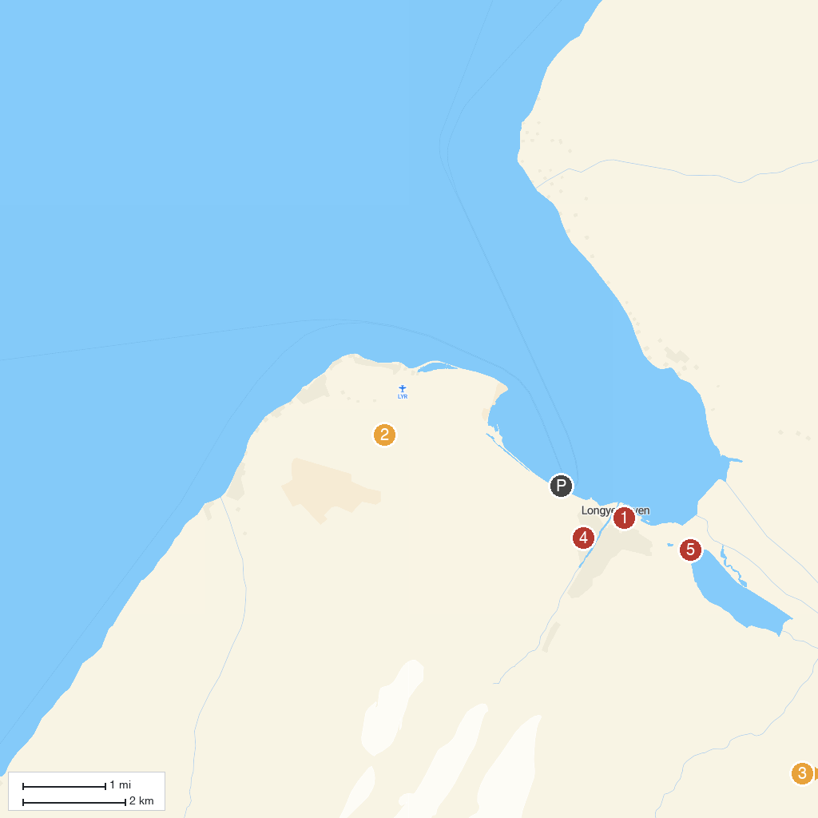
MAP KEY
1. North Pole Expedition Museum | 4. Svalbard Kirke
2. Gruve 3 | 5. Polar Bear Sign
3. Svalbard Husky AS
P. Cruise port / terminal
Map © MapTiler © OpenStreetMap contributors · cruiseports.org

