Long Island, New York, USA
Jutting 120 miles into the Atlantic east of New York City, Long Island blends Gilded Age grandeur with quiet fishing villages, North Fork vineyards, and the legendary Hamptons shore — best discovered by small ship.
⚓ Tender (no cruise pier) · 🕒 Typical call: 6-8 hrs · 💵 USD · 🗣️ English · 🍷 Wine & beaches
✍️ MY DAY IN PORT (FILL IN)
Ship / Date
In port | arrive ______ · all aboard ______
Booked excursion
Notes / meeting point
GETTING ASHORE
- Docking: Tender — small ships anchor offshore; no dedicated cruise terminal
- Walk to center: Short tender to Sag Harbor or Greenport village (5-10 min)
- Best For: Wine tasting, historic villages, Hamptons beaches, cycling
- Don't Miss: Sag Harbor Whalers Museum and Main Street's 19th-century streetscape
GETTING AROUND
- 🚕 Taxi: Metered + surcharges — Local taxis operate in most towns. Useful for short trips, especially where rideshare coverage is limited in eastern Lon
- 📱 Rideshare: ✅ Uber, Lyft
TOP THINGS TO DO
- Sag Harbor Whaling Heritage Walk — Stroll Main Street past Federal-style captains' houses and visit the Sag Harbor Whaling & Historical Museum, housed in an 1845…
- North Fork Wine Trail — The North Fork AVA packs 40+ wineries into a 30-mile stretch.
- The Hamptons & Gilded Age Estates — Southampton and East Hampton are famous for grand shingle-style estates, boutique shopping on Jobs Lane, and wide Atlantic beaches.
- Cooper's Beach or Atlantic Avenue Beach — Southampton's Cooper's Beach is one of the top-rated public beaches on the East Coast — wide, clean, and backed by dunes.
- Greenport Village & Railroad Museum — The charming Victorian village of Greenport features the East End Seaport Museum, the Long Island Railroad's Greenport terminus…
BEST WALKS
- Sag Harbor Main Street Loop: 1.5 miles · Easy · 45-60 min — From the village dock, walk up Main Street past the Old Whalers' Church (1844), the Sag Harbor…
- Greenport Waterfront Stroll: 1 mile · Easy · 30-45 min — Walk from the ferry dock along the waterfront to Mitchell Park, take a spin on the 1920s carousel…
WEATHER · DAYLIGHT · MONEY
Month | High °F | Low °F | Rainy days
May | 60 | 52 | 11
Jul | 77 | 70 | 10
Sep | 72 | 65 | 10
Daylight: May 5:31AM–8:00PM · Jul 5:30AM–8:19PM · Sep 6:30AM–6:57PM
cruiseports.org/long-island-new-york · Confirm terminal & all-aboard time with your ship

Long Island, New York, USA — Port Map
Red = walkable sights · Amber = excursions farther out · P = cruise terminal
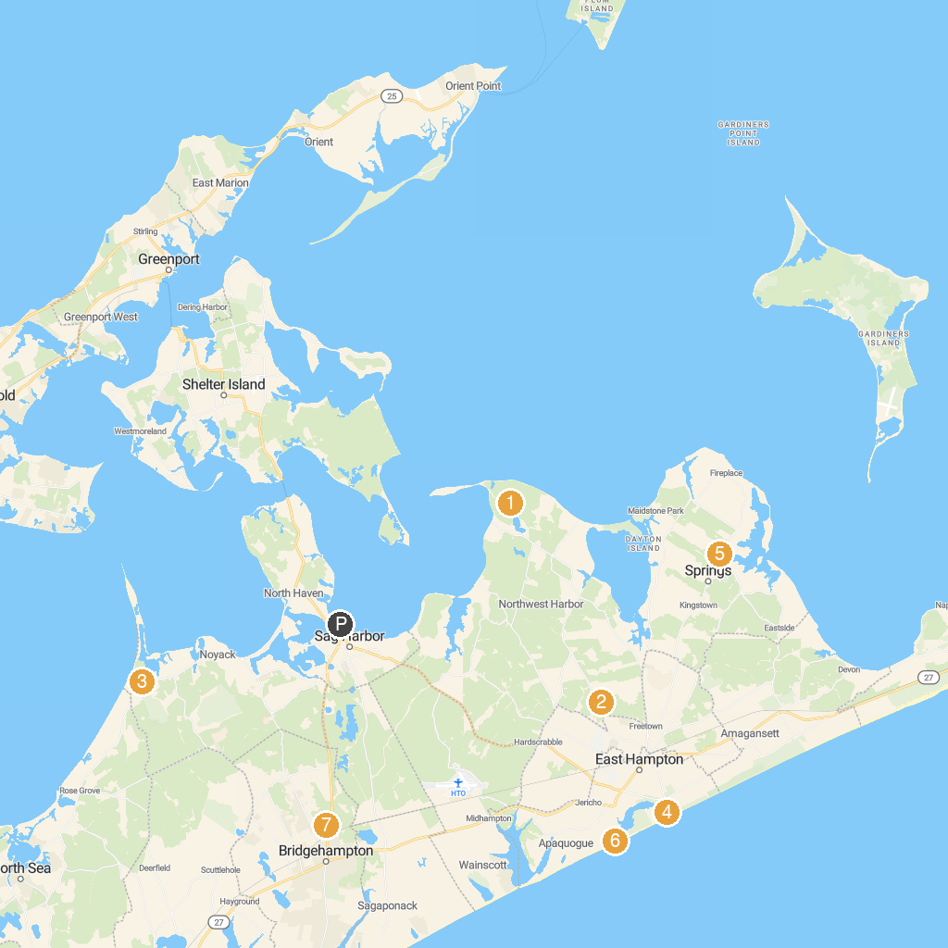
MAP KEY
1. Parrish Art Museum | 5. Maidstone Club
2. Cedar Point County Park | 6. Pollock-Krasner House
3. LongHouse Reserve | 7. East Hampton Main Beach
4. Elizabeth A. Morton National Wildlife Refuge | 8. Children's Museum of the East End
P. Cruise port / terminal
Map © MapTiler © OpenStreetMap contributors · cruiseports.org

