Lofoten Islands, Nordland, Norway
Arctic peaks plunge into fjords rimmed with white-sand beaches. Red fishermen's cabins (rorbuer), drying cod racks, and the midnight sun make Lofoten one of Norway's most otherworldly cruise stops.
⚓ Pier (Svolvær) or Tender (Leknes/Gravdal) · 🕒 Typical call: 7-10 hrs · 💵 Norwegian Krone (NOK) — virtually cashless · 🗣️ Norwegian / English widely spoken · 🌅 Arctic Circle: midnight sun Jun–Jul
✍️ MY DAY IN PORT (FILL IN)
Ship / Date
In port | arrive ______ · all aboard ______
Booked excursion
Notes / meeting point
GETTING ASHORE
- Docking: Svolvær: small-medium ships dock, large ships tender. Leknes/Gravdal: mostly tender, 4 km from town.
- Walk to Center: Svolvær: 0-5 min to shops & cafes. Leknes pier: 4 km to town — shuttle recommended.
- Best For: Scenic drives, Arctic beaches, Viking history, wildlife boat tours, photography
- Don't Miss: Reine viewpoint, Haukland Beach, Lofotr Viking Museum, Henningsvær village
GETTING AROUND
- 🚕 Taxi: NOK 170–250 (~$16–23 USD) — Taxis serve Svolvær and Leknes/Gravdal piers but are expensive and scarce. Pre-booking is strongly recommended — multipl
- 📱 Rideshare: ❌ not available
TOP THINGS TO DO
- Reine & Hamnøy — The Postcard View — Drive south to Reine, the most photographed village in Norway — red rorbuer reflected in steel-calm fjords beneath jagged granite…
- Lofotr Viking Museum — Built on the site of the largest Viking longhouse ever discovered (83 m long).
- Trollfjord Sea Eagle Safari — RIB or small boat into the dramatic Trollfjord to spot white-tailed sea eagles swooping for fish.
- Haukland & Uttakleiv Arctic Beaches — Two of Europe's most beautiful beaches — white sand, turquoise water, mountain backdrops.
- Henningsvær — Venice of Lofoten — A fishing village spread across small islands connected by bridges.
BEST WALKS
- Svolvær Harbor & Town Center: 1-2 hrs | Easy | Flat — Wander from the cruise quay along the waterfront to Torget (town square), past fish restaurants…
- Gravdal Pier to Buksnes Church: 30 min | Easy | Flat road — From the Leknes/Gravdal tender pier, a 1.2 km walk along the waterfront brings you to Buksnes…
WEATHER · DAYLIGHT · MONEY
Month | High °F | Low °F | Rainy days
May | 47 | 39 | 16
Jul | 62 | 52 | 12
Sep | 53 | 46 | 16
Daylight: Sep 6:18AM–7:32PM
cruiseports.org/lofoten-islands · Confirm terminal & all-aboard time with your ship

Lofoten Islands, Nordland, Norway — Port Map
Red = walkable sights · Amber = excursions farther out · P = cruise terminal
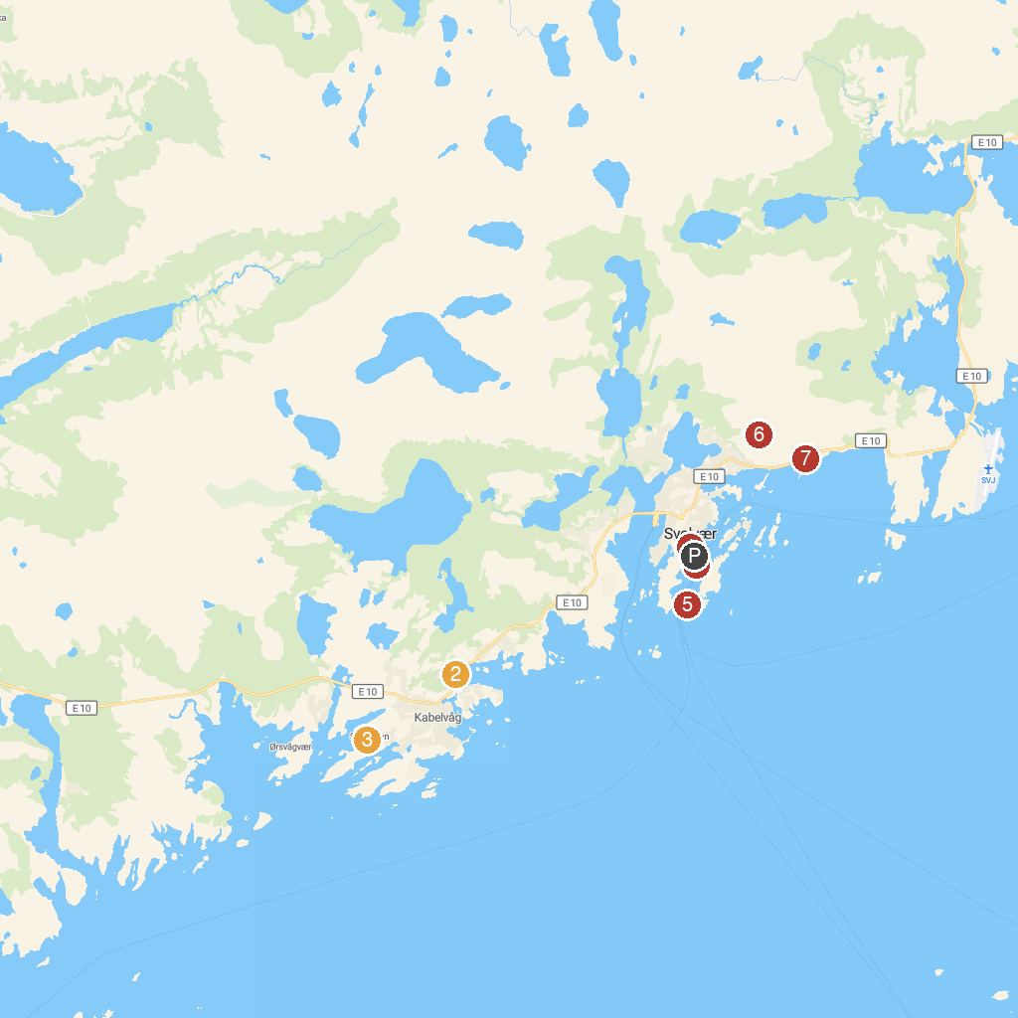
MAP KEY
1. Visit Lofoten | 5. Svolvær Pier
2. Vågan Church | 6. Svolværgeita
3. Lofotmuseet | 7. Svolvær Strand
4. Magic Ice Lofoten
P. Cruise port / terminal
Map © MapTiler © OpenStreetMap contributors · cruiseports.org

