Loen, Vestland, Norway
One of Norway's most dramatic fjord villages, Loen pairs a record-breaking cable car with glacial lakes, via ferrata, and jaw-dropping Nordfjord scenery — all within minutes of the tender pier.
⚓ Tender port (new pontoon pier) · 🕒 Typical call: 7-9 hrs · 💵 Norwegian Krone (NOK) — cashless widely accepted · 🗣️ Norwegian / English widely spoken · 🏔️ Adventure & nature focus
✍️ MY DAY IN PORT (FILL IN)
Ship / Date
In port | arrive ______ · all aboard ______
Booked excursion
Notes / meeting point
GETTING ASHORE
- Docking: Tender — ships anchor in Nordfjord; pontoon pier in village center
- Walk to center: Pier lands in village; Skylift base 5 min walk
- Best For: Cable cars, glacier hikes, fjord scenery, via ferrata
- Don't Miss: Loen Skylift to Mt Hoven (1,011 m) — one of the world's steepest
GETTING AROUND
- 🚕 Taxi: 210–270 NOK one-way — Taxis meet ships at Olden cruise pier, about 6-7 km from Loen village. The ride takes roughly 6-7 minutes and is the eas
TOP THINGS TO DO
- Loen Skylift to Mt Hoven — One of the world's steepest cable cars climbs from sea level to 1,011 m in just 5 minutes.
- Via Ferrata Loen — A guided secured climbing route up Mt Hoven, highlighted by the Gjølmunnebrua suspension bridge — the longest via ferrata bridge…
- Lake Lovatnet & Kjenndalsbreen Glacier — A boat cruise across the neon-green glacial Lake Lovatnet aboard MS Kjenndal II, followed by a bus ride to the tongue of…
- Breng Seter & Tsunami History Walk — Walk the flat road along Lake Lovatnet to the 19th-century grass-roofed farm at Breng Seter — one of Norway's most photographed…
- Hotel Alexandra Grand Buffet — The legendary Hotel Alexandra — a grand historic property right in Loen — is famed throughout Norway for its lavish dinner buffet…
BEST WALKS
- Village to Loen Church & Skylift Base: 20–30 min · Flat · Free — From the tender pier, stroll through the village to the white octagonal Loen Church (1844), whose…
- Lake Lovatnet Road to Breng Seter: ~3 km one way · Flat · ~40 min each way — Follow the lakeshore road south from the village along the vivid turquoise-green Lake Lovatnet to…
WEATHER · DAYLIGHT · MONEY
Month | High °F | Low °F | Rainy days
May | 54 | 42 | 17
Jul | 69 | 55 | 21
Sep | 61 | 49 | 19
Daylight: May 4:38AM–10:21PM · Jul 4:18AM–10:58PM · Sep 7:00AM–7:54PM
cruiseports.org/loen · Confirm terminal & all-aboard time with your ship

Loen, Vestland, Norway — Port Map
Red = walkable sights · Amber = excursions farther out · P = cruise terminal
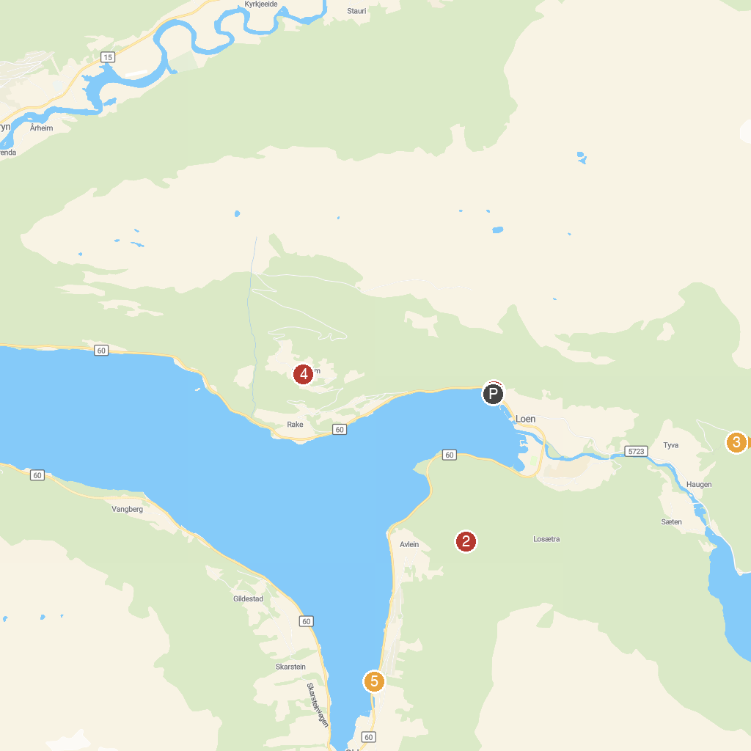
MAP KEY
1. LOEN Skylift | 4. Oppheim
2. Huaren Viewpoint | 5. Olden
3. Tjugenfossen
P. Cruise port / terminal
Map © MapTiler © OpenStreetMap contributors · cruiseports.org

