Lødingen, Nordland, Norway
Tucked at the confluence of Ofotfjorden, Tysfjorden, and Vestfjorden, Lødingen is an authentic Arctic village with sea eagles overhead, a historic pilot station, and the Lofoten Islands practically next door.
⚓ Pier or tender (port-dependent) · 🕒 Typical call: 5–8 hrs · 💵 NOK — cards accepted everywhere · 🗣️ Norwegian (English widely spoken) · 🦅 Wildlife & fjord scenery
✍️ MY DAY IN PORT (FILL IN)
Ship / Date
In port | arrive ______ · all aboard ______
Booked excursion
Notes / meeting point
GETTING ASHORE
- Docking: Pier for smaller/expedition ships; larger vessels may anchor and tender
- Walk to center: 1–5 min from pier or tender landing
- Best For: Sea eagle safaris, fjord walks, authentic Norwegian village life
- Don't Miss: Lødingen Church (1897) and the waterfront at Lødingen Brygge
GETTING AROUND
- 🚕 Taxi: 150–250 NOK (~$14–23 USD) — Lødingen Taxi (+47 76 93 10 01) serves the area. Fares are short-trip based given the town's compact size; book in advan
TOP THINGS TO DO
- Sea Eagle Safari by RIB — Zoom into the fjords aboard a rigid inflatable boat to spot white-tailed sea eagles — Europe's largest raptor — soaring above…
- Fjord Fishing with a Local Skipper — Try your hand at catching cod, saithe, and halibut in the rich waters where three fjords converge.
- Lødingen Village History Walk — Explore the village with a local guide covering the 19th-century pilot station, Lødingen Church (1897), the old telegraph…
- Hike to Vestfjord Panorama — A moderate uphill walk behind the village rewards you with sweeping views across the Vestfjorden toward the jagged peaks of…
- Lødingen Brygge & Local Waterfront — Stroll the historic wharf area (Dampskipsbrygga), stop at the Havnebørsen pub and restaurant, browse local art, and soak up the…
BEST WALKS
- Village Loop: Harbor to Church & Brygge: 2.5 km · 45 min · Easy · Free — Start at the guest harbor, walk to Lødingen Church (1897) with its striking white wooden exterior…
- Coastal Path to Vestfjord Viewpoint: 4 km · 1.5 hrs · Moderate · Free — Head south along the shoreline from the harbor, then climb the hill path behind the pilot station…
WEATHER · DAYLIGHT · MONEY
Month | High °F | Low °F | Rainy days
May | 48 | 38 | 16
Jul | 64 | 52 | 12
Sep | 53 | 44 | 16
Daylight: Sep 6:12AM–7:27PM
cruiseports.org/lodingen · Confirm terminal & all-aboard time with your ship

Lødingen, Nordland, Norway — Port Map
Red = walkable sights · Amber = excursions farther out · P = cruise terminal
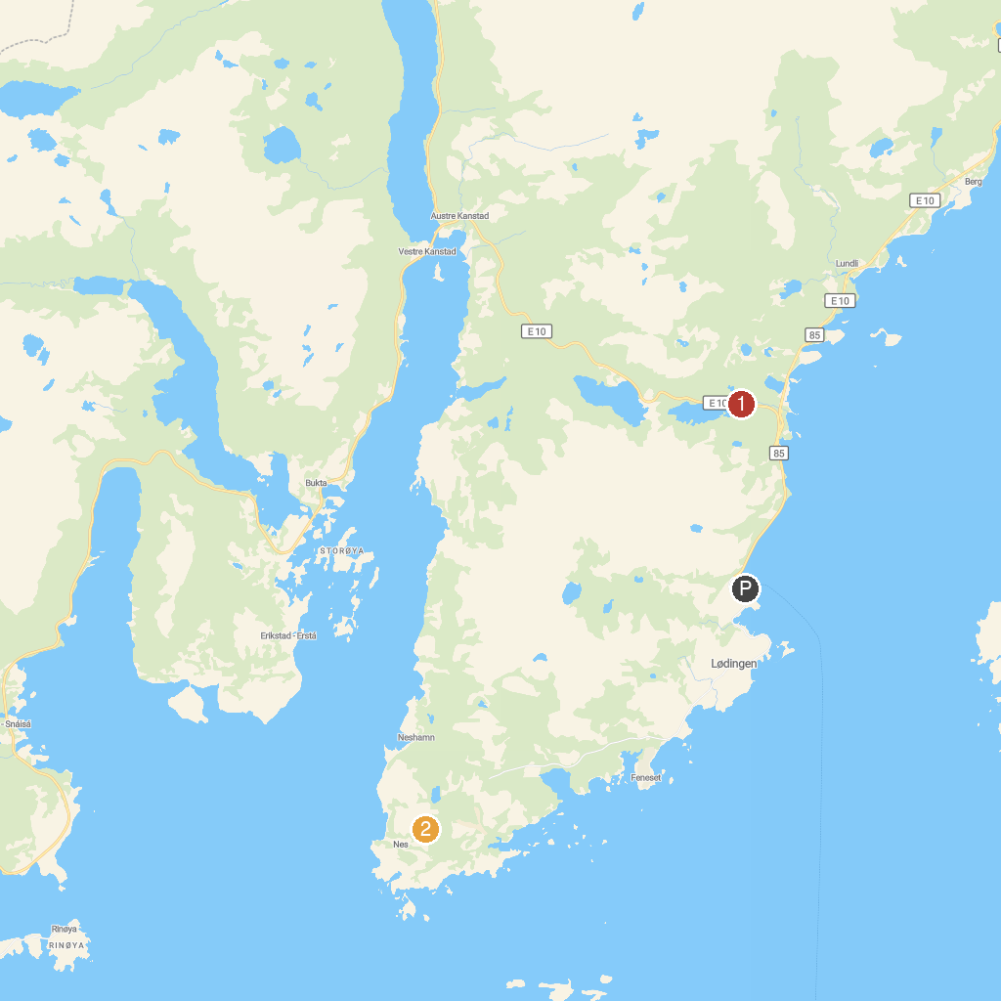
MAP KEY
1. Grønelva fossefall | 2. Vestfjord Panorama
P. Cruise port / terminal
Map © MapTiler © OpenStreetMap contributors · cruiseports.org

