Lochmaddy, North Uist, Scotland
North Uist's main village is the gateway to a watery labyrinth of lochs, prehistoric monuments, and some of Europe's most pristine white-sand beaches — all under a vast, ever-changing Hebridean sky.
⚓ Tender (small pier) · 🕒 Typical call: 6-8 hrs · 💷 British Pounds (GBP) · 🗣️ English & Scottish Gaelic
✍️ MY DAY IN PORT (FILL IN)
Ship / Date
In port | arrive ______ · all aboard ______
Booked excursion
Notes / meeting point
GETTING ASHORE
- Docking: Tender to Lochmaddy pontoon (ferry terminal pier)
- Walk to Centre: 2-5 min from tender pontoon
- Best For: Prehistoric sites, beaches, birdwatching, Gaelic culture
- Don't Miss: Barpa Langass Neolithic cairn & Clachan Sands beach
GETTING AROUND
- 🚕 Taxi: ~£10–£20 for short island runs — DMI Taxi (24/7) and Alda's Taxis/Minibus serve Lochmaddy and North Uist. Best for reaching sites like Balranald Nature R
- 📱 Rideshare: ❌ not available
TOP THINGS TO DO
- Barpa Langass Neolithic Cairn — One of Scotland's best-preserved chambered cairns, built 5,000 years ago on a hillside overlooking a loch.
- Clachan Sands & Machair Walk — The west coast's white shell-sand beaches are strikingly beautiful — turquoise water backed by dunes and, in summer, carpets of…
- RSPB Balranald Reserve — One of the UK's premier sites for hearing the elusive corncrake and spotting lapwings, oystercatchers, and seals.
- Taigh Chearsabhagh Museum & Arts Centre — The cultural heart of North Uist — a museum covering island history, peat-cutting traditions, and Gaelic heritage alongside a…
- Kayaking the Lochs & Sea Inlets — North Uist's labyrinth of freshwater and sea lochs is a world-class sea kayaking destination.
BEST WALKS
- Lochmaddy Village & Camera Obscura: 2 miles round-trip · 45-60 min · Easy coastal path — From the tender pontoon, walk through the village past Taigh Chearsabhagh and follow the coastal…
WEATHER · DAYLIGHT · MONEY
Month | High °F | Low °F | Rainy days
May | 53 | 47 | 16
Jul | 59 | 54 | 19
Sep | 58 | 53 | 18
Daylight: May 5:06AM–9:44PM · Jul 4:53AM–10:15PM · Sep 6:59AM–7:46PM
cruiseports.org/lochmaddy · Confirm terminal & all-aboard time with your ship

Lochmaddy, North Uist, Scotland — Port Map
Red = walkable sights · Amber = excursions farther out · P = cruise terminal
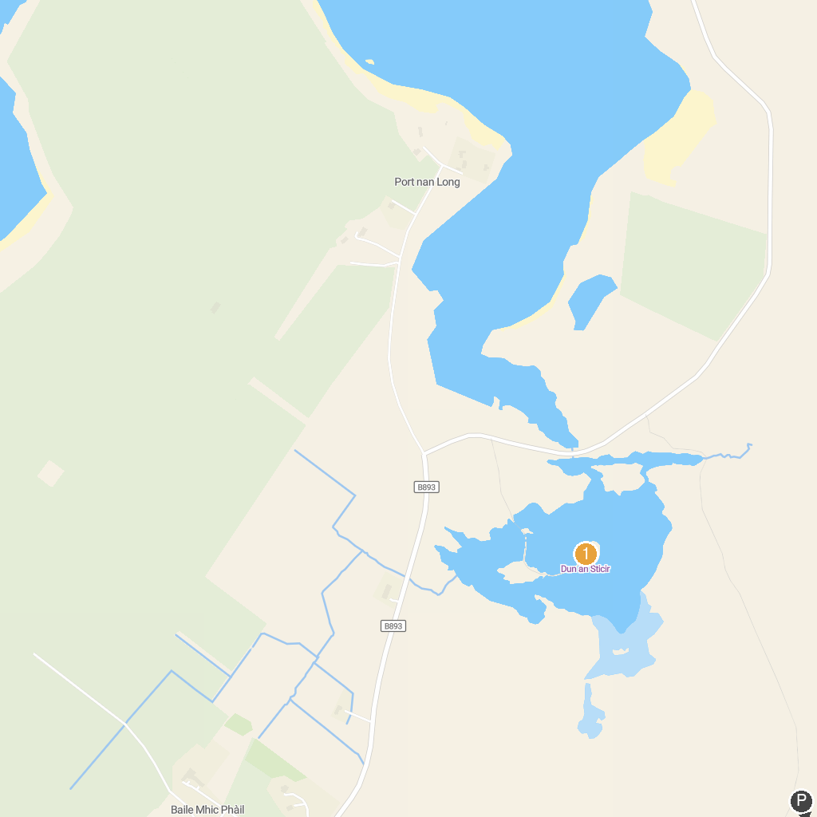
MAP KEY
1. Dun an Sticir | 2. East Beach
P. Cruise port / terminal
Map © MapTiler © OpenStreetMap contributors · cruiseports.org

