Livorno, Tuscany, Italy
The port that unlocks Tuscany. Florence's Uffizi, Pisa's Leaning Tower, the villages of Cinque Terre — all within reach of a single shore day. Livorno itself rewards those who stay, with canals, a grand esplanade, and market-stall fish fry.
⚓ Docked · 🕒 Typical call: 8-10 hrs · 💶 Euro (€) · 🗣️ Italian · 🏛️ Gateway to Florence & Pisa
✍️ MY DAY IN PORT (FILL IN)
Ship / Date
In port | arrive ______ · all aboard ______
Booked excursion
Notes / meeting point
GETTING ASHORE
- Docking: Terminal at Porto Mediceo; gangway to quay — no tender
- Walk to center: 10-15 min on foot to Piazza della Repubblica
- Best For: Art, history, architecture; day-trippers to Florence or Pisa
- Don't Miss: Pisa's Piazza dei Miracoli or the Uffizi Gallery in Florence
GETTING AROUND
- 🚕 Taxi: €10–€20 to city center — Taxis are available at the cruise terminal. Agree on a price before boarding or confirm the meter is running; drivers ma
- 📱 Rideshare: ❌ not available
- 🚌 Hop-on hop-off: ✅
TOP THINGS TO DO
- Pisa & the Leaning Tower — The Piazza dei Miracoli is one of Italy's most photogenic squares — the Leaning Tower, the Duomo, and the Baptistery clustered on…
- Florence: Uffizi, Duomo & Renaissance City — The cradle of the Renaissance is 80 km away.
- Cinque Terre Village Walk — Five pastel fishing villages clinging to coastal cliffs — Monterosso, Vernazza, Corniglia, Manarola, Riomaggiore.
- Livorno Old Town: Canals & Fortezza Vecchia — Skip the big day-trips and explore Livorno itself — the 16th-century Fortezza Vecchia guards the harbor, the Venezia Nuova canal…
- Tuscan Food & Wine Tour — Tuscany's wines (Chianti, Brunello), olive oils, and charcuterie are among Italy's finest.
BEST WALKS
- Port Gate to Piazza della Repubblica: 1.5 km · 20 min · Flat — A straight, easy walk from the cruise terminal gate through the historic center to Livorno's main…
- Terrazza Mascagni Seafront Stroll: 2 km · 25 min one way · Flat — Livorno's most beloved promenade — a vast checkerboard terrace overlooking the Tyrrhenian Sea.
WEATHER · DAYLIGHT · MONEY
Month | High °F | Low °F | Rainy days
May | 69 | 57 | 11
Jul | 84 | 71 | 4
Sep | 77 | 65 | 8
Daylight: May 5:54AM–8:36PM · Jul 5:51AM–8:57PM · Sep 6:58AM–7:28PM
cruiseports.org/livorno · Confirm terminal & all-aboard time with your ship

Livorno, Tuscany, Italy — Port Map
Red = walkable sights · Amber = excursions farther out · P = cruise terminal
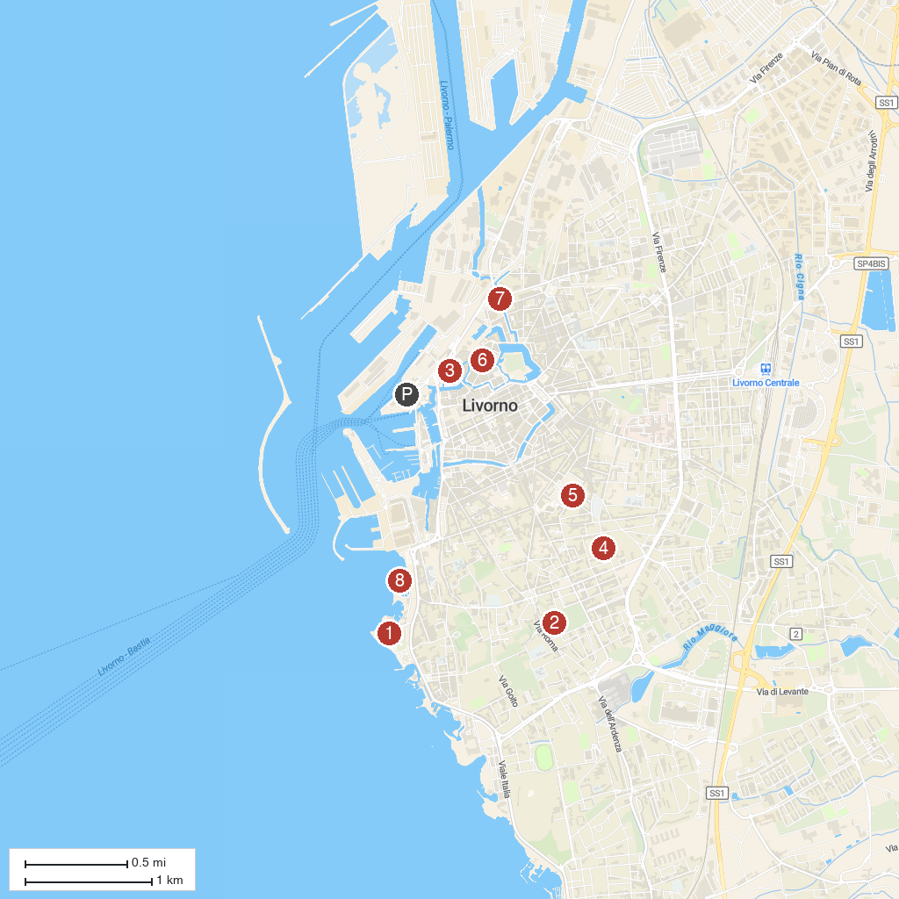
MAP KEY
1. Acquario di Livorno | 5. Santa Maria del Soccorso, Livorno
2. Villa Fabbricotti | 6. Chiesa di Santa Caterina
3. Church of San Ferdinando | 7. Customs on the Water
4. Villa Maria | 8. Scoglio della Regina
P. Cruise port / terminal
Map © MapTiler © OpenStreetMap contributors · cruiseports.org

