Livingston, Izabal, Guatemala
A town with no roads in or out, Livingston is Guatemala's Garifuna heartland — part Caribbean, part Mayan, entirely its own. Tender in to coconut bread, Punta drumbeats, and the dramatic Río Dulce canyon.
⚓ Tender port · 🕒 Typical call: 6-8 hrs · 💵 USD & Guatemalan Quetzal (GTQ) · 🗣️ Spanish & Garifuna
✍️ MY DAY IN PORT (FILL IN)
Ship / Date
In port | arrive ______ · all aboard ______
Booked excursion
Notes / meeting point
GETTING ASHORE
- Docking: Tender only — ships anchor offshore; 5–15 min ride to the municipal pier
- Walk to center: Immediate — main street (Calle Principal) begins at the pier
- Best For: Garifuna culture, Río Dulce canyon boat tour, Siete Altares waterfalls
- Don't Miss: Tapado soup and fresh pan de coco (coconut bread) from street vendors
GETTING AROUND
- 🚕 Taxi: ~$2–3 USD (Q20) — Local taxis are available for slightly longer hops within town. Agree on the fare before you get in — meters are not com
- 📱 Rideshare: ❌ not available
TOP THINGS TO DO
- Río Dulce Canyon Boat Tour — Speed through a 300-foot limestone gorge draped in tropical jungle, passing hot springs, water lilies, and indigenous fishing…
- Siete Altares Waterfalls — Seven freshwater cascades and natural pools hidden in the rainforest, about 3 miles north of town.
- Garifuna Town Walk & Culture — Explore Calle Principal, visit the Garifuna cultural displays, watch drumming demonstrations, and sample the unique…
- Playa Blanca Boat Trip — A private white-sand beach with coconut palms accessible only by a 25–30 minute boat ride from Livingston.
- Tapado & Local Cuisine — Livingston's signature dish is Tapado — a rich coconut-milk seafood soup with crab, fish, and shrimp.
BEST WALKS
- Calle Principal Town Walk: 0.6 mi · 15 min · Easy — Walk up the main street from the municipal pier past souvenir stalls, local cafes, and brightly…
WEATHER · DAYLIGHT · MONEY
Month | High °F | Low °F | Rainy days
May | 86 | 77 | 24
Jul | 84 | 76 | 30
Sep | 85 | 77 | 29
Daylight: May 5:25AM–6:17PM · Jul 5:32AM–6:30PM · Sep 5:43AM–5:56PM
cruiseports.org/livingston · Confirm terminal & all-aboard time with your ship

Livingston, Izabal, Guatemala — Port Map
Red = walkable sights · Amber = excursions farther out · P = cruise terminal
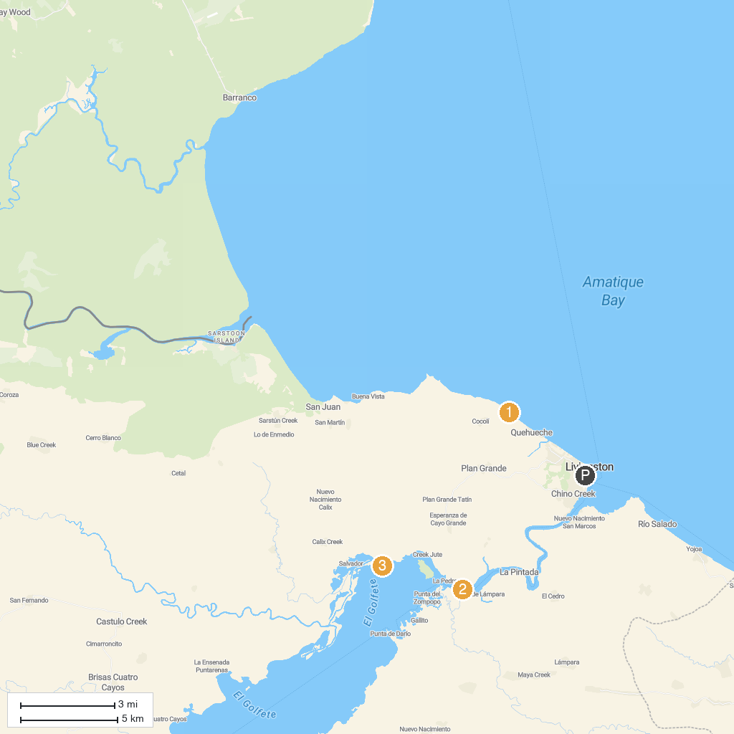
MAP KEY
1. Siete Altares | 3. Biotopo Protegido Chocón Machacas
2. Centro Ecoturístico Agua Caliente | 4. Playa Blanca, Livingston
P. Cruise port / terminal
Map © MapTiler © OpenStreetMap contributors · cruiseports.org

