Liverpool, England, United Kingdom
One of Britain's most storied port cities, Liverpool delivers an unbeatable combination of world-class music heritage, grand Victorian waterfront architecture, and genuinely free museums — all steps from the ship.
⚓ Docked (floating pontoon, Pier Head) · 🕒 Typical call: 8-10 hrs · 💷 Currency: British Pound (GBP) · 🗣️ Language: English
✍️ MY DAY IN PORT (FILL IN)
Ship / Date
In port | arrive ______ · all aboard ______
Booked excursion
Notes / meeting point
GETTING ASHORE
- Docking: Floating pontoon berth at Pier Head; ships up to 350 m; no tendering required
- Walk to centre: 5–15 min on foot to Royal Albert Dock, Three Graces, and city centre
- Best For: Beatles fans, history lovers, waterfront walks, free museums
- Don't Miss: The Beatles Story at Albert Dock and the iconic Three Graces on the waterfront
GETTING AROUND
- 🚕 Taxi: £9–£12 — Metered taxis queue at the rank directly outside the terminal on St Nicholas Place. Journey to Liverpool Lime Street or
- 📱 Rideshare: ✅ Uber
- 🚌 Hop-on hop-off: ✅
TOP THINGS TO DO
- Beatles Heritage Tour — Hit the legendary Cavern Club on Mathew Street, Strawberry Field, Penny Lane, and the childhood homes of John Lennon and Paul…
- Royal Albert Dock & Museums — Historic Royal Albert Dock houses The Beatles Story, Tate Liverpool, and the Merseyside Maritime Museum — all within steps of…
- Mersey Ferry River Cruise — The classic 50-minute 'Ferry 'Cross the Mersey' round trip departs from Pier Head and gives superb views of the waterfront Three…
- Chester Day Trip — Just 45 minutes by train, Chester offers complete Roman city walls, unique two-tiered medieval shopping rows (The Rows), Chester…
- Lake District Day Excursion — A longer coach excursion to England's premier national park — spectacular glacial lakes, fells, and quaint villages like…
BEST WALKS
- Waterfront & Three Graces Walk: 1.5 km · 20–25 min · Flat — From the cruise terminal, stroll south along the waterfront promenade past the Museum of Liverpool…
- Beatles City Walk: 2.5 km · 30–40 min · Flat — From Albert Dock, walk to the Beatles Statues at Pier Head, head up Water Street past grand banking…
WEATHER · DAYLIGHT · MONEY
Month | High °F | Low °F | Rainy days
May | 60 | 47 | 12
Jul | 67 | 56 | 17
Sep | 63 | 53 | 14
Daylight: May 5:11AM–9:05PM · Jul 5:03AM–9:32PM · Sep 6:46AM–7:26PM
cruiseports.org/liverpool · Confirm terminal & all-aboard time with your ship

Liverpool, England, United Kingdom — Port Map
Red = walkable sights · Amber = excursions farther out · P = cruise terminal
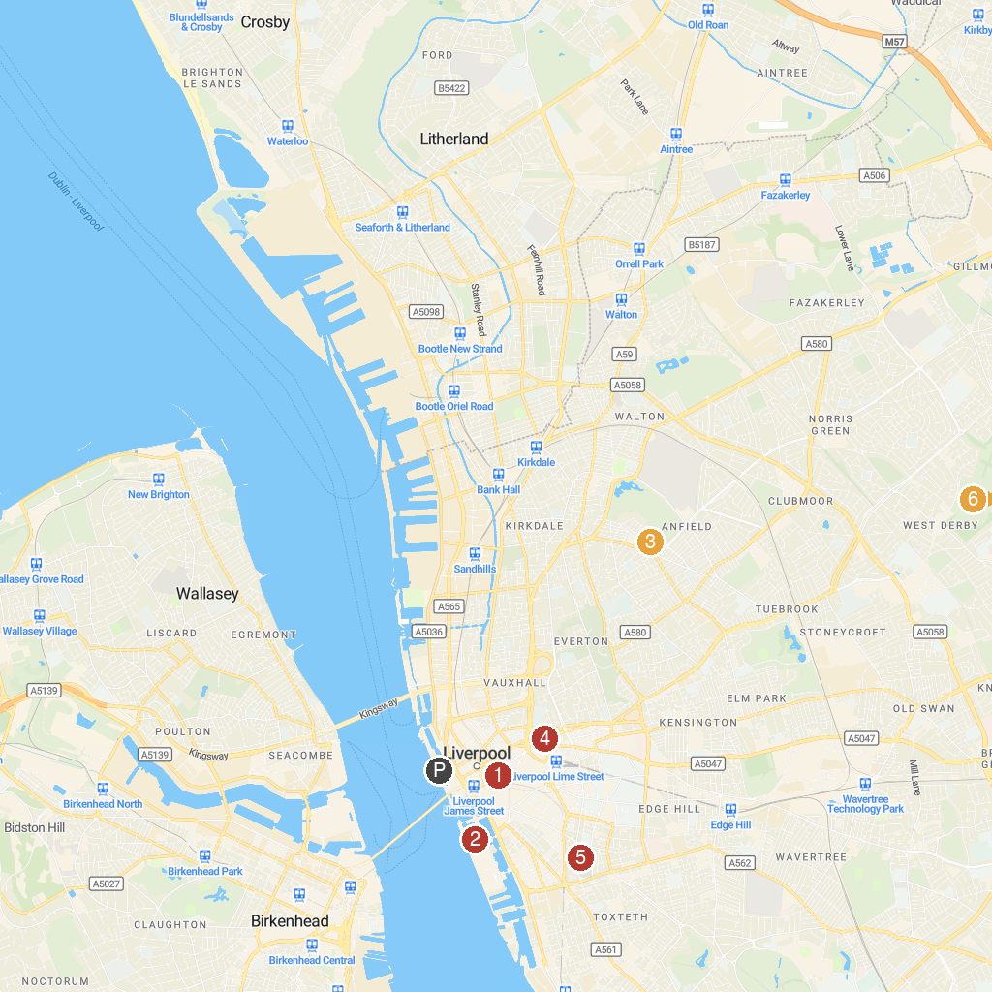
MAP KEY
1. The Cavern Club | 4. Walker Art Gallery
2. Royal Albert Dock Liverpool | 5. Liverpool Cathedral
3. Anfield | 6. Knowsley Safari
P. Cruise port / terminal
Map © MapTiler © OpenStreetMap contributors · cruiseports.org

