List auf Sylt, Schleswig-Holstein, Germany
Germany's northernmost town sits at the tip of Sylt — an island of wild dunes, pristine beaches, and world-class oysters that draws the country's elite and wandering cruise ships alike.
⚓ Tender port · 🕒 Typical call: 7-10 hrs · 💶 Euro (€) · 🗣️ German
✍️ MY DAY IN PORT (FILL IN)
Ship / Date
In port | arrive ______ · all aboard ______
Booked excursion
Notes / meeting point
GETTING ASHORE
- Docking: Tender to Lister Hafen (List Harbour)
- Walk to center: 0 min — tender lands at harbor; shops, GOSCH & museum steps away
- Best For: Dunes, oysters, seal tours, cycling the Ellenbogen
- Don't Miss: Sylter Royal oyster tasting and the Ellenbogen peninsula lighthouses
GETTING AROUND
- 🚕 Taxi: €5 base + ~€2.80/km; List to Westerland ~€35–45 — Metered taxis serve the whole island under the official North Frisian Islands tariff. The ride from List port to Westerl
- 📱 Rideshare: ❌ not available
TOP THINGS TO DO
- Ellenbogen Dunes & Lighthouses — Cycle or walk the 4.5 km to the Ellenbogen (Elbow) peninsula — Germany's northernmost point — passing wild sheep, towering…
- Wadden Sea Seal Watching Cruise — Board an Adler-Schiffe boat at List Harbour for a cruise across the UNESCO Wadden Sea to see harbour seal colonies lounging on…
- Sylter Royal Oyster Tasting — Visit Dittmeyer's Austerncompagnie, a short walk from the harbour, to see the indoor seawater purification basins where Sylter…
- Naturgewalten Forces of Nature Museum — Highly interactive exhibition on the geology, weather, and ecology of Sylt and the Wadden Sea — right at the harbour.
- West Beach & Strandkorb — Take the bus or bike to Sylt's wild North Sea-facing West Beach.
BEST WALKS
- Harbour Village Stroll: 1 km · 20 min · Flat — From the tender dock at List Harbour, walk the boardwalk past GOSCH, the Naturgewalten museum, and…
- Königshafen Bay Walk: 3 km · 45 min · Easy — Head north from the harbour along the edge of Königshafen (King's Harbour), a calm sheltered bay.
WEATHER · DAYLIGHT · MONEY
Month | High °F | Low °F | Rainy days
May | 55 | 50 | 11
Jul | 65 | 61 | 14
Sep | 63 | 58 | 14
Daylight: May 5:18AM–9:27PM · Jul 5:08AM–9:55PM · Sep 6:59AM–7:42PM
cruiseports.org/list-auf-sylt · Confirm terminal & all-aboard time with your ship

List auf Sylt, Schleswig-Holstein, Germany — Port Map
Red = walkable sights · Amber = excursions farther out · P = cruise terminal
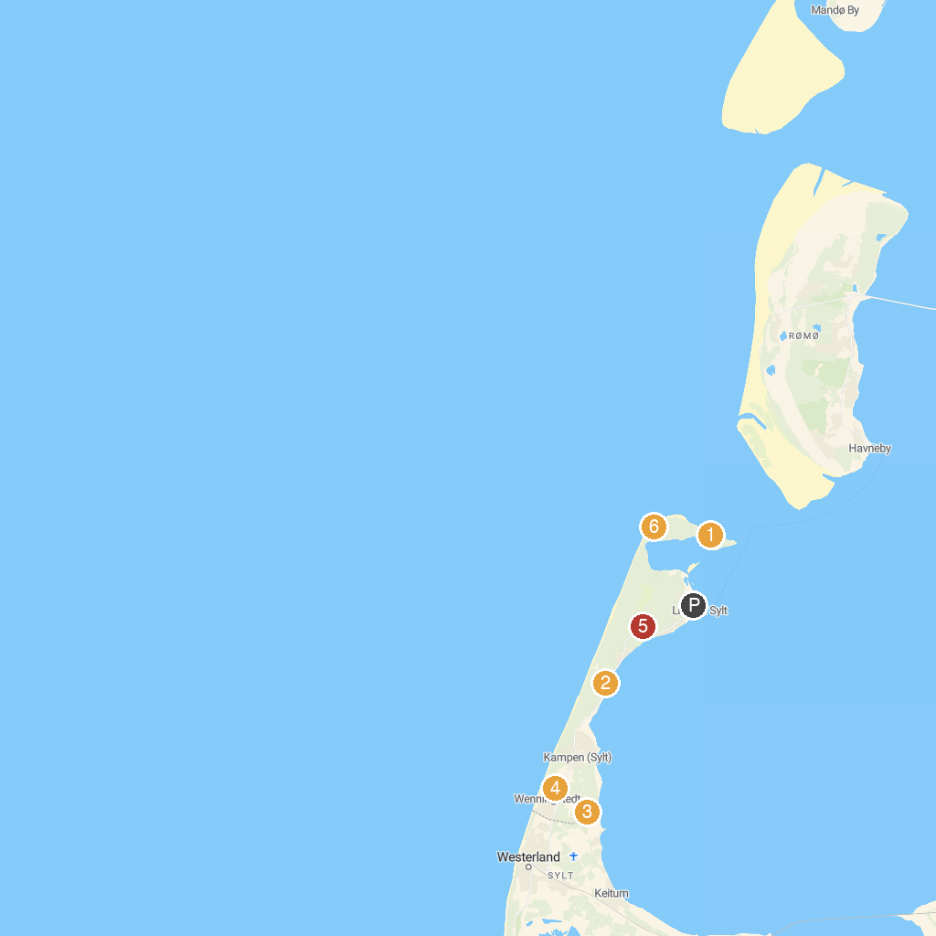
MAP KEY
1. Leuchtturm List-Ost | 5. Hjerpsted Church
2. Naturpfad Vogelkoje Kampen | 6. Wanderdüne Horst
3. Naturzentrum Braderup | 7. Leuchtturm List-West
4. Friesenkapelle
P. Cruise port / terminal
Map © MapTiler © OpenStreetMap contributors · cruiseports.org

