Lipsi Island, Dodecanese, Greece
The antidote to Santorini crowds — Lipsi is 16 square kilometres of whitewashed lanes, turquoise coves, and octopus drying in the sun. Most cruise ships anchor in the bay and tender passengers straight into the heart of a working Greek harbour.
⚓ Tender (most ships) · 🕒 Typical call: 5–8 hrs · 💶 Currency: Euro · 🗣️ Language: Greek (English widely spoken) · 🌊 Best for: beaches & slow travel
✍️ MY DAY IN PORT (FILL IN)
Ship / Date
In port | arrive ______ · all aboard ______
Booked excursion
Notes / meeting point
GETTING ASHORE
- Docking: Tender — ships anchor in the bay; small vessels may berth at the main pier
- Walk to village: Tender/gangway drops you at the harbour; Chora is 5–10 min uphill
- Best For: Unspoiled beaches, authentic Greek island life, fresh seafood
- Don't Miss: Grilled octopus at the harbour & Platis Gialos Beach
GETTING AROUND
- 🚕 Taxi: €2–€8 — A small number of taxis are based at the port. Fares are low due to the island's compact size — beach trips run €4–€8 ea
- 📱 Rideshare: ❌ not available
TOP THINGS TO DO
- Platis Gialos Beach — The island's standout beach — a wide sandy bay of shallow turquoise water fringed by tamarisk trees.
- Chora Village Walk — Wander the pedestrianised lanes of whitewashed houses draped in bougainvillea.
- Panagia tou Charou Church — An early-17th-century church (founded around 1600) famous across Greece for its rare icon of the Virgin Mary holding the…
- Lipsi Winery — Lipsi's Fokiano grape produces a distinctive sweet red wine that, during the Italian occupation, was shipped to the Vatican for…
- Katsadia Beach & Dilaila — A sheltered sandy cove 30 minutes' walk or 5 minutes by taxi south of the port.
BEST WALKS
- Harbour to Chora: 0.5 km · 10 min · Easy–moderate — From the tender dock follow the waterfront past the harbour tavernas, then take the paved steps…
- Harbour to Lientou Beach: 0.7 km · 10 min · Easy — From the pier turn right (south-east) along the flat coast path to reach Lientou Beach — calm…
WEATHER · DAYLIGHT · MONEY
Month | High °F | Low °F | Rainy days
May | 74 | 62 | 5
Jul | 86 | 73 | 0
Sep | 81 | 69 | 2
Daylight: May 6:12AM–8:13PM · Jul 6:03AM–8:22PM · Sep 7:06AM–7:19PM
cruiseports.org/lipsi-island · Confirm terminal & all-aboard time with your ship

Lipsi Island, Dodecanese, Greece — Port Map
Red = walkable sights · Amber = excursions farther out · P = cruise terminal
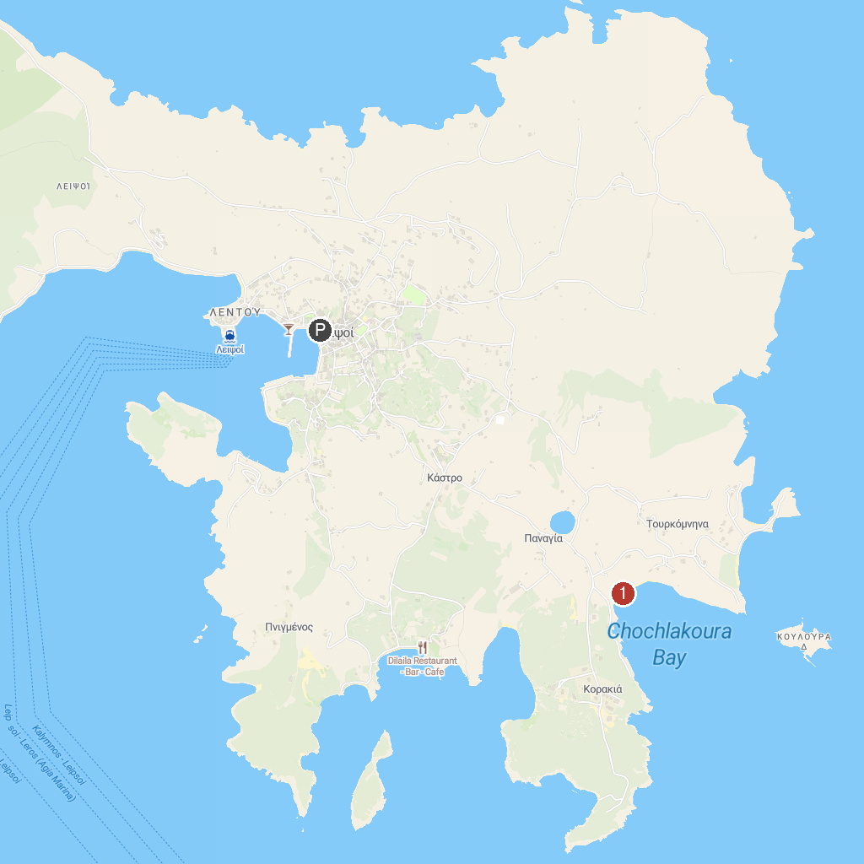
MAP KEY
1. Chochlakoura Beach | 3. Blefoutis beach
2. Agia Matrona-Kioura
P. Cruise port / terminal
Map © MapTiler © OpenStreetMap contributors · cruiseports.org

