Lipari, Aeolian Islands, Italy
The largest of the Aeolian Islands rises from a UNESCO-listed volcanic seascape — ancient obsidian trade routes, a Norman hilltop castle, and the best pane cunzato in Italy await.
⚓ Tender port (most ships) · 🕒 Typical call: 6–8 hrs · 💶 Currency: Euro · 🗣️ Language: Italian · 🌋 UNESCO World Heritage
✍️ MY DAY IN PORT (FILL IN)
Ship / Date
In port | arrive ______ · all aboard ______
Booked excursion
Notes / meeting point
GETTING ASHORE
- Docking: Tender to Marina Lunga; small ships may dock at Sottomonastero pier
- Walk to center: ~1 km (10–15 min) from Marina Lunga into Lipari Town center
- Best For: History, volcanic scenery, Sicilian food, archaeology
- Don't Miss: Aeolian Archaeological Museum and Belvedere Quattrocchi viewpoint
GETTING AROUND
- 🚕 Taxi: €5–€15 — Taxis wait at the port and town center. Short rides around Lipari town run €5–€10; cross-island trips up to €15. No ride
- 📱 Rideshare: ❌ not available
TOP THINGS TO DO
- Aeolian Archaeological Museum — Inside the castle complex, this is one of Europe's finest prehistoric collections — ancient Greek theatrical masks, Neolithic…
- Belvedere Quattrocchi — The island's most famous viewpoint — dramatic cliffs and the Pietra Lunga and Pietra Menalda sea stacks plunging to the sea, with…
- Canneto & Spiaggia Bianca — Canneto is Lipari's main beach — dark volcanic sand and pebbles with clear water and beach-club loungers.
- Lipari Town & Castle Walk — Wander Corso Vittorio Emanuele II, climb through the ancient castle gates, visit the Norman Cathedral of San Bartolomeo, and…
- Aeolian Food & Wine — Try pane cunzato (Lipari's iconic seasoned bread with capers, tomatoes and tuna), pasta alla eoliana, granita con brioche, and a…
BEST WALKS
- Marina Lunga to Castle & Cathedral: 1.5 km | 25–35 min | Moderate (steep final climb) — From the tender landing at Marina Lunga, walk the waterfront into town and climb the cobbled ramp…
- Marina Lunga to Canneto Beach: 3 km | 45 min walk (or 10 min by bus) | Easy — Head north along the coast road from Marina Lunga to reach Canneto, the island's most accessible…
WEATHER · DAYLIGHT · MONEY
Month | High °F | Low °F | Rainy days
May | 67 | 64 | 6
Jul | 80 | 77 | 2
Sep | 77 | 74 | 8
Daylight: May 5:48AM–8:04PM · Jul 5:48AM–8:23PM · Sep 6:42AM–7:07PM
cruiseports.org/lipari-island · Confirm terminal & all-aboard time with your ship

Lipari, Aeolian Islands, Italy — Port Map
Red = walkable sights · Amber = excursions farther out · P = cruise terminal
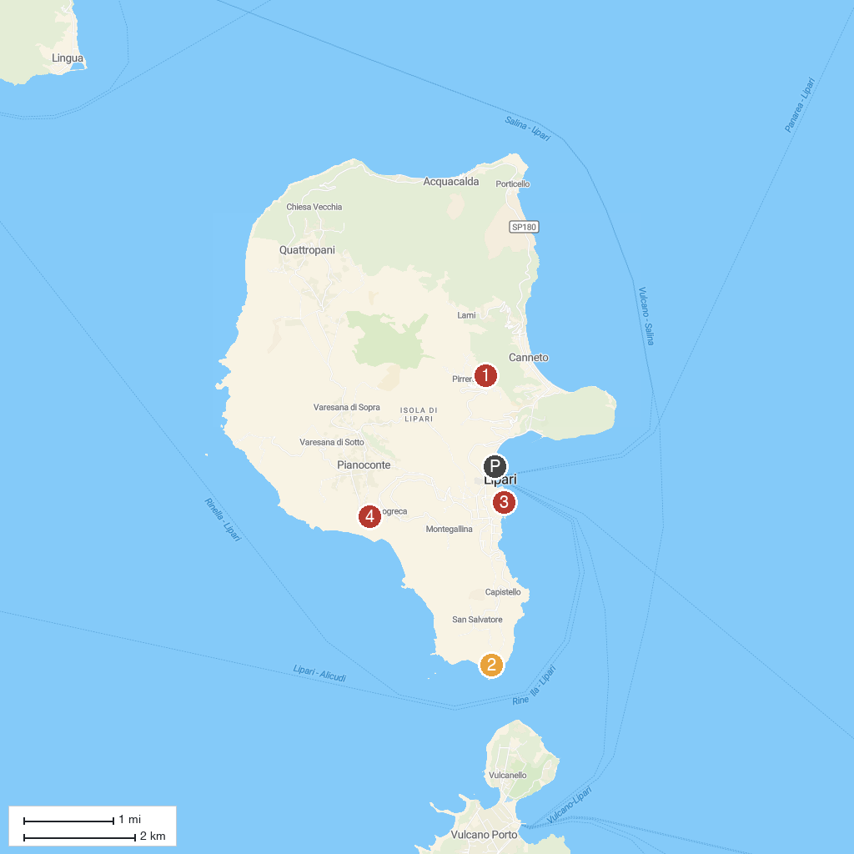
MAP KEY
1. Forgia Vecchia di Lipari | 3. Museo Archeologico Eoliano "Luigi Bernabò Brea"
2. Punta della Crepazza lipari | 4. Belvedere Quattrocchi
P. Cruise port / terminal
Map © MapTiler © OpenStreetMap contributors · cruiseports.org

