Linz, Upper Austria, Austria
Austria's third city surprises visitors with a Baroque main square, cutting-edge museums, and the birthplace of the world's oldest cake recipe — all steps from the Danube pier.
⚓ Docked (riverside pier) · 🕒 Typical call: 8–10 hrs · 💶 Euro (€) · 🗣️ German (English widely spoken)
✍️ MY DAY IN PORT (FILL IN)
Ship / Date
In port | arrive ______ · all aboard ______
Booked excursion
Notes / meeting point
GETTING ASHORE
- Docking: Docked along Donaulände, south bank of Danube
- Walk to center: 5–10 min flat walk to Hauptplatz
- Best For: History, modern art, foodie experiences, day trips to Salzburg
- Don't Miss: Linzer Torte at Café Jindrak & Pöstlingberg tram ride
GETTING AROUND
- 🚕 Taxi: €10–€20 — Regulated metered taxis; base fare ~€6.40 daytime. The port to city center is a short ride, typically €10–€20 depending
- 📱 Rideshare: ✅ Uber, Bolt
TOP THINGS TO DO
- Pöstlingberg Tram & Viewpoint — Ride one of the world's steepest adhesion railways — and Austria's steepest — from Hauptplatz to the top of Pöstlingberg.
- Ars Electronica Center — Museum of the Future — A world-renowned museum exploring AI, biotechnology, and digital art.
- Hauptplatz & Linz Castle — Explore one of Central Europe's largest enclosed urban squares, dominated by the Baroque Trinity Column.
- Linzer Torte & Coffeehouse Trail — The world's oldest cake recipe was born here.
- Day Trip to Salzburg — Salzburg is just 90 minutes by train from Linz Hauptbahnhof.
BEST WALKS
- Riverside to Hauptplatz & Old Town: 1.5 km • 30–45 min • Easy • Flat — Walk west from the Donaulände pier along the river promenade, passing the Lentos Art Museum's glass…
- North Bank: Ars Electronica & Urfahrmarkt: 2 km loop • 45–60 min • Easy • Flat — Cross the Nibelungenbrücke to the north bank, walk along the riverside to the striking Ars…
WEATHER · DAYLIGHT · MONEY
Month | High °F | Low °F | Rainy days
May | 66 | 49 | 16
Jul | 79 | 61 | 13
Sep | 70 | 54 | 10
Daylight: May 5:23AM–8:35PM · Jul 5:18AM–8:58PM · Sep 6:40AM–7:14PM
cruiseports.org/linz · Confirm terminal & all-aboard time with your ship

Linz, Upper Austria, Austria — Port Map
Red = walkable sights · Amber = excursions farther out · P = cruise terminal
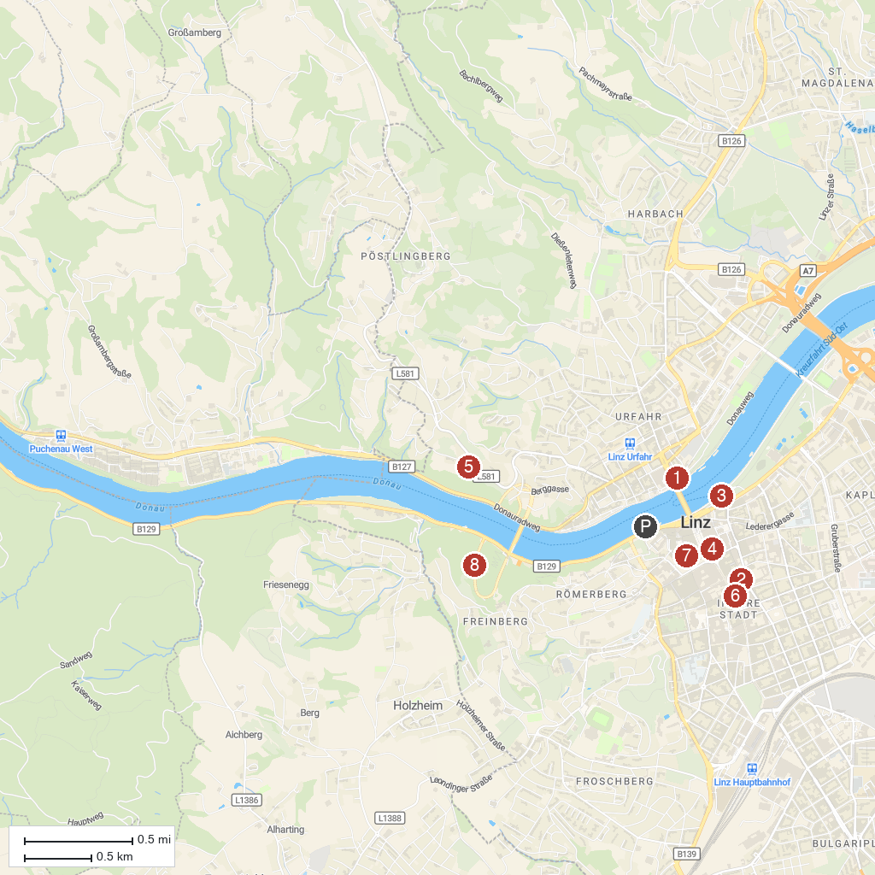
MAP KEY
1. Ars Electronica Center | 5. Zoo Linz
2. OK Center for Contemporary Art Austria | 6. Carmelite Convent Linz
3. Lentos Kunstmuseum Linz | 7. Mozarthaus
4. Alter Dom - Ignatiuskirche | 8. Franz-Josefs-Warte
P. Cruise port / terminal
Map © MapTiler © OpenStreetMap contributors · cruiseports.org

