Linz am Rhein, Rhineland-Palatinate, Germany
Known as Die Bunte Stadt am Rhein — 'The Colorful Town on the Rhine' — Linz enchants with a medieval Altstadt painted in reds, greens, and golds, all reachable in minutes from the dock.
⚓ Docked (riverside pier) · 🕒 Typical call: 3-5 hrs · 💶 Euro (€) · 🗣️ German
✍️ MY DAY IN PORT (FILL IN)
Ship / Date
In port | arrive ______ · all aboard ______
Booked excursion
Notes / meeting point
GETTING ASHORE
- Docking: Alongside on the Rhine promenade — no tender required
- Walk to center: ~200-300 m (3-5 min) through the historic Rheintor gate
- Best For: Medieval architecture, local wine, and leisurely strolling
- Don't Miss: Burg Linz glassblowing and the half-timbered Rathaus on Marktplatz
GETTING AROUND
- 🚕 Taxi: €8–12 — Taxis are available at the pier. District of Neuwied rates apply: ~€3.80 base fare plus ~€2.40/km. The short distance to
- 📱 Rideshare: ✅ Uber, FREE NOW
TOP THINGS TO DO
- Burg Linz Castle & Glassblowing Workshop — Built in 1365 by the Archbishop of Cologne, Burg Linz houses artisan craft shops, a Roman-style glassblowing workshop, and a…
- Altstadt Walk — Historic Half-Timbered Town Hall — Stroll Rheinstraße and the Buttermarkt past brilliantly painted 15th- and 16th-century Fachwerk houses.
- St. Martin's Church — Medieval Frescoes — Begun in 1206, this hilltop church preserves exceptional 13th- through 15th-century wall paintings rarely seen outside major…
- Rhine Riesling Tasting — Linz sits in the Middle Rhine wine region.
BEST WALKS
- Altstadt & Burg Linz Loop: 1.5 km · 45-60 min · Easy (cobblestones) — From the Rhine pier, pass through the Rheintor gate, walk up Rheinstraße to Marktplatz to see the…
- Up to St. Martin's Church: 0.8 km each way · 20 min · Moderate (uphill lane) — From Marktplatz, follow the signposted lane up to St.
WEATHER · DAYLIGHT · MONEY
Month | High °F | Low °F | Rainy days
May | 65 | 49 | 13
Jul | 76 | 60 | 13
Sep | 69 | 54 | 9
Daylight: May 5:42AM–9:12PM · Jul 5:36AM–9:36PM · Sep 7:06AM–7:44PM
cruiseports.org/linz-am-rhein · Confirm terminal & all-aboard time with your ship

Linz am Rhein, Rhineland-Palatinate, Germany — Port Map
Red = walkable sights · Amber = excursions farther out · P = cruise terminal
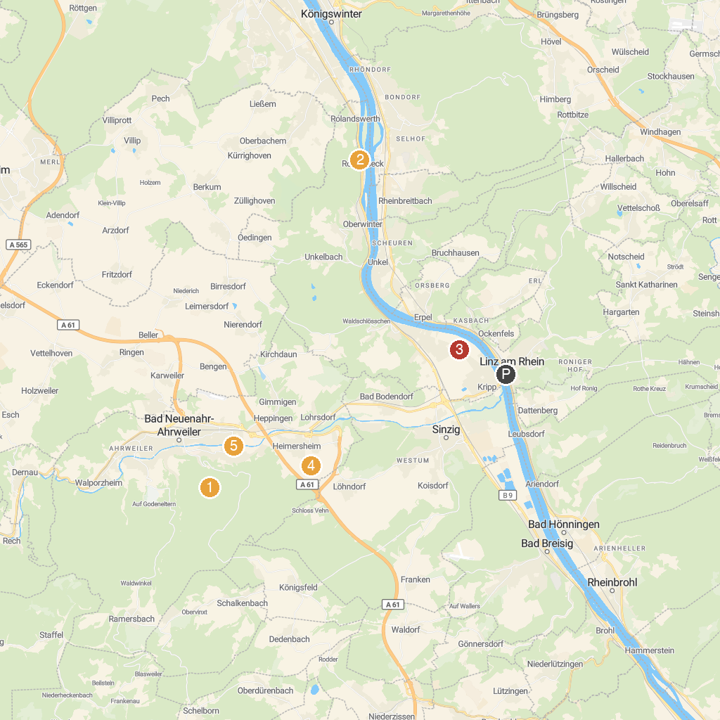
MAP KEY
1. Burg Odenhausen | 5. Arp Museum Bahnhof Rolandseck
2. Schloss Drachenburg | 6. Friedenskapelle „Schwarze Madonna“
3. Forest Adventure Treeclimbing Park Bad Neuenahr | 7. Sitzbank XXL
4. Dokumentationsstätte Regierungsbunker | 8. Lenné Park
P. Cruise port / terminal
Map © MapTiler © OpenStreetMap contributors · cruiseports.org

