Lillesand, Agder, Norway
One of Norway's best-preserved 18th-century harbor towns, Lillesand charms with its iconic white wooden houses, car-free quayside, and access to the royal playground of the Blindleia waterway.
⚓ Tender (most ships) / Small ships dock · 🕒 Typical call: 5–8 hrs · 💳 Cashless — cards everywhere (NOK) · 🗣️ Norwegian (English widely spoken)
✍️ MY DAY IN PORT (FILL IN)
Ship / Date
In port | arrive ______ · all aboard ______
Booked excursion
Notes / meeting point
GETTING ASHORE
- Docking: Tender for most ships; small/expedition vessels dock at Dampskipskaien quay
- Walk to center: 0 min — tender dock is in the harbor center
- Best For: Old-town strolling, boat tours, fresh shrimp on the quay
- Don't Miss: Blindleia boat tour or a bag of freshly boiled shrimp from a fishing boat
GETTING AROUND
- 🚕 Taxi: NOK 470–600 (~€40–52) one way — Taxis at Kristiansand cruise terminal can take you directly to Lillesand in about 25 minutes. Taxi Sør is the main local
- 📱 Rideshare: ✅ Uber
TOP THINGS TO DO
- Blindleia Boat Tour — A roughly 20-km inland waterway sheltered by a chain of skerries, Blindleia threads past summer cabins, tiny lighthouses, and…
- Lillesand Town Museum (Carl Knudsengården) — A merchant's house from 1827 preserves the town's shipbuilding golden age — with a historic pharmacy, tool exhibits, and a lovely…
- Kaldvell Nature Reserve Hike — About 4 km from the port, Kaldvell offers river trails past ruins of historic pulp mills, stone bridges, and small waterfalls — a…
- Old Town Stroll & Shrimp on the Quay — Wander Strandgata and Nygata to admire the white Empire-style houses, then buy a bag of freshly boiled shrimp from a fishing boat…
- Lillesand Church Visit — A picturesque 1889 Swiss-style wooden church sitting on a hill 15 minutes from the harbor, with views over the town and coastline.
BEST WALKS
- Old Town Heritage Walk: 1.5 km · 30–45 min · Easy — From the harbor, head into the old town streets (Strandgata, Nygata) to see the iconic white wooden…
- Beach Walk to Bystranda: 1 km · 10–15 min · Easy — A short, flat walk south along the waterfront from the harbor to Bystranda town beach — a small…
WEATHER · DAYLIGHT · MONEY
Month | High °F | Low °F | Rainy days
May | 59 | 44 | 11
Jul | 69 | 55 | 13
Sep | 61 | 51 | 14
Daylight: May 5:00AM–9:46PM · Jul 4:45AM–10:17PM · Sep 6:56AM–7:45PM
cruiseports.org/lillesand · Confirm terminal & all-aboard time with your ship

Lillesand, Agder, Norway — Port Map
Red = walkable sights · Amber = excursions farther out · P = cruise terminal
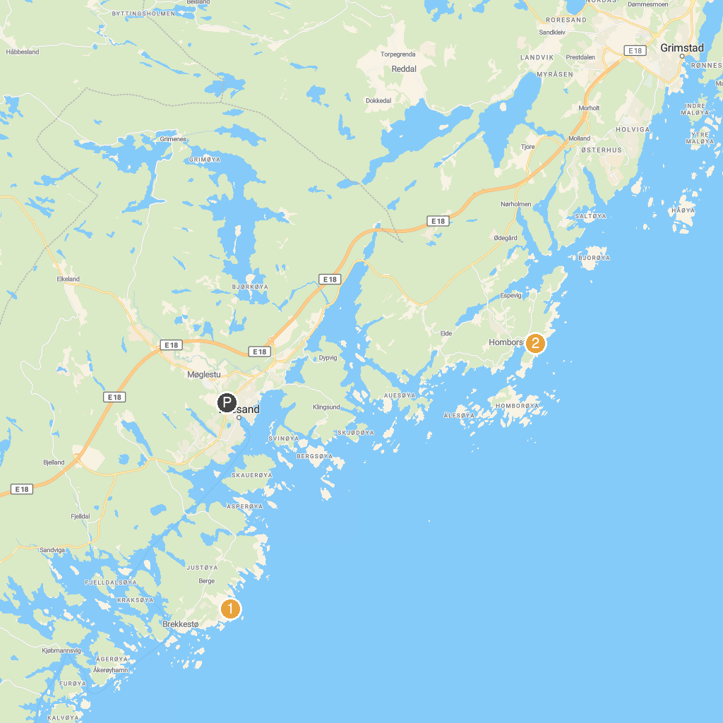
MAP KEY
1. HKB 31./979 Justöen | 3. Mollestadtree
2. Kalvehageneset
P. Cruise port / terminal
Map © MapTiler © OpenStreetMap contributors · cruiseports.org

