Liepāja, Latvia
Latvia's 'City of Wind' delivers a double life: crumbling Soviet bunkers sinking into the Baltic Sea at Karosta, then pristine Art Nouveau streets and sugar-white sand just minutes away.
⚓ Pier port (no tender) · 🕒 Typical call: 8–10 hrs · 💶 Currency: Euro (€) · 🗣️ Language: Latvian / English widely spoken
✍️ MY DAY IN PORT (FILL IN)
Ship / Date
In port | arrive ______ · all aboard ______
Booked excursion
Notes / meeting point
GETTING ASHORE
- Docking: Pier — commercial berths inside port; smaller ships near Trade Canal (~1 km walk), larger ships ~3–4 km from center
- Walk to Center: 10–15 min from Trade Canal berth; taxi/tram recommended from commercial berths
- Best For: Soviet history buffs, beach lovers, organ music, Art Nouveau architecture
- Don't Miss: Karosta Prison extreme tour & the world's largest mechanical pipe organ at Holy Trinity Cathedral
GETTING AROUND
- 🚕 Taxi: €3–5 — The cruise terminal is approximately 3 km from the city center, making taxi rides short and affordable. Taxis meet ships
- 📱 Rideshare: ✅ Bolt
TOP THINGS TO DO
- Karosta Prison Extreme Tour — The only military prison in Europe open to tourists — used by both Tsarist and Soviet regimes.
- Karosta Northern Forts & Coastline — Tsarist fortifications from the 1890s, deliberately blown up in 1908, now collapsing dramatically into the Baltic Sea.
- Holy Trinity Cathedral & Great Organ — A 1758 cathedral housing the world's largest unreconstructed mechanical pipe organ — over 7,000 pipes.
- Blue Flag Beach & Seaside Park — Sugar-white sand historically fine enough for hourglasses stretches along the Baltic.
- Art Nouveau & Musical Trail Walk — Metal musical notes embedded in the cobblestones guide you past Graudu and Dzintaru street facades, the Musicians' Alley of Fame…
BEST WALKS
- City Center Musical Trail: 2 km · Easy · 45 min — Follow the bronze musical notes embedded in the cobblestones from Rose Square through the historic…
- Seaside Park to Beach: 1.5 km · Easy · 30 min — From the city center, stroll south through Jūrmalas Parks past ornate wooden summer villas and the…
WEATHER · DAYLIGHT · MONEY
Month | High °F | Low °F | Rainy days
May | 60 | 46 | 10
Jul | 70 | 59 | 14
Sep | 63 | 53 | 12
Daylight: May 5:20AM–9:45PM · Jul 5:08AM–10:14PM · Sep 7:07AM–7:53PM
cruiseports.org/liepaja · Confirm terminal & all-aboard time with your ship

Liepāja, Latvia — Port Map
Red = walkable sights · Amber = excursions farther out · P = cruise terminal
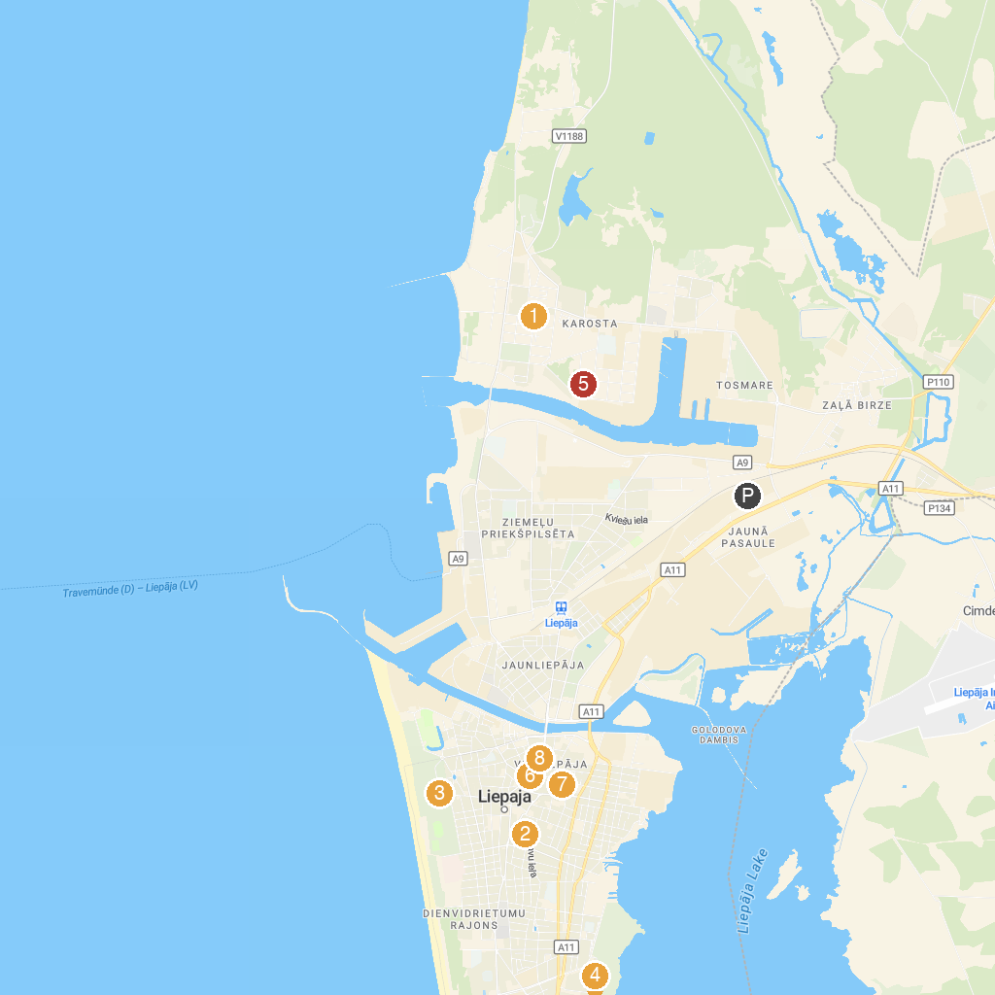
MAP KEY
1. The Naval Orthodox Cathedral of Saint Nicholas | 5. Karosta Prison
2. Liepāja Occupation Museum | 6. Rose Square
3. Spoku koks (Tree of Ghosts) | 7. Liepājas Amatnieku Nams
4. Liepājas Paintball klubs | Combat Arena | Wargame.lv | 8. Holy Trinity Cathedral
P. Cruise port / terminal
Map © MapTiler © OpenStreetMap contributors · cruiseports.org

