Liège, Wallonia, Belgium
La Cité Ardente earns its name — a fiery river city of 374-step staircases, medieval alleys, caramelized waffles, and an underground spirit called peket. Less polished than Bruges, far more real.
⚓ River pier (no tender) · 🕒 Typical call: 6-8 hrs · 💶 Euro (€) · 🗣️ French
✍️ MY DAY IN PORT (FILL IN)
Ship / Date
In port | arrive ______ · all aboard ______
Booked excursion
Notes / meeting point
GETTING ASHORE
- Docking: Quai de la Goffe — walk directly off the gangway onto the Meuse promenade
- Walk to center: 5 min to Place Saint-Lambert; Grand Curtius Museum is 1 min away
- Best For: Architecture, Belgian food, history, authentic city life
- Don't Miss: Montagne de Bueren (374 steps), Liège waffle from a street stall, Sunday La Batte market
GETTING AROUND
- 🚕 Taxi: €10–€20 — Metered taxis are available at the cruise terminal. Fares to the city center typically fall in this range depending on e
- 📱 Rideshare: ✅ Uber, Bolt
TOP THINGS TO DO
- Montagne de Bueren & Citadel Views — Climb 374 monumental steps carved into the hillside — built in 1880 so soldiers could reach the city quickly.
- Grand Curtius Museum — A 17th-century red-brick mansion right on the quay houses Liège's finest collections — decorative arts, arms and armour…
- Outremeuse — The Rebel Republic — Cross the footbridge to this bohemian neighbourhood that once declared itself an independent republic.
- Calatrava Train Station — Liège-Guillemins is a masterpiece of structural architecture by Santiago Calatrava — soaring steel arches and glass with no…
- Walloon Food & Peket Tasting — Try boulets à la liégeoise (meatballs in sweet Sirop de Liège sauce), an authentic Liège waffle (dense, pearl-sugar, eaten warm)…
BEST WALKS
- Old Town Loop: 2.5 km · 1.5-2 hrs · Moderate (steps) — From the quay, walk to the Grand Curtius Museum, then up Rue Hors-Château to the Impasses (medieval…
- Riverside to Boverie Park: 3 km · 45 min · Easy (flat) — Head south along the Meuse promenade past the Sunday market zone, cross to the Boverie island park…
WEATHER · DAYLIGHT · MONEY
Month | High °F | Low °F | Rainy days
May | 64 | 48 | 12
Jul | 74 | 58 | 13
Sep | 68 | 53 | 11
Daylight: May 5:49AM–9:19PM · Jul 5:42AM–9:43PM · Sep 7:13AM–7:51PM
cruiseports.org/liege · Confirm terminal & all-aboard time with your ship

Liège, Wallonia, Belgium — Port Map
Red = walkable sights · Amber = excursions farther out · P = cruise terminal
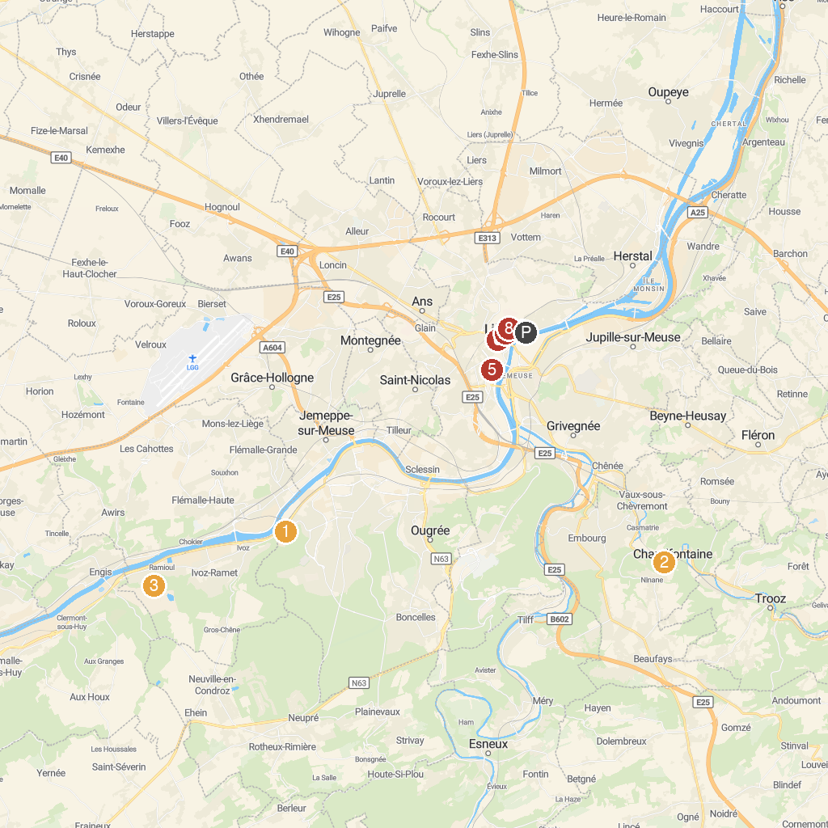
MAP KEY
1. Val Saint-Lambert Crystal Factory | 5. Church Saint-Jacques
2. Source O Rama | 6. Archéoforum
3. Prehistomuseum | 7. Museum of Walloon Life
4. Le Grand Curtius Museum | 8. Montagne de Bueren
P. Cruise port / terminal
Map © MapTiler © OpenStreetMap contributors · cruiseports.org

