Libourne, Gironde, France
A medieval English bastide at the heart of Right Bank wine country, Libourne puts Saint-Émilion ten minutes away and a world-class market steps from your gangway.
⚓ Docked (river pontoon) · 🕒 Typical call: 8-10 hrs · 💶 Euro (€) · 🗣️ French · 🍷 River cruise only
✍️ MY DAY IN PORT (FILL IN)
Ship / Date
In port | arrive ______ · all aboard ______
Booked excursion
Notes / meeting point
GETTING ASHORE
- Docking: Tied alongside at Roger de Leyburn or Jeanne d'Albret pontoon — no tender
- Walk to center: 5-10 min flat walk to Place Abel Surchamp (~500 m)
- Best For: Wine tasting, local markets, Saint-Émilion day trips
- Don't Miss: Tuesday, Friday, or Sunday morning market on the central square
GETTING AROUND
- 🚕 Taxi: €8–€15 — Taxis serve the port area with a base fare of ~€8 (includes first 2.5 km) plus €2.08/km daytime. The city center is walk
- 📱 Rideshare: ✅ Uber
TOP THINGS TO DO
- Saint-Émilion Wine Village — The UNESCO-listed hilltop village of Saint-Émilion is just 9 km away.
- Libourne Morning Market — On Tuesdays, Fridays, and Sundays, Place Abel Surchamp fills with local cheeses, truffles, fresh oysters, charcuterie, and…
- Pomerol Château Visit — Pomerol borders the town itself.
- Libourne Bastide Walking Tour — Founded in 1270 by an English lieutenant of King Edward I, Libourne is a classic bastide — a fortified grid-planned town.
- Bordeaux City Day Trip — Bordeaux is only 20-30 minutes by direct train from Libourne station.
BEST WALKS
- Quay to Town Center: 30 min · Easy · Flat — Walk the renovated riverfront north from your ship, passing the Tour du Grand Port (the last…
- Station Loop for DIY Day-Trippers: 20 min one-way · Easy — Walk from the pier along the quay to the town center, then continue inland to Gare de Libourne.
WEATHER · DAYLIGHT · MONEY
Month | High °F | Low °F | Rainy days
May | 70 | 52 | 11
Jul | 81 | 63 | 7
Sep | 77 | 58 | 8
Daylight: May 6:32AM–9:23PM · Jul 6:29AM–9:44PM · Sep 7:40AM–8:11PM
cruiseports.org/libourne · Confirm terminal & all-aboard time with your ship

Libourne, Gironde, France — Port Map
Red = walkable sights · Amber = excursions farther out · P = cruise terminal
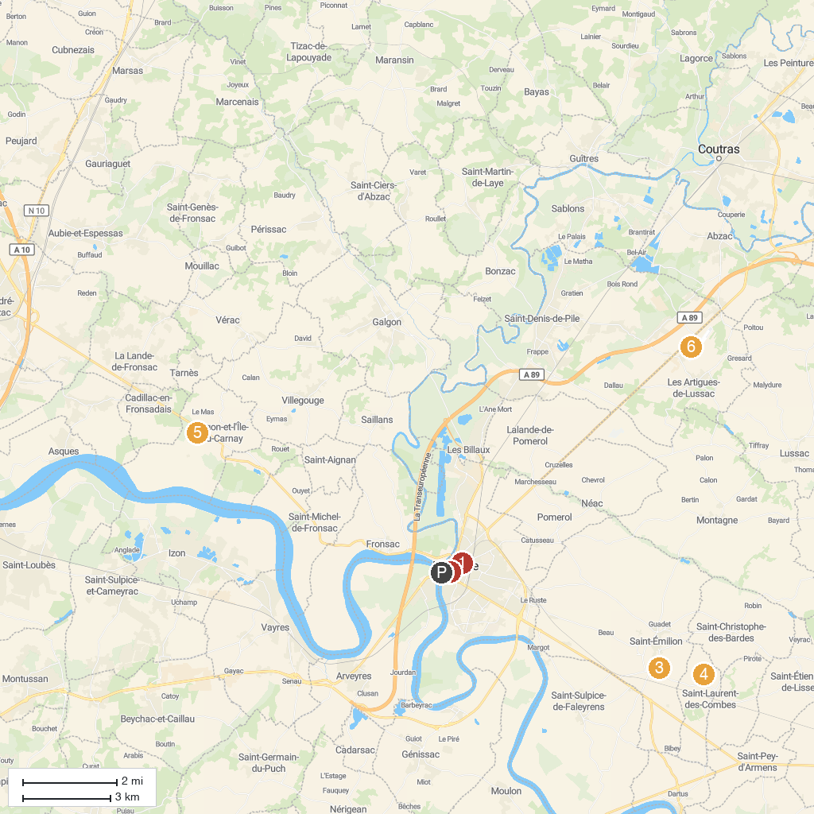
MAP KEY
1. Chapelle du Carmel | 5. Le Jardin du Fond de l'Or
2. Museum of Fine Arts and Archeology of Libourne | 6. Appy Ulm Baptême De L'air Et Initiation Au Vol En Ulm Près De Bordeaux
3. Château Saint Georges Côte Pavie | 7. Domaine de la Grave - Vignobles Roche Teycheney
4. Château Rochebelle Saint-Émilion Grand Cru Classé
P. Cruise port / terminal
Map © MapTiler © OpenStreetMap contributors · cruiseports.org

