Lesbos Island (Mytilene), Aegean, Greece
Lesbos is the Greece that tourist brochures don't oversell — a big, unhurried island of ouzo distilleries, petrified forests, a castle visible from the ship, and sardines so famous they have their own protected designation.
⚓ Pier (central harbor) · 🕒 Typical call: 7–10 hrs · 💶 Currency: Euro (€) · 🗣️ Language: Greek
✍️ MY DAY IN PORT (FILL IN)
Ship / Date
In port | arrive ______ · all aboard ______
Booked excursion
Notes / meeting point
GETTING ASHORE
- Docking: Pier — ships dock in central Mytilene harbor, steps from town
- Walk to center: 3–5 min to Ermou Street market; 15 min to the castle
- Best for: Authentic Greek culture, ouzo tasting, history, beaches
- Don't miss: Castle of Mytilene, Ermou market street, sardines at a harborside ouzeri
GETTING AROUND
- 🚕 Taxi: €7–13 — Metered taxis queue at the port exit. Fares within Mytilene town run roughly €7–10; night rates (midnight–5am) are highe
- 📱 Rideshare: ❌ not available
TOP THINGS TO DO
- Castle of Mytilene — One of the largest castles in the Mediterranean, built in the Byzantine era and expanded by the Genoese and Ottomans.
- Ouzo Tasting & Ouzeri Lunch — Lesbos produces over half the world's ouzo.
- Roman Aqueduct of Moria — A surprisingly grand Roman aqueduct with 17 arches still standing in the quiet countryside just outside Mytilene — a quick…
- Molyvos & Mithymna Castle — The island's most photogenic village — stone houses cascade down a cliffside capped by a medieval fortress.
- Tsamakia Beach — The closest organized beach to the port — a shaded pebble beach under pine trees with a beach bar, sun loungers, and changing…
BEST WALKS
- Harbor & Old Town Loop: ~2 km · 30–45 min · Easy — From the pier, walk the waterfront promenade to Ermou Street, browse the market, pass the Church of…
- Castle of Mytilene Walk: ~2.5 km one-way · 20 min · Moderate uphill — Follow the harbor road north past Tsamakia Beach and climb to the Byzantine-Genoese castle for…
WEATHER · DAYLIGHT · MONEY
Month | High °F | Low °F | Rainy days
May | 74 | 61 | 6
Jul | 89 | 74 | 1
Sep | 81 | 69 | 3
Daylight: May 6:00AM–8:19PM · Jul 6:00AM–8:38PM · Sep 6:55AM–7:21PM
cruiseports.org/lesbos-island · Confirm terminal & all-aboard time with your ship

Lesbos Island (Mytilene), Aegean, Greece — Port Map
Red = walkable sights · Amber = excursions farther out · P = cruise terminal
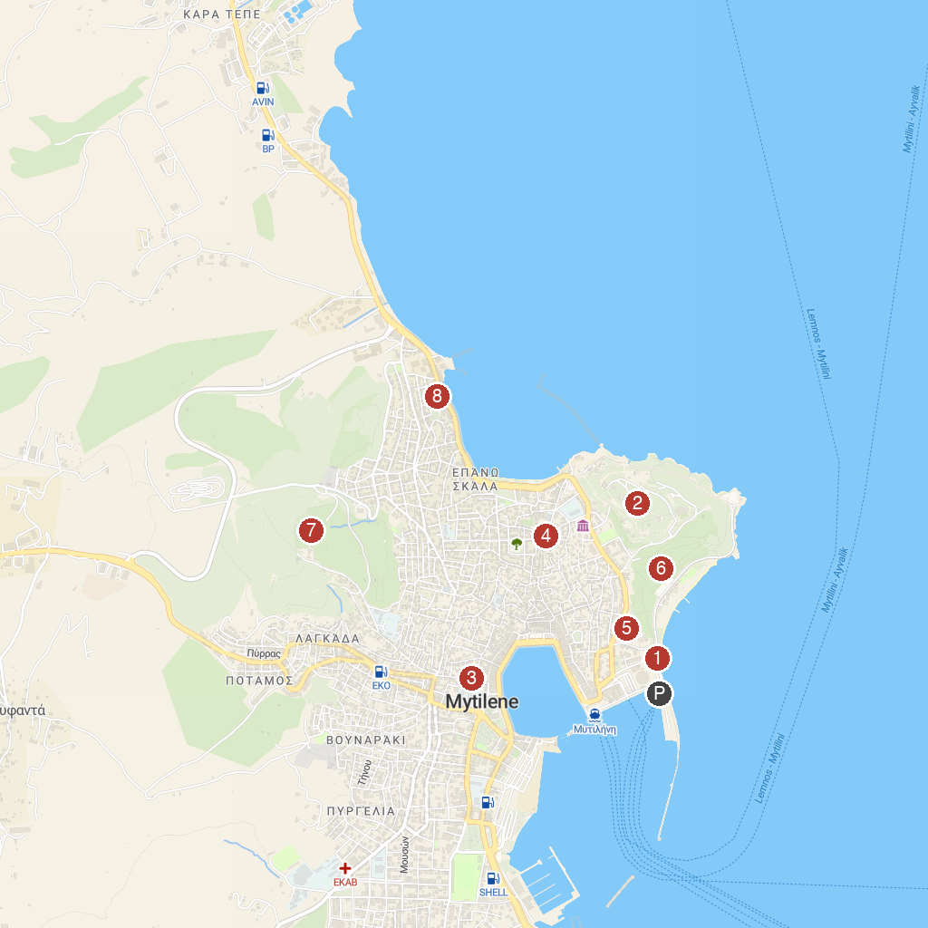
MAP KEY
1. Statue of Liberty | 5. Archaeological Museum of Mytilene
2. Castle of Mytilene | 6. Tsamakia Park
3. Byzantine Museum | 7. The Ancient Theater of Mytilene
4. Mytilene Yeni Mosque | 8. Georgiadis Mansion
P. Cruise port / terminal
Map © MapTiler © OpenStreetMap contributors · cruiseports.org

